HOW TO USE WORDPRESS!

First, go to http://newrambler.net/wpmu/wp-login.php. You’ll get a screen that looks like this, where you can enter your username and password.

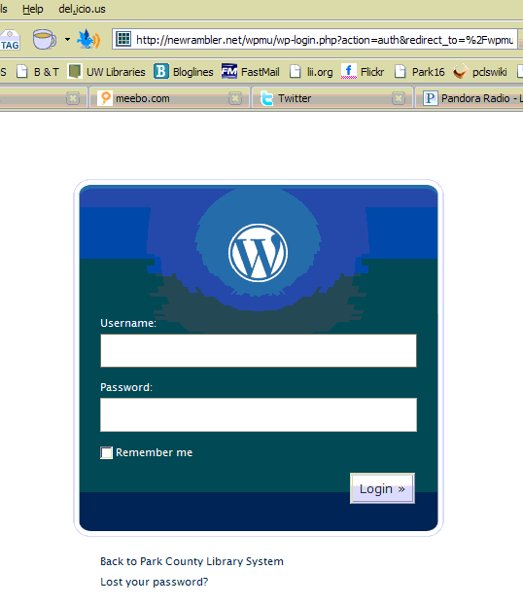
Yours will say “Howdy, cheryl” (or whatever your username is)

When you login, you’ll be taken to the Dashboard:

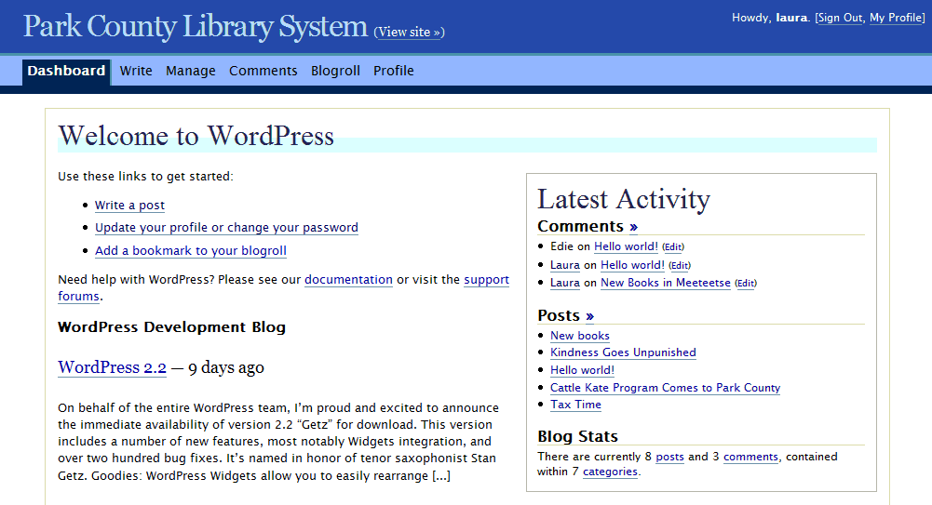

The two main things you’ll use for now are “Write a post” and “Manage.” “Write a post” allows you to add something to the front page of the website. “Manage” lets you change things you’ve written in posts or change the static pages (those are the tabs across the top—Cody, Powell, Meeteetse, Research, Library Cards, etc.).
WRITING A POST

When you click “Write a post,” you’ll get a screen like this:
Choose one or more categories. If you want something to show up in Cody News and Events, “Cody Library” MUST be one of the categories. You can add new categories if you don’t see one that fits your post.

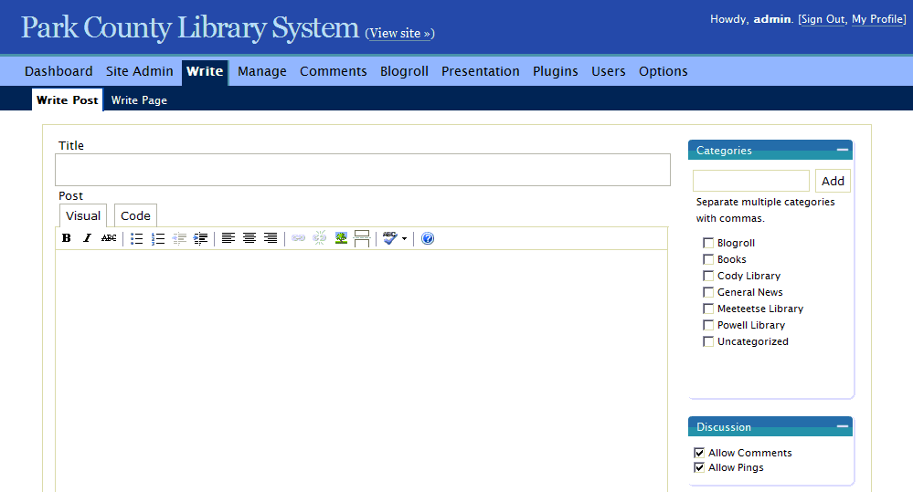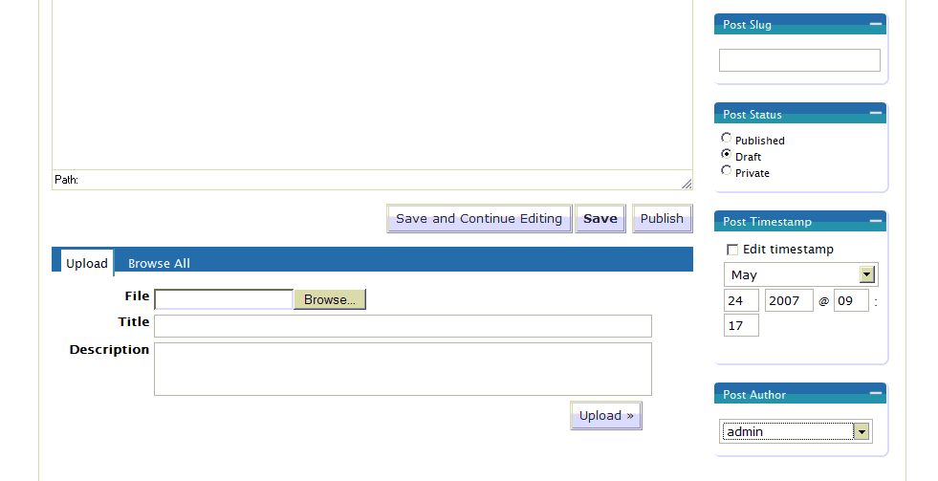
Type in a title for your post.
Leave these checked if you’re writing a Post. Uncheck them if you’re writing a Page.
This bar is similar to the formatting toolbar in Word. You can highlight text and then click on an icon to make it bold or italicized or to add a link or to do various other things.
If you want to save your work and come back to it later, click on Save. When you’re ready to have your post appear on the web page, click Publish.

There are some other things you can fiddle with (such as uploading files and changing the timestamp of a post), but we’ll get into that later.

USING THE TOOLBAR

Let’s take a closer look at the toolbar. You’re going to be using the Visual tab (the Code tab lets you see the html markup, if you’re curious).

You’ll use these icons to make links (more on links and pictures later).
Align text left, center, or right.

Spellcheck
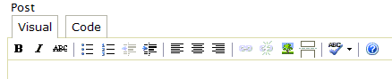
I’ve never used the help files, but here they are.
These first five buttons should be familiar. Just highlight the text you want to format and then click B (for bold), I (italics), strikethrough (which we probably won’t use much), bulleted list, or numbered list.
This will create an indented section of text, or what we call a blockquote. (The button to the left will take you back to the regular margins.)

If you are writing a really long post, click on this icon after the first paragraph or so. That will put in a “more” link for people to follow if they want to read the whole post, and it will keep the post from taking up the whole front page.

MAKING A LINK

Sometimes you’ll want to be able to link some text to a website (you can even link book titles to items in the catalog). Here’s how to do it:

- highlight the text that you want to link to
- click on the little link icon on the toolbar
- type the url of the site you are linking to in the dialog box (you can leave the Title field blank)
- click on insert

In the example below, the words “Declaration of Independence” will become a link to a Library of Congress site about the document.



