School Librarians Lead Learning and Transformation: A Professional Development Workshop Outline
From 2019-2022, the Institute of Museum and Library Services (IMLS) funded a multi-organization mentorship project entitled Accelerating Promising Practices. OCLC participated in one part of this project, titled Transforming School Library Practice, in which they mentored fifteen school librarians through the implementation of their IMLS grants to redesign their libraries for 21st-century learning, to advance staff skills, strengthen partnerships with stakeholders, and enhance programs and services that will prepare their students for success.
This mentorship involved various in-person and virtual convenings and workshops, individualized training, and more, with the goal of building a community of practice. Additional grant activities included offering free, in-person professional development workshops and an online webinar. This document offers the outline and activities included in the workshops so that school librarians can take and use them in their own educational activities.
School Librarians Lead Learning and Transformation: A Professional Development Workshop Outline 1
Objectives 2
Objectives for participants 2
Part 1: Welcome 2
Part 2: Background 3
Part 3: Community-Building and Reflection 3
Activity 3
Break 4
Part 4: Hands-on Activities and Discussion 4
Instructions 4
Station 1: School Library Advocacy 5
Station 2: Student-Centered Libraries 6
Station 3: Inquiry-Based Learning 7
Station 4: School Library Makerspaces 7
Station 5: Virtual Teaching and Learning 9
Break 9
Part 5: Reflection and Discussion 9
Activity 9
Q&A and Wrap-up 10

Objectives
In this workshop:
- Participants will learn about the purpose and structure of the School Librarian’s Information Shelf
- Participants will share their own experiences in their school libraries to inform their interest in transforming their practice and their interaction with the resources in the Information Shelf
- Participants will gain awareness and usefulness of resources from the Information Shelf
- Participants will engage in interactive, collaborative learning opportunities, with the dual purpose of taking part in their own experiential learning along with discussion about how to offer that to students
- Participants will have opportunities to build near and peer networks
This workshop is designed to:
- Introduce the resources contained in the Information Shelf
- Offer school librarians and paraprofessionals the opportunity to share information, engage in collaborative problem solving, and build and expand their peer community
- Engage participants through hands-on and reflective activities

Objectives for participants
Upon completion, participants will have:
- Learned about the purpose and structure of the Information Shelf and its resources
- Shared experiences that help foster ideas for transforming school library practices and utilizing Information Shelf resources
- Participated in interactive, learning opportunities designed to provide experiential learning with possible incorporation into future student learning
- Engaged in peer sharing and networking on topics relevant to transformation of school library practice

Part 1: Welcome
Present the agenda for the day and do an icebreaker activity.

Part 2: Background
Participants will learn about major topics and tools covered in each subject area of A School Librarian’s Information Shelf.
- School Library Advocacy: Craft a compelling impact story using data, testimonials, and strategies
  - Stakeholder buy-in
  - School library studies and data
  - Telling advocacy story
- The Student-Centered Library: Implement effective approaches and models to create student-centered learning experiences in school libraries
  - Creating interactive spaces
  - Strategies for student-centered learning
  - School and public library partnership
- Inquiry-based Learning: Support student-driven learning in school libraries using models and examples
  - IBL Models
  - IBL in Practice
- School Library Makerspaces: Leverage creative and compassionate approaches and materials for a successful school library makerspace
  - Makerspaces
  - Compassionate making
- Virtual Teaching and Learning: Explore effective tools and practices for teaching and learning in online spaces
  - Delivering engaging online learning
  - WA Digital TeachKit

Part 3: Community-Building and Reflection
Participants will engage in an activity designed for both individual reflection and community-building.

Activity
“I Like, I Wish, I Wonder”
Instructions:
- Reflect on your school library as it is right now. What do you like about your school library? Write that down on a sheet of paper, starting with “I like….” Maybe there are many things you like, but feel free to list a few. (5 mins)
- What do you wish for your school library? Maybe there are some ways you’d like to grow your library, aspects of your collection or different types of programs that you’d like to enhance or spotlight. Write these down on the same sheet of paper, starting with “I wish…” (5 mins)
- Finally, what do you wonder about your school library? Are there things missing or things that work differently from how you’d like them to, and you wonder why that is or how it could be different? Write those down on the paper, starting with “I wonder…” (5 mins)
- Now share some of your ideas with folks at your table or with a partner nearby; preferably with someone you’ve not met yet.
  - Are there similarities in others’ responses? Differences? New ideas?
- Keep this sheet of paper with you as you go through today’s workshop. We’ll refer back to it at the end.

Break

Part 4: Hands-on Activities and Discussion
Participants will dive into the categories of the Information Shelf and engage in facilitated discussions and hands-on activities that demonstrate the process and value of advocacy, designing student-centered programming and spaces, and building peer learning communities.

Instructions
Stations have been created at tables around the room, with each station representing a subject area in the Information Shelf.
Materials at each station include:
  - A few printed materials from the Information Shelf for exploration and learning
  - A sheet with discussion prompts
  - A sheet with instructions for the station’s hands-on activity
Participants can engage in one round of activities, share out what they learned with the larger group, and then move to another station for additional rounds as time allows.

Station 1: School Library Advocacy
- Printed materials could include the infographics on school library statistics, the Practical Tips for Advocacy, etc.
- Discussion prompts can include:
  - What is something that happened in the last year at your school library that you are proud of?
  - How would you tell people about this great thing?
- Activity ideas:
  - Based on your answers to the discussion prompt questions, consider what kinds of data you could gather to tell that story. Examine the pieces of paper on the table for ideas of different kinds of data: surveys, interviews, focus groups, entry/exit tickets, storytelling, observations, and other things. Assemble the ones you’d like to use and create a data quilt that you can then use to guide your advocacy work.
  - Think about how you might build stronger relationships with the teachers and administrators in your school. Consider: Who do you want to build a relationship with? Why do you want to build that relationship? (Keep in mind that the relationship itself can be the goal.) Then select from a series of cards to assemble a creative approach for building your relationship. Share your approach with others and give each other feedback. The cards should be in the following categories:
    - When is a good time to build this relationship?
      - Before school; after school; prep period, lunch; other
    - Where would you like to meet this teacher/administrator?
      - Classroom; library; outdoors; teacher’s lounge; other
    - What kind of relationship do you want to build?
      - One-time connection for an assignment; regular interactions during school year; first step to building additional connections; brainstorming partner for program ideas; other
    - How will you go about building this relationship?
      - Host a teatime; email to set up a meeting; give a library tour; go for a walk outside; other
  - Select from strips of paper that have sentence fragments on them. They represent just a few of the things you do every day to make a difference in your school library. Use these strips to build an advocacy narrative starting with “I…” This narrative will tell the story of your library. Share your narrative with others at your table. Sentence fragments include: Serve communities, build literacy and learning, encourage lifelong learning, encourage students to be curious, support teachers in their classroom, connect learning to life skills, bring the fun, enable children and youth to find the books they love, stand for intellectual freedom, center diversity, equity, and inclusion, bring people together, provide access to print and digital resources and tools for learning, and others.

Station 2: Student-Centered Libraries
- Printed materials can include Public Library & School Library Collaboration Toolkit, the See, Think, Wonder Worksheet, and the ConnectedLib Toolkit.
- Discussion prompts can include:
  - How are you arranging the physical space in your library to center the learning needs and opportunities for your students?
  - What are some ways you could partner with your local public library? What would be involved in building that partnership?
- Activity ideas:
  - Think about partnering with a local public library. What might be an idea around which you could build this partnership? A summer reading-related event, expanding access to learning resources for students, supporting a parents’ night event with library-card sign-ups, etc. Then use post-its to build a recipe to make that partnership possible. Write down the ingredients for this partnership on the post-its, thinking about roles and responsibilities, resources, promotion, etc. Once you have your ingredients laid out, talk with others at your table about what you’ve built and see if you would make any changes. Does your partnership recipe seem doable? What would be your next step in making it happen?
  - See, Think, Wonder: Choose an image from the ones printed at your table. Use the See, Think, Wonder worksheet to guide you as you try and determine what is happening in the image. Ask yourself, what do you see in the image? What do you think? What do you wonder? Remember that this kind of activity can be useful with students of all ages, it might just need some adaptation.

Station 3: Inquiry-Based Learning
- Printed materials can include the AASL Standards Framework, the 5 Elements of Information Inquiry and Inquiry Process Models document.
- Discussion prompts can include:
  - What are your students curious about?
  - What inspires them?

- Activity idea:
  - Quick Write and Turn and Talk: Choose a topic from the post-its on the table. Then write a few ideas related to that topic that you could research if you were working on a research paper. Once you have some ideas, turn to someone else at the table and talk about what you’ve written to get feedback and guidance from your peers. Then switch and listen to what your partner has written. If there are questions you’re not sure how to answer, these can be areas to do additional research and exploration. This activity can be a simple way to build inquiry-based learning into your library curriculum.

Station 4: School Library Makerspaces
- Printed materials can include the Compassionate Making Resources document
- Discussion prompts can include:
  - How might makerspaces be more accessible for all students?
  - What barriers do you currently see either in your own makerspace or in others you’ve seen?
  - How could makerspaces be more sustainable, through materials, technology, etc.?
- Activity idea:
  - Torn-Art Portraits: Think about why your school library is important to you. Ask yourself, why are you a school librarian? Find construction paper and tear it into different shapes that you glue onto a sheet of paper to construct a portrait of yourself as a school librarian or of your school library. Think about how you can convey your passion and dedication to your work through your portrait. Let go of perfectionism! Embrace the freedom of tearing paper. Work quickly and don’t overthink it. Feel free to discuss the discussion prompts as you create. Think about how you can use this activity in your school library with your students. How might this help them strengthen their empathy and compassion for one another? Your students could create their own portraits and learn new things about each other.
Here are some examples of portraits school librarians have made. You can see that there are similar motifs across these portraits—a love for students and the work of being a school librarian, a dedication to reading and storytelling, the constant curiosity of the work, and more.
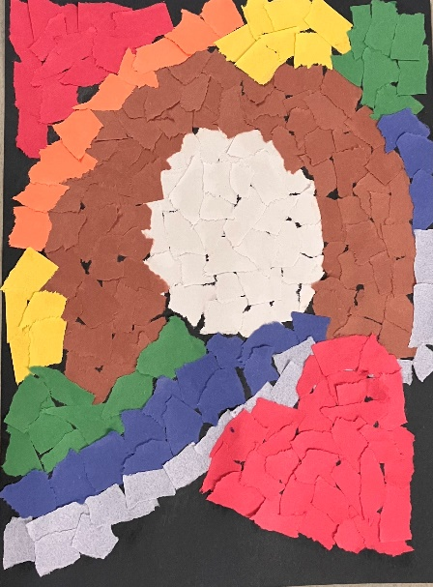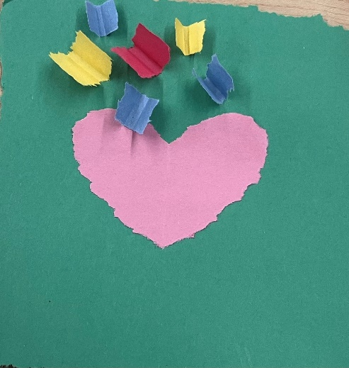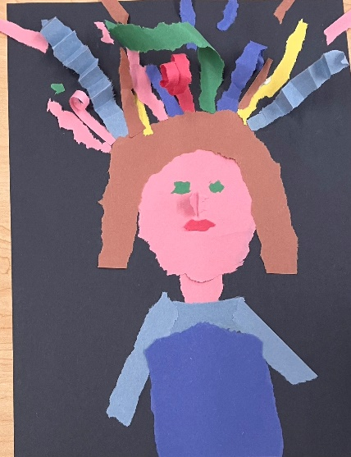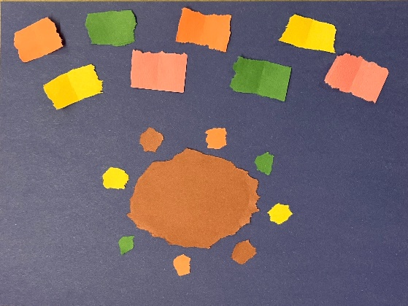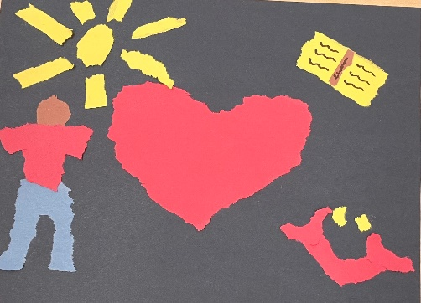

Station 5: Virtual Teaching and Learning
- Printed material can include the Tips for Using TeachKit document
- Discussion prompts can include:
  - What successes and challenges have you experienced around virtual teaching and learning tools and strategies?
  - What would a successful virtual teaching and learning experience look like for your school library?
- Activity idea:
  - Red Light, Yellow Light, Green Light: Designate someone at your table to be in charge of a timer (use your phone or some other timer). Set the timer to seven minutes and start with Red Light: Discuss the tools, strategies, or approaches that you found did not work for you during the pandemic when you were teaching online. When the timer goes off, move to Yellow Light and reset the timer for seven minutes. Discuss the tools, strategies, or approaches that you want to continue using, or have continued using that have been helpful and useful. When the timer goes off, move on to Green Light. Set the timer for six minutes. Discuss the tools, strategies, or approaches that you would like to create or implement that you think would be helpful in future virtual teaching and learning situations. When the timer finishes, you’re done! What have you learned and what do you want to apply to your school library?

Break

Part 5: Reflection and Discussion
Participants will engage in final reflection activities to consider how they might apply what they’ve learned and discuss their ideas with one another to build a community of peers.

Activity
Individual reflection:
Return to your responses in the I Like, I Wish, I Wonder activity earlier. Take a few moments to add any new information, ideas, questions you now have to your original responses.
Large group discussion:
- What have you learned today that you didn’t already know?
- What is one idea you want to apply now?

Q&A and Wrap-up

Lewrick, M., Link, P., & Leifer, L. (2020). The Design Thinking Toolbox: A Guide to Mastering the Most Popular and Valuable Innovation Methods. Wiley.
Martin, M. H., & Washington, R. (n.d.). “Read-a-Rama.” Website. www.read-a-rama.org.

