Opioid Crisis Support Kit for Public Libraries
BETA VERSION
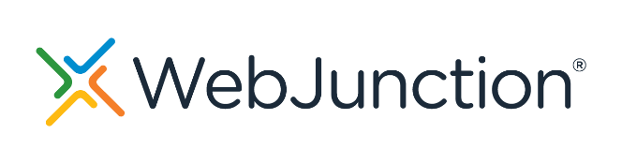
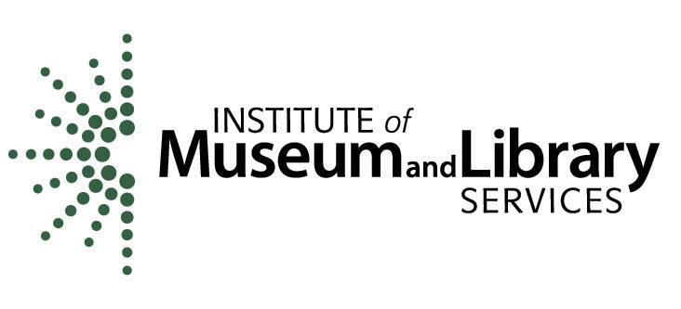
March 2024
The project is made possible by support from OCLC and the Institute of Museum
and Library Services project number, LG-250082-OLS-21.
© 2024 OCLC.
This work is licensed under a Creative Commons Attribution 4.0 International License. creativecommons.org/licenses/by/4.0/
March 2024

OCLC Dublin, Ohio 43017 USA
www.oclc.org

Please direct correspondence to:
WebJunction social@oclc.org

Suggested citation:
OCLC. 2024. Opioid Crisis Support Kit for Public Libraries (Beta Version). Dublin, OH: OCLC.

PREFACE
Through a grant from the Institute of Museum and Library Services, OCLC has produced and is testing a support kit to help library staff learn more about the opioid crisis and implement a local response through programming and library services.
This kit follows work done by OCLC and the Public Library Association, which looked at how public libraries were engaging in opioid response activities. The research conducted between 2017-2020 resulted in a summary report (doi.org/10.25333/qgrn-hj36) and eight research-based case studies (doi.org/10.25333/cx18-1p87) highlighting varying opioid response efforts across the US. Additional information about the project can be found online: oc.lc/opioid-crisis.
This is a beta version of the kit, with the opportunity for library staff to provide feedback that will inform the final version.

INTRODUCTION
Public libraries are respected local institutions that connect community members to credible information and services. Libraries are open to all, including those who may be in crisis. As community anchor institutions, libraries are leveraging their assets in response to the opioid crisis that has gripped the country. High-profile national news stories and research from the project Public Libraries Respond to the Opioid Crisis with Their Communities (oc.lc/opioid-crisis) have featured libraries’ responses, ranging from providing access to information and resources on addiction, prevention, treatment, and recovery support, to training staff to use the drug naloxone to help reverse overdoses.
This support kit has been informed by subject matter experts, case study research, cross-sector discussions with library leaders and front-line library staff, and national and local community partner organizations. In the library research conducted by OCLC and PLA, interviewees from public libraries and their community partners shared that even a small first step made a critical difference. In 2023, a group of staff from 15 public libraries completed pilot testing of this support kit and provided feedback that informed this version of the resource.

How to use this resource
Every library, individual, and community is different, and there is no single solution for approaching this work. The activities in each section are suggestions to help grow a participant’s skills and knowledge. However, the content may not always align with the local situation or your experience. Read through the activities and select those that can support your learning and your community. This support kit is provided as a Microsoft Word document to allow users the greatest level of flexibility. Your notes and comments can all be saved in the document, and/or you can print out a copy.
Feedback from users is essential to improving the resource. After reviewing and/or using the support kit, please take a few minutes to provide your thoughts and recommendations in this survey: surveymonkey.com/r/support-kit

Terms and language
The following terms appear in this resource, and these are their working definitions:
Opioids: A class of drugs that includes prescription medications used to provide pain relief, such as hydrocodone (Vicodin®), oxycodone (OxyContin®, Percocet®), morphine, codeine, and fentanyl. Heroin, which is a non-prescription drug, is also an opioid (Johns Hopkins Medicine, hopkinsmedicine.org/health/treatment-tests-and-therapies/opioids).
Addiction: A treatable, chronic medical disease involving complex interactions among brain circuits, genetics, the environment, and an individual’s life experiences. People with addiction use substances or engage in behaviors that become compulsive and often continue despite harmful consequences (American Society of Addiction Medicine, asam.org/quality-care/definition-of-addiction/glossary-of-addiction).
Harm reduction: An evidence-based approach is designed to help reduce the negative impact of behavior associated with substance use in both individuals and at the community level (Cleveland Clinic, health.clevelandclinic.org/what-is-the-harm-reduction-model).
Naloxone: A medicine that rapidly reverses an opioid overdose. It is an opioid antagonist. This means that it attaches to opioid receptors and reverses and blocks the effects of other opioids. (National Institute on Drug Abuse, nida.nih.gov/publications/drugfacts/naloxone).
Opioid use disorder (OUD): A problematic pattern of opioid use that causes significant impairment or distress. A diagnosis is based on specific criteria such as unsuccessful efforts to cut down or control use, or use resulting in social problems and a failure to fulfill obligations at work, school, or home, among other criteria (Recovery Research Institute, recoveryanswers.org/addiction-ary).
Substance use disorder: Occurs when the recurrent use of alcohol and/or drugs causes clinically significant impairment, including health problems, disability, and failure to meet major responsibilities at work, school, or home. (Substance Abuse and Mental Health Services Administration, samhsa.gov/find-help/disorders).

Action 1: Getting to Why
This crisis is about people, first and foremost. It is people who are impacted, people who are hurting, and it is people who are often desperately in need of help and resources. And it’s also people who can provide the information and support that could be lifesaving or life-changing. For your library, as a trusted community resource, there is an opportunity to help connect people to that valuable information. This connection to information is a core service of the public library, and the people in need could include individuals who may be struggling, as well as their friends, family, neighbors, and even your co-workers. In some libraries, and with some staff, this connection and opportunity isn’t always an obvious direction. These staff may be looking to understand how this work fits into the library’s services and programs, or what this toolkit refers to as getting to the “why” for the library.
Getting to why your library’s response to the opioid crisis matters can start with learning about the many facets of this issue, including how the opioid crisis impacts the community. Seeking information about what is happening in your community, and even more broadly in your region or state, helps to identify and define a role for your library in providing support. Because the opioid crisis is such a broad and impactful issue, many resources are freely available online and through nonprofits and government agencies at the local, state, and national levels.

Activity 1: Videos and stories
The impacts of the opioid crisis can be greatly misunderstood and stigmatized, and it is helpful to have a baseline understanding of issues that may be impacting people. These short videos help to explain how the human body can respond to opioids and lead to addiction, how addiction can develop, and the individuals affected. As you watch the videos, write down one thing you learned or something that resonates with you.
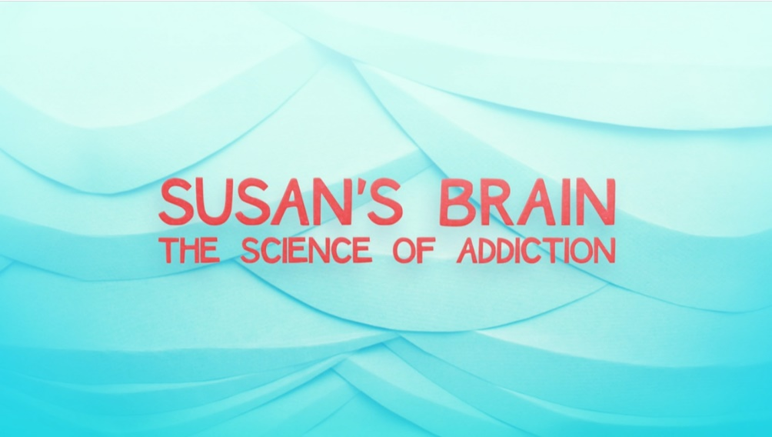
Video 1: “Susan’s Brain, The Science of Addiction,” by Lily Fang (4 minutes, 28 seconds) youtu.be/pe5loX720Rk:
What is one thing that you heard that was new to you?

Video 2: “Stevi Rae’s Rx Awareness Story,” by the Centers for Disease Control (2 minutes, 26 seconds) youtube.com/watch?v=PFFH0f8Wumc
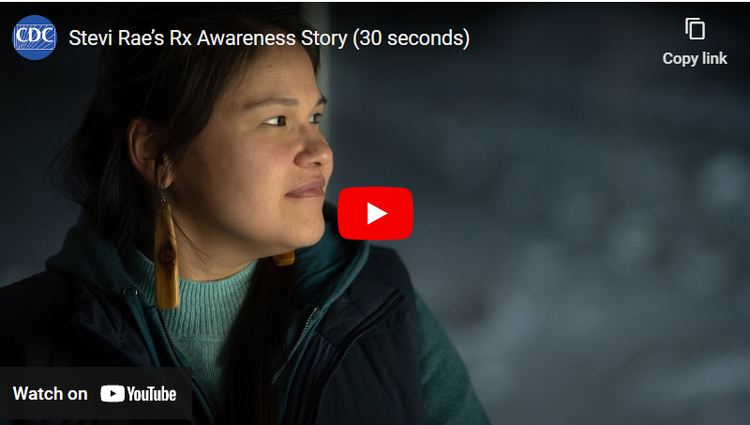
What resonated with you about this story?

Video 3: “David’s Rx Awareness Story,” by the Centers for Disease Control (2 minutes, 26 seconds) youtube.com/watch?v=35Nx6-P2mfI
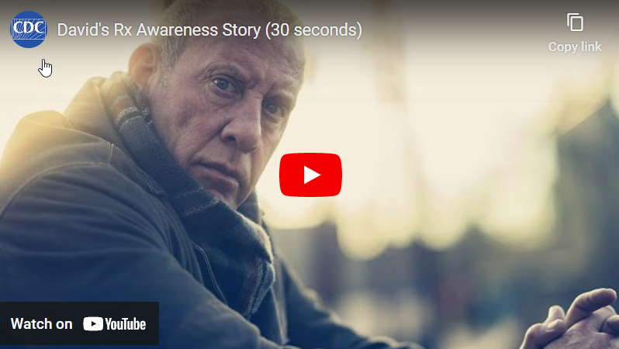
What resonated with you about this story?

Video 4: “Tele’s Rx Awareness Story,” by the Centers for Disease Control (1 minute, 44 seconds) youtube.com/watch?v=MF-3jeD05sk
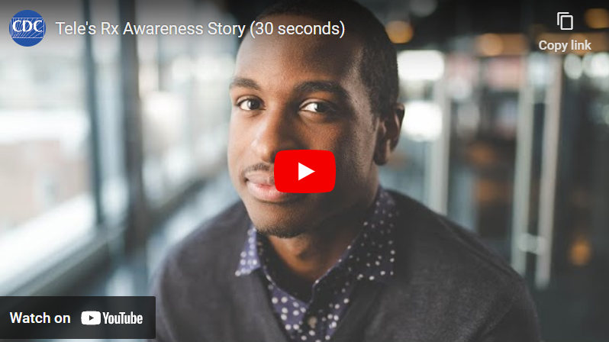
What resonated with you about this story?

- Additional stories and resources from the CDC Rx Awareness program are available: cdc.gov/rxawareness/stories/index.html
- Other video/story resources: “Tragedy and Hope: Stories of Painkiller Addiction,” from WNED-TV, Buffalo, New York: pbslearningmedia.org/collection/tragedy-hope-stories-of-painkiller-addiction

Activity 2: Reflection questions
- What is drawing you to this work? What do you see as being the “why” for your library?

- What concerns do you have, or do you think other library stakeholders might raise about programming and services related to meeting needs around the opioid crisis?

- What resources does your library already make available that help to address individual and/or public health concerns? Consider both the print and digital collection, including electronic resources. Also, think about past or current programs and services and any partnerships the library has connected to supporting a healthy community.

- What questions or information could you see patrons seeking from the library about opioid use disorder or addiction? What barriers might prevent them from accessing this information?

Activity 3: Stories from the field
Many public libraries have been offering programs and services to their communities that are in response to the opioid crisis. These two examples include how they see this work connected to the library’s mission and vision.
Video 1: Trisha Shively, Kokomo Howard Public Library (6 minutes, 24 seconds)
vimeo.com/926409834/0eb042a36c
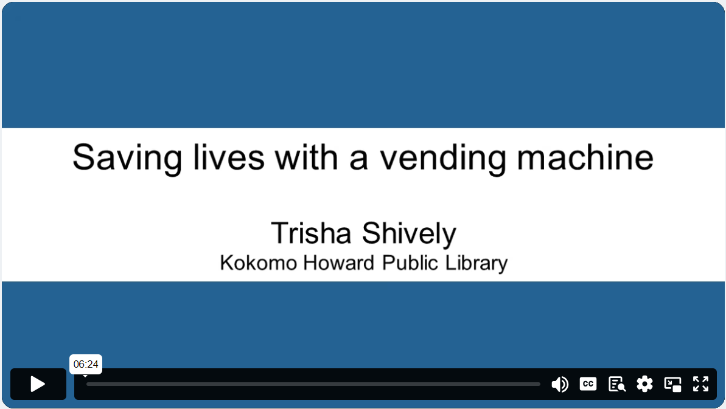

Video 2: Karen Wilson, Charles County Public Library (3 minutes, 11 seconds)
vimeo.com/926456145/5efa803398
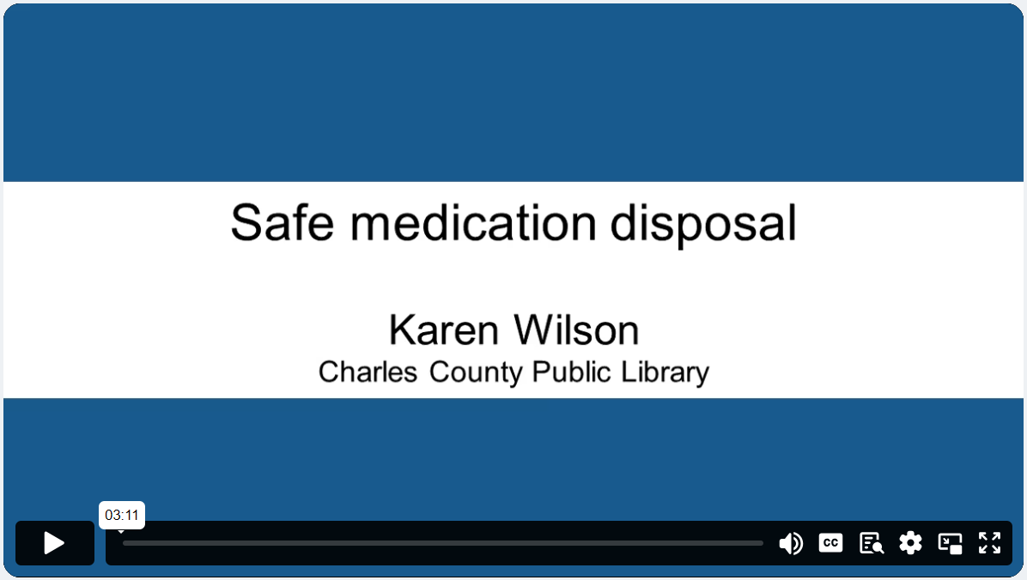
Notes
Consider the activities, what you learned, and your overall impressions of the content. What was helpful or changed your thinking? What else do you want to explore around this topic?

Feedback
Feedback from users is essential to improving the resource. Please take a few minutes to provide your thoughts on this section and any recommendations in this survey: surveymonkey.com/r/support-kit.

Action 2: Explore your community data
In the first action, you explored the idea of getting to the “why” and learning about how this crisis is impacting individuals and your community. Listening to personal stories and experiences can help with understanding more about the people dealing with these issues, but combining these stories with data can create a more holistic view of the situation. Exploring data is another way to expand on understanding the health concerns that impact your community, which is essential to informing the community, leadership, staff, and other stakeholders about local needs and planning potential service responses. Monitoring health-related community data and conditions also can become part of the library’s ongoing strategic planning.
Libraries can benefit from connecting with local and/or state health department staff to discuss the issues and data they are tracking in the community. Health agencies/departments are the most common partner for libraries in addressing the opioid crisis, and their staff can be a source for understanding both local health priorities and opportunities for the library to support. They also may have resources for your library to distribute to the community and capacity to help support or fund programming and service enhancements.

Activity 1: Where to look
The Robert Wood Johnson Foundation provides free access to health data through County Health Rankings & Roadmaps. The site compiles data from sources such as the Centers for Disease Control and Prevention, the US Bureau of Labor Statistics, the National Center for Education Statistics, and the US Census Bureau to provide a local snapshot of many health-related issues. The data includes a wide range of data points such as rates of access to health care, social and economic factors such as poverty and graduation rates, as well as data on specific health issues such as diabetes, HIV prevalence, and drug overdose deaths.
Open the County Health Rankings & Roadmaps (countyhealthrankings.org) tool in your browser. Scroll down to the section “How healthy is your community?” then enter your zip code and select your county/district to find your local data. Expand the section “Additional Health Behaviors” to find the number of drug overdose deaths reported in the county. Note: The data is adjusted to account for a population of 100,000 to create consistent reporting across locales of all sizes. If the overdose rate is listed as 20 and your county has 25,000 people, then 5 deaths are estimated. If the overdose rate is listed as 20 and the population of your community is 200,000, then 40 deaths are estimated. The population of the county can be found in the “County Demographics” section at the top of the results.
What is the drug overdose rate for your county? ____________

What about surrounding counties and the rest of the region or state? Any surprises?
Explore the other data points available in the tool. How might you use this data to identify areas where the library can support healthy community outcomes?

Another data point to explore is the county-level data showing opioid dispensing rates (cdc.gov/drugoverdose/rxrate-maps/opioid.html) from the Centers for Disease Control and Prevention. The map is clickable, and you can zoom in and out. These rates show the number of opioid prescriptions per year dispensed per 100 people.
What is the opioid dispensing rate for your county/area? ____________
What about surrounding counties and the rest of the region? Any surprises?

Pulling it together
These data points tell you part of the story about what is happening in your community, but it doesn’t automatically define a path for your library in how to respond to the opioid crisis. Low prescribing or overdose rates don’t mean that offering programming or resources of substance misuse isn’t helpful or needed. Libraries in areas with lower overdose or prescribing rates can still offer valuable programming and resources in support of a healthier community.
A reminder about data
Most demographic and health data that is provided in these national tools use data that may be one to two years old, and not reflect the current situation in your area. Later in this support kit, in Action 3, activities include connecting with organizations that may have more details about current, local concerns.
Notes
Consider the activities, what you learned, and your overall impressions of the content. What else do you want to explore around this topic?
Feedback

Feedback from users is essential to improving the resource. Please take a few minutes to provide your thoughts on this section and any recommendations in this survey: surveymonkey.com/r/support-kit.

Action 3: Consider community assets and
connect with partners
Staff time, budget, and shifting priorities all impact the collections, programs, and services that a library can provide to the community. It can be a challenging balancing act to make it all work. One way to increase capacity is to leverage the expertise of subject matter experts and partners in your efforts. Partnerships can increase capacity, funding, and strength, particularly around topics of shared concern such as the opioid crisis. By partnering with organizations like public health departments or nonprofits that specialize in issues such as substance use disorder and/or harm reduction, libraries can gain access to subject matter experts, programming opportunities, and connect to local nonlibrary users.
Partnerships can look very different, depending on capacity and needs. The relationship between libraries and other organizations can be informal without a written agreement or very detailed with deliverables and respective responsibilities. Research on libraries and the opioid crisis from OCLC and PLA shows that libraries have worked with local partners on everything from cross-promoting activities, to hosting events in library spaces, to co-designing public programs (oc.lc/opioid-crisis). The common thread is that they are mutually beneficial to the participating organizations. These don’t have to be active, ongoing collaborations that go on for months or years. A short, or even a one-time engagement with an organization to meet a common goal and then stepping back, can still add considerable value.
Some of the issues that have exacerbated the opioid crisis, such as legality, access to health care, and stigma, make it particularly powerful to partner with other organizations with subject matter expertise. Aligning with existing efforts helps to limit silos in the community that can emerge when many organizations and individuals are working independently toward solutions to important issues and concerns. Seeking opportunities for your library to participate and contribute also helps to increase the visibility of the library as a powerful partner.
Partnerships aren’t necessary for moving forward or working in this space, and not having a partner shouldn’t be viewed as a barrier. It's possible that partnerships are too challenging for your library for a range of reasons or simply not an option. Partnerships require staff time that can already be very limited. There is also a proximity issue; your library may be in a more rural location with few organizations providing services. It can still be helpful to reach out and see if there are opportunities that can be beneficial, or in cases where distance is a factor, sharing information and promoting events or programs may be more realistic. A key to much of this work is a willingness to talk, explore possibilities, and be open to solutions.

Activity 1: Current partners
Partners can help to connect the library to community members who aren’t aware of the library’s range of programs, services, or resources, or who are not library users at all. Consider these questions:
- What organizations (if any) are you currently partnering with or recently have partnered with to provide programming and services, and on what topics? What is the extent of the partnership, and how active is it?
Organization | Topic/Area of focus | Status of partnership
Tip: Other staff in your library may have relationships with partners around outreach, programming, and services. Discuss this with colleagues to capture a more complete picture of the reach and range of partnerships.

Evaluating and exploring potential partners
Partners for libraries in addressing the opioid crisis can be found in many places, including these examples:
- Health departments
- Social workers, human services departments
- Nonprofits focusing on substance use disorder
- Harm reduction organizations
- Community coalitions focusing on substance use disorder or mental health
These organizations can provide a range of resources that can support community needs. Contributions that could be accessed through partners may include:
- Specialized resources geared toward specific population groups (e.g., youth or multilingual materials)
- Subject matter experts that can provide training to library staff and/or patrons and/or participate in library programs or events
- In-kind donations (e.g., Deterra, deterrasystem.com bags for safely disposing of unused medications or naloxone to revive someone who is experiencing an overdose)
- Information about drug take-back events and location sites to safely dispose of unused medications
- Connecting with individuals with lived experience
- Collaborating on funding/grant requests to better address shared needs and priorities
- Promotion of and advocating for library programs and services in the community, reaching previous untapped users/patrons

Activity 2: Documenting your strengths
As you prepare to speak to partners, consider the strengths that your library can bring to a collaboration and be prepared to share them. In research conducted by OCLC in 2020, organizations that partnered with libraries on opioid response programming shared that “they did not originally consider the library as a potential partner…but after having worked with the library, all partners stated they would do so again.”1 It probably won’t be surprising to know that many people and organizations don’t realize all that the library has to offer. Consider these potential strengths and if you think they describe your library:

Strength | Agree | Disagree
A trusted organization that reaches diverse community members
Physical space for meetings
A safe, nonstigmatized place for people to talk about difficult issues
Marketing reach for programs the organization offers
Vetted topical resources, including books, journals, and databases
Staff knowledgeable in curating and connecting people with community resources
If you disagreed with any of the potential strength statements, do you see this as an area where the library could improve?

What other strengths or resources does your library have that you would want to highlight? Are there specific segments of the population that you are well connected with that would be helpful for partners to understand?

Space is powerful
If you or a potential partner aren’t ready for a more collaborative relationship, one approach is to encourage these organizations to meet at your library and include details about their events on the library’s website; this initial engagement could lead to greater connection and familiarity with the library and staff. If there are community-wide coalitions to address the crisis or substance abuse issues, meeting at the library could be an option. If or when you’re ready, the library could also join as a contributing member of these coalitions.

Activity 3: Connect with health departments
Health departments are one of the most common partners for libraries in addressing the opioid crisis. They can provide subject matter expertise, financial support, and resources that can be beneficial to libraries seeking to develop programming or services. Depending on the size of your community, you may need to look beyond your immediate area to find the organization responsible for supporting community health, but it will generally be supported by local government. This could be a city, county, parish, regional, or state organization and will require research to identify a contact. Start by determining which agency is responsible for supporting community health in your area.
What is the name of this organization and where are they located?

Consider reaching out to the health organization staff by email or phone and having an informal conversation about what they see happening in the community around the opioid crisis and what resources they make available. This doesn’t need to be a commitment to do any work, just an opportunity for additional data and information gathering. Ask about their current programs and priorities for addressing the opioid crisis and where they need help.
What do you want to tell this health department about the library? Review your earlier answers under Action 1 about what your library already does to support healthy communities. What would be good for this organization to know? What resources such as meeting room space, communications tools, databases, books, etc., would be a good discussion point for your conversation?

What concerns or challenges could you see arising in partnering with a health department, which is often a government agency? For example, are there perceptions or preconceived notions about what they do and how they interact with the community that could create a barrier?

Tip: Not every local health department will be receptive to a partnership or sharing resources. Consider expanding to discuss opportunities with a state or regional agency if you aren’t finding local interest.
Initial steps could include starting a conversation with potential community partners or subject matter experts. Ask where they see gaps or opportunities for shared work. Listen to what partners identify as needs and highlight what the library can offer and support.

Activity 4: Discovering new partners
A tremendous amount of work is already going on at local and national levels to support needs connected to the opioid crisis. There are organizations and coalitions that were formed specifically to address the crisis in the last 10 years, as well as other organizations whose services and scope have grown to include opioid-related responses.
These organizations can be approached as potential partners or to get local information about the impact of the opioid crisis on the community. They can help to highlight gaps in service or information that the community may be searching for or need. Finding these organizations, individuals, or agencies may require conducting an online search or speaking with people in your network who are familiar with the landscape and can make the connection. Connections can come in many different ways when the door is open to conversation and possibilities. Talk to people about what you’re looking to do, listen to what they are trying to accomplish, and identify where there is alignment.
Consider these different types of partners in your community or region. Research at least two different organization types and how they serve the community. Read about their services and the areas that they focus on. In addition to searching on the web, try the Neighborhood Navigator (navigator.aafp.org), a geo-mapping tool that identifies organizations and various services, including health care, based on zip code.

Type of partner | Organization/individual
Social workers
Human services departments
Local therapists or mental health professionals
Nonprofits focusing on treatment for opioid/substance use disorder
Nonprofits/organizations that support people who have loved ones who are struggling (Al-Anon, Nar-Anon)
Harm reduction organizations
Community coalitions focused on opioid/substance use disorder or mental health
Veterans support organizations
Other:
Other:

Other benefits to partnerships
Two potentially beneficial aspects of a partnership include access to additional funding streams and access to resources, such as staff or materials. Grantmaking organizations that provide funding for projects or even for operational costs often like to see partners working together on common goals that can benefit the community. Small projects between partners can serve as a “proof of concept” for funders that the ideas are viable and that the organizations have a shared commitment and priorities that will bring change and value to the community.
It's never too early to think big and imagine the possibilities. As you move through an experience with a partner, think about if they would be a good long-term partner, or what other types of things you could collaborate on. How can your work together be leveraged to appeal to funders who would bring needed resources to your community?

Resources to explore
- Local chapters of health and social services professional organizations may be able to connect you with subject matter experts; for example, the National Association of Social Workers (socialworkers.org/About/Chapters) may be able to support the library with resources to engage in your health programming and opioid response
- 3 Ways to Build Partnerships at Your Small Library (programminglibrarian.org/blog/3-ways-build-partnerships-your-small-library), State Library of Iowa via Programming Librarian
- WebJunction’s resources on Partnerships & Collaboration (webjunction.org/explore-topics/partnerships.html)

Notes
Consider the activities, what you learned, and your overall impressions of the content. What else do you want to explore around this topic?

Feedback
Feedback from users is essential to improving the resource. Please take a few minutes to provide your thoughts on this section and any recommendations in this survey: surveymonkey.com/r/support-kit.

Action 4: Increase awareness and knowledge
of the issue
Learning and training opportunities for library staff—and even board members—can increase understanding and confidence in addressing this crisis. It also serves to strengthen the “why” that was explored in Action 1. From addressing the use of stigmatizing language, to establishing and reinforcing policies that support both the staff and the community on a range of issues, there are a range of topics and ideas that can be explored to help increase knowledge and awareness about the opioid crisis and it’s impacts.

Addressing stigma
Individuals dealing with opioid use disorder, along with their friends and family who love them, can face tremendous stigma and judgment. In The Opioid Use Disorder Prevention Playbook (hub.nic-us.org/groups/opioid-epidemic/the-nic-playbook), the National Interoperability Collaborative maintains that removing the stigma associated with opioids is a key concern: “If the environment of interaction by professionals (police, health care providers, etc.) can become more non-discriminatory and non-judgmental, there is a higher probability that the road to recovery will be shorter and more likely to result in a positive outcome.” This environment can be extended to the library as a place where people seek out professional services and information. By working toward reducing stigma on this issue, libraries can be part of a community-wide solution.
One tangible issue to focus on is how library staff talk about and describe patrons and individuals in the community who are dealing with substance use disorder. Reducing and removing language that can be stigmatizing is helpful on many levels. How we refer to and describe individuals who are in crisis—experiencing issues like substance use disorder, mental health, or homelessness—can impact how our communities and colleagues see these people. This can include nicknames or code names that staff may call patrons. It’s important to remember that many people, including our friends and colleagues, may be afraid of talking about these issues if they feel judgment or stigma. We can all engage in using language that helps to remove these barriers.
Another concern that comes with the use of stigmatizing language that doesn’t center on the individual person is that it has a dehumanizing effect. Engaging in dehumanizing language has been proposed as a protective factor that workers may engage in to avoid emotional exhaustion.2 Language that puts people first is a step toward acknowledging the complexity of the human experience and allows for more compassion.
Here are some examples of stigmatizing language and alternatives that be used:

Instead of this | Use this
Junkie; Addict | Individual with substance use disorder
Clean; Former addict | Person in recovery
Dirty drug test | Tested positive (drug test)
Source: “Words Matter - Terms to Use and Avoid When Talking About Addiction” https://nida.nih.gov/nidamed-medical-health-professionals/health-professions-education/words-matter-terms-to-use-avoid-when-talking-about-addiction

Activity 1: Words matter
How we talk about people and the words we choose to describe situations are important considerations. Library staff sometimes encounter behavior from patrons within the library that can feel challenging, including negative behaviors connected to drug use. This is often frustrating for the staff and other patrons, however, being mindful of how we describe these situations can be very impactful.
This video from Shatterproof (2 minutes, 8 seconds) explores how removing stigmatizing language can change perceptions and treatment (youtube.com/watch?v=5QX17g6Xuk0):
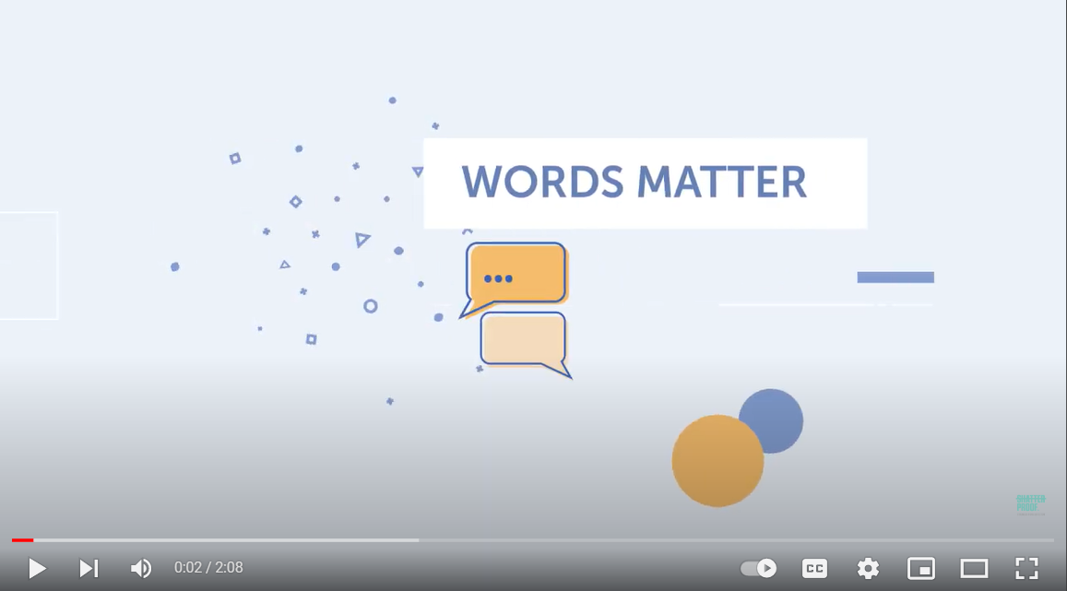
What is one thing that you heard/learned that was new to you?

Additional resources on language use
- “Why words matter in the substance use conversation” (pewtrusts.org/en/research-and-analysis/articles/2020/05/05/why-words-matter-in-the-substance-use-conversation), Pew
- Addictionary (recoveryanswers.org/addiction-ary), Recovery Research Institute
- “Words matter: How language choice can reduce stigma” (facesandvoicesofrecovery.org/wp-content/uploads/2019/06/Words-Matter-How-Language-Choice-Can-Reduce-Stigma.pdf), Faces and Voices of Recovery
- Change Your Language (https://www.shatterproof.org/our-work/ending-addiction-stigma/change-your-language), Shatterproof

Policies
One way to support the use of destigmatizing language is through customer service policies, which can establish standards that can be expected of library staff and their engagement with patrons. These can reference issues such as privacy and use of language. Stigma is not likely to be directly addressed, but may be broadly described as “professionalism,” “dignity,” or “respect.”
Here are a few example statements from published library policies:
- “Treat every patron with equal respect and every request with equal importance.” Wixom Public Library (MI) wixomlibrary.org/library-policies.
- “The library will offer the same quality of services to all patrons regardless of age, race, sex, nationality, educational background, physical limitations, or any other criteria that may be the source of discrimination.” Fairview Public Library (NY) libraries.4cls.org/margaretville/wp-content/uploads/2018/02/Customer-Service-Policy.pdf.
- “All staff shall treat everyone with dignity and respect. A good guide for this is for all staff to treat others in the ways they would like to be treated. By concentrating on the needs of users and coworkers and genuinely caring about their well-being, staff demonstrate that they hold other human beings in high regard. Staff collaborations should not harm anyone’s self-esteem but rather encourage a positive personal interaction.” Trenton Free Public Library (NJ) trentonlib.org/wp-content/uploads/2020/04/CustomerServicePolicy.pdf.
- “All interactions and transactions between a library patron or group of patrons and the Saugus Public Library are considered confidential and will be discussed only in a professional context. . . Staff must remember that, although the temptation to discuss or share difficult transactions at the public desk is great, any such discussions are to be private and kept among staff.” Saugus Public Library (MA) sauguspubliclibrary.org/about/library-policies/customer-service-policy.

Activity 2: Influencing through policies
- Does your library have a customer service policy? Check: ☐Yes / ☐No
- If yes, is it something that you think your colleagues are familiar with? Consider how staff are made familiar with policies and how they are shared. Check: ☐Yes / ☐No
- If there is a policy, is it shared with patrons and easily accessible? Check: ☐Yes / ☐No
- If there is no policy, would one be helpful as part of the library’s broader efforts to serve the community and provide guidance to staff. Check: ☐Yes / ☐No
While your position within the library may not have the responsibility for creating or approving policies, each staff member should have the agency to ask questions about potential policies and make suggestions to the library leadership.
- What steps would you like to take to reinforce or implement a customer service experience in the library that acknowledges the importance of respect, trust, and privacy? Remember that even if you don’t have control over establishing a policy within your organization, you can still reflect on your own professional values and standards.

Facts and statistics
Better understanding the facts about the opioid crisis and addiction in general can be helpful for setting the context for a response. Local partners that you explored in earlier actions may be able to provide additional context and support around understanding these issues. Here are just a few to consider:
  - On average, 221 Americans die every day from an opioid overdose.3
  - Of 12- to 17-year-olds who misused prescription opioids, 57% got them from a friend or relative.4
  - Roughly 21% to 29% of patients prescribed opioids for chronic pain misuse them.5
  - Almost 90% of large, rural counties lack sufficient opioid treatment programs.6
  - The genes that people are born with account for about half of a person’s risk for addiction.7
  - A large-scale national study showed that opioid overdose deaths decreased by 14% in states after they enacted naloxone access laws.8

Training and education for staff
In research conducted for the Public Libraries Respond to the Opioid Crisis with Their Communities project (oc.lc/opioid-crisis), staff at the Denver Public Library and the New Orleans Public Library shared that both offering staff ongoing opportunities to train to administer naloxone—a medication that can reverse an opioid overdose—and making these trainings optional contributed to a successful experience and increased buy-in. Staff who were uncertain about participating were able to hear from colleagues about the training and decide to attend at a future date. Colleagues were serving as trusted sources who could make the topic more approachable.
Trainings that could be helpful for staff include:
- Information about administering or understanding how naloxone works. This could be offered along with CPR and other trauma-response skills.
- Mental Health First Aid (mentalhealthfirstaid.org) is a course that covers how to help someone experiencing a mental health or substance use challenge. The training helps learners to identify, understand, and respond to signs of addictions and mental illnesses. Library staff and the public can participate in trainings scheduled throughout the country; libraries can also consider working with organizations to host training at the library.
- Presentation from a harm-reduction organization or public health agency on how the opioid crisis is impacting the community, or recognizing the signs of an overdose (example: Save a Life from a Prescription Opioid Overdose, cdc.gov/rxawareness/prevent/index.html).
- From Burnout to Balance (learn.webjunction.org/enrol/index.php?id=690 is a course designed to empower staff to prevent burnout and enhance well-being at work in libraries, archives, or museums. Learners will develop a self-care plan tailored to their individual needs using evidence-based techniques to manage stress, enhance emotional regulation, and build resilience.

Activity 3: How is staff learning supported in your library?
What are the ways that your staff engage in learning and sharing opportunities? Are there dedicated staff training hours or days? Emailing? Internal newsletter? Discussion during staff meetings? The subject matter and complexity of an issue can be one driver for the type of training that needs to be delivered to be effective. Regardless of a formal learning structure, all staff can contribute to a culture of learning by engaging their colleagues in conversation and sharing information.

Which of these styles are used for sharing information or providing training in your library, and which would you be personally comfortable supporting?

Style | Used by staff (Y/N) | Viable option? Personal comfort level
Email
Newsletter content
In-person training time
Staff meetings
Staff training hours/days
Other
Other

Resources to explore
Information and videos about substance use disorder and opioids for a general audience:
- Addiction Policy Forum, Addiction A-Z (addictionpolicy.org/addiction-a-z)
- Addiction Policy Forum, collection of videos, (addictionpolicy.org/videos)
- Centers for Disease Control and Prevention, Save a Life from a Prescription Opioid Overdose (cdc.gov/rxawareness/prevent/index.html)

Notes
Consider the activities, what you learned, and your overall impressions of the content. What else do you want to explore around this topic?

Feedback
Feedback from users is essential to improving the resource. Please take a few minutes to provide your thoughts on this section and any recommendations in this survey: surveymonkey.com/r/support-kit.

Action 5: Focus on library staff care
For many library staff, supporting patrons on challenging topics can surface deep emotions and be difficult work. An effect for some staff can be compassion fatigue, which is described by The American Institute of Stress as “the emotional residue or strain of exposure to working with those suffering from the consequences of traumatic events. It differs from burn-out, but can co-exist.”9 Compassion fatigue surfaces with a range of topics. For example, during the Great Recession, library staff experienced compassion fatigue from helping people locate information related to filing for unemployment, assistance programs, housing options, and job seeking during a period of considerable uncertainty and stress.
Responding to the opioid crisis or other health crises such as the COVID-19 pandemic can lead to compassion fatigue among staff. It is important to recognize this to anticipate both your individual needs and the broader needs of the library staff. Supporting staff requires that their concerns and fears be heard and that they have a choice in their role. Staff need to feel empowered to make the right decision for themselves when it comes to engagement on this issue—this includes participating in training to use interventions such as naloxone. Forcing participation or adherence to policies can cause its own form of trauma. Advocating for understanding how staff feel about new policies, asking what they are concerned about and what they need to be successful can go a long way to minimizing concerns and making new endeavors successful.
A valuable approach to consider is that of “trauma-informed care.” The principles of trauma-informed care are increasingly appearing in libraries in large part due to the movement to include and embed social workers in public libraries. Trauma-informed care can apply to engagements with colleagues and the public, because we each come with a unique set of experiences and those aren’t always known by others. The Public Library Association has a Social Work Task Force whose members have been generous with their time and expertise in helping to familiarize library staff on how using a trauma-informed approach can help with serving the community and in our interactions with colleagues.
Understanding compassion fatigue, trauma-informed care, and how it can improve relationships in the library is ideally addressed and supported at the leadership level of the library. However, this may not be possible in your library for a variety of reasons. It is still valuable to learn and use the knowledge in your own interactions.

Activity 1: Understanding the trauma-informed approach
Read this one-page overview from the Public Library Association’s Social Work Task Force on trauma-informed care in libraries: Public Library Social Work—Overview of Trauma-Informed Care (ala.org/pla/sites/ala.org.pla/files/content/tools/Public-Library-Social-Work_Overview-of-Trauma-Informed-Care_FINAL.pdf)
What is one thing that you learned that was new to you?

Emergency response plans
Medical emergencies happen in libraries, and like a stroke or heart attack, an overdose is a medical emergency that requires medical care. Having an emergency plan is an important aspect not only to providing that medical assistance, but also to caring for and preparing staff for a potentially traumatic event in the library. We prepare with the hope we will never need to use the information or skills, but that we can be ready if it’s necessary.
Not every workplace will take the time to prepare staff for emergencies—this is a universal truth and libraries are no exception. Library leadership and boards may be hesitant to engage in activities connected to empowering staff to consider their work with a trauma-informed lens and to prepare for opioid-related emergencies. This hesitancy may limit the possibility of making progress in these areas, and it can feel isolating for staff looking for change or more guidance. If you find yourself in this situation, consider finding allies outside of your workplace who you can talk to. You can still be proactive on a personal level, which can positively impact your response during all kinds of crises.
Information that can be covered in an emergency response plan includes reminders such as:
- Contact 911 to report the emergency and request assistance
- How to handle the area of the library where the emergency is occurring; staff should be prepared to clear the area of both patrons and staff to prepare for emergency responders and allow for privacy
- Information about who on the library staff should be notified if an emergency occurs, including after-hours contact information
Staff at your local police or fire departments can help to inform the development of a response plan with information about local policies. It also helps to create those relationships prior to an emergency.
These are template examples for disaster/emergency responses. These are very detailed, with many different facets beyond a medical emergency such as damage to the collection and natural disasters. Your library may have different needs from these examples, but they can be customized to create a plan that meets the needs of your library.
- Disaster Preparedness Toolkit (statelibraryofiowa.gov/index.php/libraries/toolkits-guides/disaster-preparedness-toolkit), State Library of Iowa
- Librarian’s Disaster Planning and Community Resiliency Guidebook and Workbook (njstatelib.org/services_for_libraries/resources/disaster_planning), New Jersey State Library

Activity 2: Review or create an emergency response plan
- Does your library have an emergency response plan? Check: ☐Yes / ☐No
- If yes, is it something that you think your colleagues are familiar with? Consider how staff are made familiar with policies and how they are shared. Check: ☐Yes / ☐No
- If an emergency response plan does not exist, what steps would you like to take to establish or encourage the implementation of one? Remember that even if you don’t have control over establishing a policy within your organization, you can still reflect on your own needs for clarity and support.

Post-crisis planning
A post-crisis plan is initiated to support staff and patrons in the event that a traumatic event or crisis occurs at the library. How will the library support staff who were affected? A post-crisis plan will prepare the library to respond to an event like witnessing an overdose as well as if/when patrons or colleagues suffer another type of health crisis or trauma.
Information that can be covered in a post-crisis response plan include reminders such as:
- How to engage with staff who were involved in the crisis—acknowledging that the experience of talking about and reliving the event can be a form of secondary trauma.
- Staff may be eligible to access support through an employee assistance program (EAP), which is a benefit provided through a health insurance provider; determine if this type of coverage is available through your organization and how the services can be accessed.
- What local agencies might be available in the event of a crisis? Are there organizations with social workers, counselors, or other similar roles, who you can build a relationship with now prior to an event?

Activity 3: Review or create a post-crisis plan
- Does your library have a post-crisis plan in place? Check: ☐Yes / ☐No
- If yes, is it something that you think your colleagues are familiar with? Consider how staff are made familiar with policies and how they are shared. Check: ☐Yes / ☐No
- Does your organization have access to an employee assistance program (EAP)?
Check: ☐Yes / ☐No
- If yes, is this incorporated into the post-crisis plan? Check: ☐Yes / ☐No
- If a post-crisis plan does not exist, what steps would you like to take to establish or encourage the implementation of one? Remember that even if you don’t have control over establishing a policy within your organization, you can still reflect on your own needs for clarity and support.

Resources to explore
  - Tiffany Russell and Anne Chapman presented on “Mental Health First Aid and Trauma-Informed Approaches for Libraries” (learn.webjunction.org/enrol/index.php?id=514) in a WebJunction webinar.
  - Elissa Hardy, the Community Resource Specialist at Denver Public Library, offered a webinar (vimeo.com/220517757) through the Massachusetts Library System addressing compassion fatigue in libraries.
  - Infopeople produced the webinar, “Preventing and Treating Compassion Fatigue with Self-Care” which is available through WebJunction (learn.webjunction.org/enrol/index.php?id=460).
  - Trauma-Informed Libraries Facebook group (facebook.com/groups/1775447376011577/about): “We are a collaborative of library professionals and library supporters who seek to share ACEs [Adverse Childhood Experiences] Science with our institutions, organizations and communities; explore and implement Trauma-Informed approaches; and build community resilience through our programs, practices and publications.”
  - Substance Abuse and Mental Health Services Administration (SAMHSA), Practical Guide on Implementing a Trauma-Informed Approach (store.samhsa.gov/product/practical-guide-implementing-trauma-informed-approach/pep23-06-05-005).
  - Katherine Manning’s article in the Harvard Business Review, “We Need More Trauma-Informed Workplaces” (hbr.org/2022/03/we-need-trauma-informed-workplaces).
  - WebJunction course, “Introduction to Crisis Communications for Libraries, Archives, and Museums.” (learn.webjunction.org/enrol/index.php?id=688).
  - WebJunction Course, “Crisis Communications Planning for Libraries, Archives, and Museums.” (learn.webjunction.org/enrol/index.php?id=689).

Notes
Consider the activities, what you learned, and your overall impressions of the content. What else do you want to explore around this topic?

Feedback
Feedback from users is essential to improving the resource. Please take a few minutes to provide your thoughts on this section and any recommendations in this survey: surveymonkey.com/r/support-kit.

Action 6: Community engagement and
programming options
Programming and training opportunities can help to raise awareness of the impact of the opioid crisis in the community and increase the confidence of library staff and patrons in responding to surfacing needs. Partners can be particularly helpful in supporting these training needs, providing subject matter experts, resources, and marketing support. Libraries are often working with limited budgets and staffing resources, and partners can help but there is an entry point for all libraries in this work, and the responses can look very different and still be successful.
Many opportunities, ranging from low touch to a deeper engagement, can be adapted for your local capacity and needs. Examples of programs that have been offered by libraries is available on WebJunction (webjunction.org). These programs can be virtual, in-person, or hybrid, and they can be ongoing efforts or timebound:
- Provide informational displays with books available at the library (this list of titles to consider is available from WebJunction, webjunction.org/news/webjunction/opioid-resources-for-patrons.html).
- Update the library’s website with resources that can support patron information needs.
- Distribute free pamphlets addressing substance use disorder, or information about the National Helpline (samhsa.gov/find-help/national-helpline) for treatment referrals.
- Host a guest speaker, film screening, or a book discussion.
- Host a community forum or conversation.
- Promote drug take-back events in the community (generally offered by a partner) that help to safely dispose of unwanted and unneeded medication, preventing misuse or abuse. The Drug Enforcement Agency maintains a list of local organizations that collect medications (takebackday.dea.gov). Related messaging could also include using medication lockboxes for safely storing medications in the home.
- Make drug disposal bags available to aid in the prevention of opioid misuse by providing a way for people to dispose of unwanted medications easily and safely. For example, the Twinsburg Public Library (OH) distributed Deterra (deterrasystem.com) bags to the community through their engagement with the Summit County Community Partnership. Another type of bag is made available through DisposeRx (disposerx.com).
- Explore establishing a peer navigator program with a local partner. Peer navigators or peer providers are trained professionals who offer support on a variety of mental and physical health issues and have lived experience. Libraries such as Kalamazoo Public Library (MI) and Denver Public Library have included peer navigators to aid in supporting patrons with social service needs. While this is a high-touch initiative, it can be well supported by external partners who provide training and prepare peer navigators. The Kalamazoo Public Library and their partners at the Recovery Institute of Southwest Michigan started their program with just a few hours of peer navigation support per week but were able to later expand the program as they shared the impact with stakeholders and secured additional funding.

When planning for programming on this topic, factor in the following considerations:
Program evaluation: Along with any partners, consider how to capture information about how the library is meeting community needs. Because of the sensitivity of the topic, collecting evaluation forms or other data from attendees may be particularly challenging. If statistical data isn’t possible, review options for collecting anecdotal data from presenters, partners, or similar program participants, which can aid in sharing the results with stakeholders. Participating in larger community coalitions that are focused on the crisis may be another source of sharing impact. As plans develop, it is important to consider what success will look like—and that success will be different for every library. Many libraries have reported challenges with getting attendance at programs. What will you need to see to feel successful?
Sustainability: When considering a programming response, also factor in the importance of sustainability. What will be needed to maintain the programming or service moving forward? Depending on the type of response, sustainability may be less of an issue. For example, book displays and providing informational pamphlets may require minimal sustainability consideration. While a library may have limited capacity to offer a long-term response through programming or staffing changes, it’s still possible to move forward; a limited response can better help to define needs and ongoing requirements. When working with partners, ask about their ability to assist in supporting the cost of implementation and delivery.

Access to naloxone
Naloxone is a medication that can reverse an opioid overdose, and stocking naloxone and administering it in the event of an overdose in the library is one of the most common responses that surfaced in the case study research for this project. Sold under the brand name Narcan, many libraries host training on using naloxone for both the staff and public.
Training: Naloxone training may include how to reverse an overdose, when it should be administered, and why it’s important to have it available. Calling 911 should always be the first step after recognizing an emergency (ideally addressed in the library’s crisis response plan), but minutes can count when it comes to saving a life. The training can also address information about how opioid misuse affects individuals and the community, as well as help to break down bias about the use of naloxone. The local health department can be a good partner in providing access to this training and more information about the use of naloxone.
Many libraries have approached this as an optional training for staff to allow people to choose to participate and to help build buy-in among staff. In addition to making training optional, offering the training multiple times allows staff who may have been hesitant about the training to hear firsthand from colleagues about the value of the content. Scheduling refresher sessions annually will allow new employees and those who were previously unable to attend to participate, as well.
The New Orleans Public Library combined naloxone training with CPR and Stop the Bleed (stopthebleed.org) as part of their Bystander Response Training to prepare people for a crisis; the training was available to both the staff and public. This training was made possible through the library’s partnership with the local health department, which developed the curriculum and provided the trainers and equipment needed for the sessions.
More information about using naloxone is available:
  - NEXT Distro (naloxoneforall.org) facilitates naloxone access.
  - Get Naloxone Now (getnaloxonenow.org), “online resource to train people to respond effectively to an opioid overdose emergency.”
  - How Naloxone Saves Lives in Opioid Overdose (youtu.be/cssRZEI9ujY), a YouTube video produced by the US National Library of Medicine.
  - National Harm Reduction Coalition, “Overdose Prevention” (harmreduction.org/issues/overdose-prevention/, some are free, and some are for a fee).
  - National Harm Reduction Coalition, “All Resources” (harmreduction.org/all-resources/).
Legality: Library staff and members of the community have expressed liability concerns over naloxone administration in the event that an opioid reversal fails or the individual who received the naloxone has an adverse reaction. Every state has some form of a Good Samaritan law, which provides protection when individuals aid in an emergency. However, with regard to dispensing, carrying, and administering naloxone, each state differs on what situations apply to these laws. Your library may have access to support from a local attorney as part of your connection to local government. It is recommended to confirm what policies are in place for employees of other agencies as a starting point for the library’s policy.
Resources for Good Samaritan laws:
  - National Center for Biotechnology Information, Good Samaritan Laws (ncbi.nlm.nih.gov/books/NBK542176)
  - National Center for Biotechnology Information, Opioid-overdose laws association with opioid use and overdose mortality, from 2014 (pubmed.ncbi.nlm.nih.gov/29610001): “Laws designed to increase layperson engagement in opioid-overdose reversal were associated with reduced opioid-overdose mortality. We found no evidence that these measures were associated with increased non-medical opioid use.”
  - Prescription Drug Abuse Policy System, Good Samaritan Overdose Prevention Laws (pdaps.org/datasets/good-samaritan-overdose-laws-1501695153)
  - Prescription Drug Abuse Policy System, Naloxone Overdose Prevention Laws (pdaps.org/datasets/laws-regulating-administration-of-naloxone-1501695139)
  - Ask a local/regional law library for assistance with local laws and statutes.

Activity 1: Review the Good Samaritan laws
- What do the Good Samaritan laws outline in your state?

Examples of naloxone policies and procedures for libraries:
  - New York State Library (nysl.nysed.gov/libdev/opioid/guidance.htm)
  - Denver Public Library (publiclibrariesonline.org/wp-content/uploads/2020/02/DPL-Narcan-Use-Procedures-4-12-18.pdf)

Notes
Consider the activities, what you learned, and your overall impressions of the content. What else do you want to explore around this topic?

Conclusion
Thank you for your time and interest in this work, and for exploring the Support Kit. There are many paths that can be taken to support your community through this and any crisis. Think about how to apply the strengths of the library in approaching the issue and seek out the support of partners with expertise to help address gaps that may exist. There is a role to play in improving outcomes that align well with the mission of the public library. Together, we can make a positive difference in improving outcomes for our communities.

Share your thoughts
Feedback from users is essential to improving the resource and ensuring that the content continues to remain relevant for library staff. Please take a few minutes to provide your thoughts and recommendations in this survey: surveymonkey.com/r/support-kit

ACKNOWLEDGMENTS
This project was made possible in part by the Institute of Museum and Library Services (project number LG-250082-OLS-21).
The views, findings, conclusions, or recommendations expressed in this publication do not necessarily represent those of the Institute of Museum and Library Services.
The project team is grateful for the collective efforts of all of the libraries and staff who participated in the pilot testing of this resource. We thank them for all that they are doing to support their communities through this crisis and for their willingness to share their experiences and learnings to help guide others’ responses to the crisis.
- Lucretia Calonder, Altoona Public Library
- Dianne Connery, Pottsboro Public Library
- Jessica Cruse, Charles County Public Library
- Drea Douglas, North Bend Public Library
- Amanda George, Beauregard Parish Library
- Phyllis Goodeil, Del Norte County Library District
- Lloyd Jansen, Charles County Public Library
- Melissa Johnson, Harrington Public Library
- Melissa McGeary, Atlantic City Free Public Library
- Norman Miller, Patricia Romanko Public Library
- Elizabeth O’Hara, Community Library
- Susan Parenteau, Gill Memorial Library
- Kelly Rist, Delphos Public Library
- Karen Wilson, Charles County Public Library
- Abigail Worden, Charles County Public Library

Subject matter experts with experience in libraries, public health, mental health, substance use disorder also strengthened the content of this support kit.
- Daniel Brigman, Denver Public Library
- Kayleigh Gates, Denver Public Library (former)
- Cindy Grove, Rockport Public Library
- Tiffany Russell, Licensed Master Social Worker

NOTES

- Coleman, Michele, Lynn Silipigni Connaway, and Kendra Morgan. 2020. "Public Libraries Respond to the Opioid Crisis with Their Communities: Research Findings." Collaborative Librarianship 12(1), Article 6. https://digitalcommons.du.edu/collaborativelibrarianship/vol12/iss1/6
- Cameron, Daryl C., Lasana T. Harris, and Keith B. Payne. 2015. “The Emotional Cost of Humanity: Anticipated Exhaustion Motivates Dehumanization of Stigmatized Targets.” Social Psychology and Personality Science 7(2). https://doi.org/10.1177/1948550615604453.
- Centers for Disease Control and Prevention. 2022. “U.S. Overdose Deaths in 2021 Increased Half as Much as in 2020 – But Are Still up 15%.” https://www.cdc.gov/nchs/pressroom/nchs_press_releases/2022/202205.htm.
- Center for Behavioral Health Statistics and Quality. 2017. Results from the 2016 National Survey on Drug Use and Health: Detailed Tables. Rockville, MD: SAMHSA.
https://www.samhsa.gov/data/sites/default/files/NSDUH-DetTabs-2016/NSDUH-DetTabs-2016.pdf.
- Vowles, Kevin, Mindy McEntee, Peter Julnes, Tessa Frohe, John Ney, David van der Goes. 2015. “Rates of Opioid Misuse, Abuse, and Addiction in Chronic Pain: A Systematic Review and Data Synthesis.” Pain 156(4): 569-576. https://doi.org/10.1097/01.j.pain.0000460357.01998.f1.
- Pew. 2019. Opioid Use Disorder: Challenges and Opportunities in Rural Communities https://www.pewtrusts.org/en/research-and-analysis/fact-sheets/2019/02/opioid-use-disorder-challenges-and-opportunities-in-rural-communities.
- National Institute on Drug Abuse. 2018. “Understanding Drug Use and Addiction.” https://www.drugabuse.gov/publications/drugfacts/understanding-drug-use-addiction.
- McClellan, Chandler, Barrot H. Lambdin, Mir M. Ali, Ryan Mutter, Corey S. Davis, Eliza Wheeler, Michael Pemberton, and Alex H. Kral. 2018. “Opioid-overdose Laws Association with Opioid Use and Overdose Mortality.” Addictive Behaviors 86: 90-95. https://doi.org/10.1016/j.addbeh.2018.03.014.
- Boyd, Danielle. 2011 “Compassion Fatigue.” The American Institute of Stress (blog), 11 November 2011. https://www.stress.org/military/for-practitionersleaders/compassion-fatigue.

