What Public Libraries Are Doing Now to Create Effective Inclusion & Diversity Training Programs
November 13, 2009
By Kathryn Perkins
Director, Learning Services
WebJunction
A few weeks ago, one of our Partner Development Managers asked if I was aware of new trends in diversity training as she had been asked this question by a couple of large public libraries in her region. This piqued my curiosity to learn more about current trends in libraries as well as in the corporate and public sector.
I sent out a quick survey to 12 WebJunction members who provide human resources and/or training at their libraries and eight members took the survey. In addition, I reached out to inclusion and diversity managers at a large corporation, a non-profit and a large city to hear about emerging trends at their workplace. As I received a number of emails interested in the results, here are the findings from the survey and my interviews.
Some of the interesting findings from the survey:
- Less than 50% of the libraries who responded said they have diversity training.
- HR Directors and Training Managers are 100% responsible for delivering the programs.
- The most common way libraries provide training is by having an expert in the diversity area train onsite at the library. Other common training methods included library staff developed instructor-led programs, online courses and web teleconferencing.
- When asked where the libraries got their program content, the most frequent answers included the state, county or regional programs, Employee Assistance Programs (EAP), WebJunction, SirsiDynix, Opal, Library Journal, DDI, and state universities.
- 70% said their programs were mandatory or highly encouraged.
- When asked if diversity programs were considered compliance programs or library productivity programs, the majority of respondents said both.
- The topics covered in diversity training identified were:
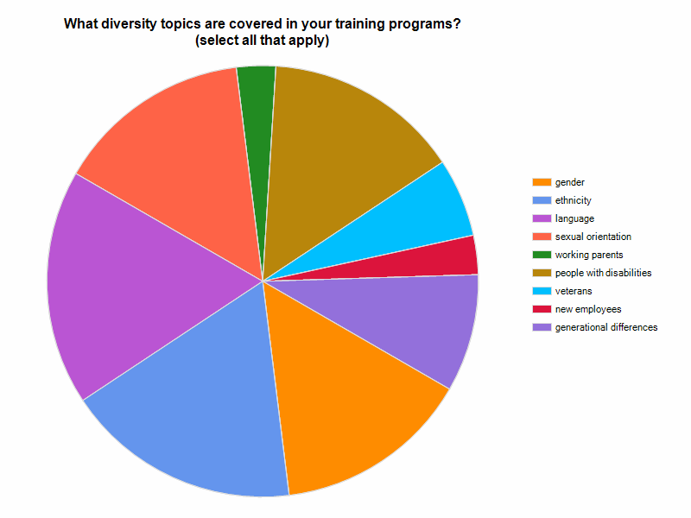
- The survey indicates there is a trend to expand the concept of diversity training from traditional topics such as gender, ethnicity and language to encompass topics such as working parents, veterans and generational differences.
- When asked what diversity activities the library was involved in outside of training, the highest rated activity was attendance at cultural events. Other activities included email alerts, media programs, business events and sponsoring ESL programs.
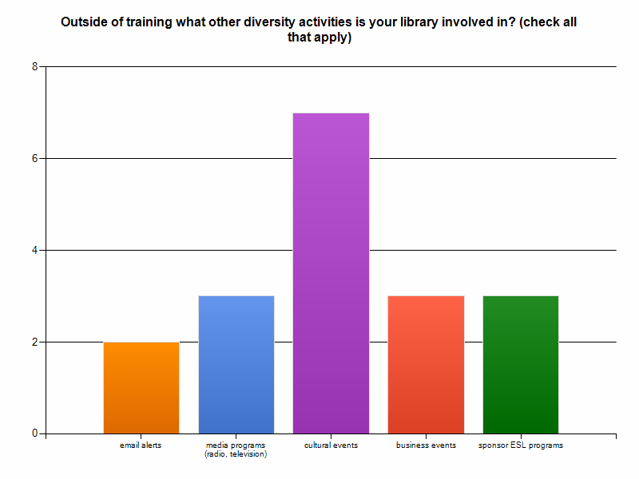

Additional recommendations based on the interviews with other organizations:
- Many organizations are calling their programs Inclusion rather than Diversity to incorporate larger topics such as bringing on new employees, working parents and caregivers. The goal is for employees not to ‘leave themselves at the door’ but bring the richness of their culture and experiences to enhance and add value to their library.
- Though adhering to compliance is an important part of these programs, there is an emphasis now to demonstrate that inclusion/diversity programs contribute to library productivity. Tying programs into human resource metrics such as retention rates, leadership development and mentoring opportunities is seen as more strategic than one-off training programs.
- In the survey, the responses indicated that diversity initiatives are driven primarily by human resource and training staff. In talking with other organizations, with the layoffs of training and human resource staff last year, many organizations are developing Employee Resource Groups (ERGs). For more information on creating effective ERGs go to: http://www.shrm.org/hrdisciplines/Diversity/Articles/Pages/CMS_023310.aspx

