Twitter Basics
Tweet: To tweet is to post an update via Twitter. The maximum length of a tweet is 140 characters, so be concise!
Followers: The people who subscribe to your tweets.
@ for Reply: Typing the ‘@’ symbol in a tweet before someone’s Twitter username indicates that you are replying to something that person tweeted earlier. Your tweet will be still be public.
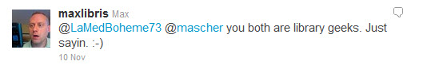
D for Direct Message: Typing ‘D’ in a tweet before someone’s Twitter username sends a private message to that person.
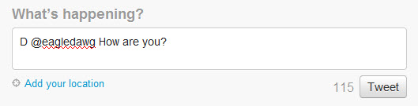
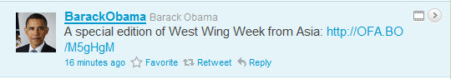
Retweet: You can easily retweet someone else’s post – hover your mouse over a tweet and notice the “Retweet” option. Add ‘RT’ to your tweet as a courtesy when you are re-posting someone else’s tweet.

You can also reply to someone’s tweet very easily by clicking on the “Reply” option.
Hashtags: These are descriptive words or acronyms preceded by ‘#’. When used in tweets, hashtags ensure that all tweets about a particular topic or event are retrieved together in a Twitter search.
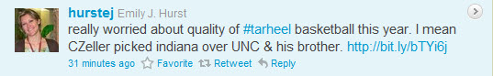
Tinyurl: Long, messy URLs can eat up your 140 character limit very quickly. Use a service such as tinyurl, snipr, shrinkify or bit.ly to reduce the length of those URLs before posting them in your tweets.

Add your location: Click on “Add Your Location” under where you enter in your tweet. The GPS information is not always correct, so you can choose from the drop down next to your supposed location to re-select.
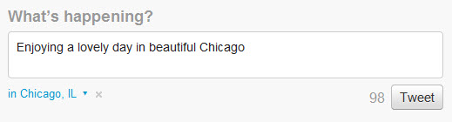

Create a search: Use the search box to create a custom search for a specific hashtag or person. Once you have searched for something, you will have the option to “Save this Search.”
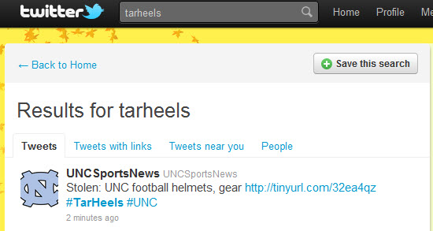

Create a custom list: Why create a list? One reason is to filter what you see in the timeline. Choose a select number of tweeters who post on a particular topic or have a particular field of expertise and create a list specifically for that topic or interest.


