Follow-up Lesson 1

Subject: Community & Culture
Title: Navigating the Community
Prepared by: J. Barnett, K. Saylor and F. Vermillion 918-485-2126 wlitgroup@yahoo.com
Name Phone E-mail
Objective/Purpose
What will be learned and why it is useful

1) Enable the participants with the knowledge of identifying and locating Business and Residents in the community as well as reading the body language of the people around me

Warm up activity  1) Facilitator/translator will handle:  - Welcome  - Pre-test  - Refreshments | Materials needed for workshop  1) Pre test  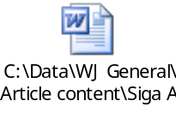  - Taken orally or written  - Adapt to locale
Learning activities  1) Finding my way  2) Body language | Materials needed for learning activities  1) Maps of the community  2) American Manners and Customs  ISBN: 0-937630-11-X  New Readers Press, $14.50  3) Power Point to adapt to locale  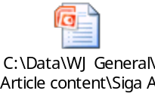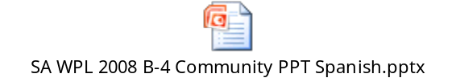

Conclusion  1) Participants will know where to go for various services in the community  2) Understanding the people around me | Materials needed for conclusion  1) Flip sheet with pictures of the various places in English and Spanish (hospitals, banks, grocery stores, library, city offices, real estate, car repair, etc.)  2) Body language information  3) Post Test  - Taken orally or written  - Adapt to locale
Extensions/Expansion/Support activities
1) Adults
- Map Quest
- Oklahoma weather
- Spanish radio stations available
2) Children
- Creating a fire truck snack—
http://www.enchantedlearning.com/crafts/edible/firetruck

Support resources/Materials/Websites (Include title, source)
- Websites
http://weather.noaa.gov/weather/OK_cc_us.html
http://www.lutz.com
http://www.enchantedlearning.com/crafts
online maps of local city, town, region, state, etc.
- Books
American Manners and Customs, New Readers Press, $14.50, ISBN 093763011X
(www.newreaderspress.com)
Community contacts/Resources

Local Chamber of Commerce
State Dept. of Transportation

