Subject: Community and Culture
Title of Lesson: History of Oklahoma
Prepared by: J. Barnett, K. Saylor and F. Vermillion 918-485-2126 wlitgroup@yahoo.com
Name Phone E-mail
Objective/Purpose: What will be learned and why it is useful

1) The objective of this activity is to share the history of our state with the participants in order to preserve the past, present and future of customs in both cultures.
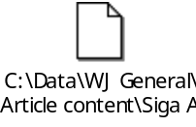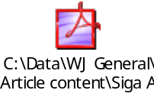
Warm-up activity  1) Facilitator/translator will handle:  - Welcomes  - Pre and Post Test  - Refreshments | Materials needed for warm-up  1) Pre Test  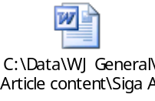  - Written or oral responses
Learning activities  1) State Matching Game | Materials needed for learning activities  - Bag of State information  - Pictures and Titles  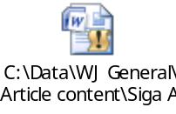  - Power Point Presentation  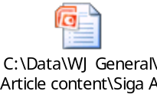  - Coloring pages  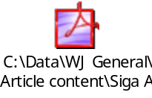

Conclusion  1) Participants will have a knowledge of the State as well as activities to play with the family | Materials needed for conclusion  1) Each participant will take home the bag of pictures and titles  2) Post Test  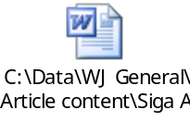
Extensions/Expansion/Support activities

1) We will be using the internet to access the facts about Oklahoma

2) Each participant will receive a book about Oklahoma
- Oklahoma (ISBN0822540983)
- S is for Sooner (ISBN1585360627)
- The Great Seal of the United States (ISBN 1404822143)

3) The kids will be making Pioneer covered Wagons
http://familycrafts.about.com/cs/groundtrans/l/blcovwag.htm

Support resources/Materials/Websites (Include title, source)

Websites:
http://www.maplandia.com/united-states/oklahoma/

http://www.infoplease.com/ipa/A0108260.html

Community contacts/Resources

Wagoner Area Chamber of Commerce
Wagoner Historical Society
Wagoner Historical Museum
Wagoner Literacy Group

