Title: The Job Interview
Follow-up Lesson 2 Subject: Employment

Prepared by: Altus Public Library/Great Plains Literacy Council khale@spls.lib.ok.us
Name e-mail
Objective/Purpose: What will be learned and why it is useful

1) Participants will learn how to prepare for a job interview
- What to do prior to the interview
- What to do during the interview
- What to do after the interview


Warm up activity  1)Facilitator/translator will:  - Pass out registration and schedule  - Present pre-test given  - Introduce the “Interview Order” Activity | Materials needed for warm up  1) Pre Test  - 5 minutes  - Written/oral  - See attached test  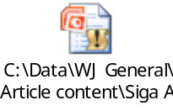  2) Interview Order activity  - The Grab Bag of Work  3) Script and Power Point on Topic  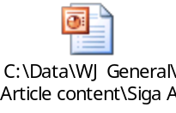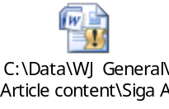
Learning activities  1)Facilitator/translator will  - show participants what they need to do before, during and after an interview | Materials needed for learning activities  1) Computer with Internet connection, In-Focus projector and screen, dry erase and/or easel board  2) Participants will receive folder with the following:  - brochure with basic information on Internet resources;  - flyer with guidelines and instructions to get a library card;  - paper & pencils  - calendar marked with future activities
Conclusion  1) Facilitator/translator will:  - have participants do post test  - have participants complete evaluation form  - answer questions and announce future activities related to the theme | Materials needed for conclusion  1) post test  2) evaluation sheet in English & Spanish  3) Calendar marked with dates of future activities
Extensions/Expansion/Support activities

Children
Children’s program will be offered for ages 3-10. see attached program description


Adults
Time will be allowed to help any adult participant to get library cards, and/or show the library facilities and where the computers for public use are located. Time will be allowed for practice to any attendee interested in searching on the Internet.

Refreshments will be served
Support resources/Materials/Websites (Include title, source)

1) See attached Sign activity 2 in English & Spanish
2) Computer, In-Focus projector and projection screen, library card applications
3) Brochures, copies, pencils, paper and calendars
4) Refreshments
5) See attached bibliography for books and references

Community contacts/Resources

