
A GUIDE TO PROPOSING AND PREPARING SCRIPTS FOR TUTORIALS
AT THE
SAN FRANCISCO PUBLIC LIBRARY

By Mark Hall and Dan Hensley

Contents
Online tutorials at SFPL 3
Have a tutorial idea? Here is what is involved: 3
Tutorial Topic Proposal 4
The Tutorial Script 5
Chart Scripts – What they are, how to make one 6
About the Chart Script 6
Left Column Guidelines 6
Right Column Guidelines 6
Appendix A – Tutorial Topic Proposal Example 8
Appendix B – Applying the Fade Effect in PowerPoint 9
Appendix C – Screenshots 10
Appendix D – File Structure Guidelines 11
Appendix E - Screencast examples from other institutions 12
Appendix F - Screencasting resources 13
Appendix G – Complete Script Example 14

Online tutorials at SFPL
Online tutorials are short videos that combine animated computer screen demonstrations with PowerPoint slides and voice narration to give, in effect, a guided tour of an online tool or resource. The San Francisco Public Library has purchased software and has trained staff to create online training tutorials for the public and is now turning to staff across the system to contribute ideas for new productions.
Content for SFPL online tutorials is to be created by the people who are most qualified to address the needs of our community – the staff that provides for San Francisco’s information needs on a daily basis. Any staff member who sees a need for a new tutorial and is able to commit to spending five to ten hours developing the idea into a production-ready script is encouraged to bring forward ideas to the Service Innovations Task Force.
Because creating these tutorials requires a significant investment of staff time, it’s important to establish a clear need for a new tutorial before proceeding with production. The tutorial proposal procedure, outlined in further detail on the following pages of this document, is designed to prioritize new tutorials so that tutorials that will provide the most value – those that are in-demand, timely, and appropriate for our community – are put into production as efficiently as possible.

Have a tutorial idea? Here is what is involved:
Do some research. The Tutorial Topic Proposal questionnaire on the next page establishes a framework for determining the need for a tutorial on a particular subject. Consider those questions and gather any other evidence that you can find.
Bring the questionnaire to the Service Innovation Task Force. Contact Brian Bannon to schedule a slot in an SITF meeting. Bring responses to the questionnaire to discuss your idea. If it is established that there is a need for the tutorial, the proposal will go to Public Services for final approval.
Once the tutorial proposal is approved, draft a script. The guidelines for scriptwriting are found later in this guide. Write a draft of the script, then format it following the “chart script” guidelines explained below. Carefully proofread and edit the script (maybe enlist colleagues to help edit) then submit it to SITF for final proofing. Once the script is ready, it will be passed to the Ethnic Services Committee for translation (if translations are necessary) and then to the Public Tutorial Committee for production.
Be available to consult with the Public Tutorial Committee. The scriptwriter’s role in production is to be available to answer questions about the script and to offer feedback on drafts of the tutorial as it is produced.

Tutorial Topic Proposal
This questionnaire is meant to help establish the need for a tutorial on a given topic. If you have an idea for a tutorial, please consider the questions below, then contact the Chief of Branches to arrange to discuss your idea at a Service Innovations Task Force meeting.
- File size is an issue – tutorials that are much longer than five minutes will be problematic for slow connections. Three minutes is a good goal.
  - Can this topic be presented in less than five minutes?
  - If not, can it be broken into smaller pieces?
- SFPL regularly tailors content (programming, websites, etc.) to specific groups. Online tutorials are prioritized in the same way.
  - Which audience does your tutorial idea address?
  - Is an online tutorial the best way (or at least a good) way to address this audience?
  - What are some challenges involved in addressing this audience (i.e. language, computer proficiency, information literacy skills)?
- In library instruction, it is important to identify concrete objectives for any learning opportunity. This practice gives a tutorial focus and keeps it us on point.
  - What are the learning objectives?
  - Use this format to frame your objective: After viewing this tutorial, the learner will [insert a skill or bit of knowledge that is an outcome of the tutorial].
- Creating a tutorial can take upwards of twenty hours of combined effort by several staff members to create. It is therefore very important that we establish and follow priorities to ensure the most effective use of our staff.
  - Does this tutorial fit into our training priorities?
  - Does this content already exist is a suitable format elsewhere? If so, can our patrons access it without cost?

The Tutorial Script
Or “What do I have to submit to the Tutorial Committee?”
A tutorial script must clearly communicate the textual content that will make up the narration (and captions) of a tutorial and the on-screen action that will make up the video portion of the tutorial. To accomplish all of that, a scriptwriter must prepare a few documents:
- An unformatted script containing only text that will be used for closed captions.
- A PowerPoint file that will be included in the tutorial during segments that do not involve a live computer screen.
- A script formatted as a table (“chart script”) that will be used to record the tutorial. See below for more details on the chart script.

There is no prescribed order for creating these documents, though it may be simplest to create the chart script last because it will contain elements of both the text and the PowerPoint slide show.
The unformatted script is a Word document that contains only the text of what will be said by the narrator in the tutorial. Formatting is not particularly important here, but the recommended procedure is to separate lines of text (containing no more than one or two sentences) with blank lines.
The PowerPoint file is a slide show that will be inputted into the tutorial only during segments where showing the computer screen (a website or computer program) is not necessary. The whole script does not need to be adapted to the PowerPoint slide show. One way to think of it is to use PowerPoint slides for explaining versus using the computer screen for demonstrating. The example script in Appendix G.
Bullet points in the PowerPoint slides should sum up what the narrator says in fewer words than the narrator will use.
There are a couple of technical specifications for tutorial PowerPoint slide shows.

- Please use the SFPL Tutorial PowerPoint template, available on Staffnet.
- Please apply the Fade transition to each bullet point. See Appendix B for instructions.
The Chart Script is explained in detail in the next section of this guide.

Chart Scripts – What they are, how to make one

About the Chart Script
To format a tutorial script for the people who will be recording it, open a new Word document and insert a table with two columns and several rows to start. That's the basic format for the chart script. The cells in the left column function as a storyboard and should include a screenshot of each screen that will be used in the tutorial. On the right side paste the text that accompanies each screen. The text can include both the actual text, to be spoken by the narrator, plus explanatory text describing mouse movements, search terms, etc.
See the guidelines below, and then have a look at Appendix A for a complete example of a chart script.

Left Column Guidelines
The left column shows the person creating the visual content of the tutorial what screens should be appear in the tutorial and the order in which they should appear in the tutorial.
- See the “Screenshots” section of this toolkit for tips about capturing images.
- For a section of a tutorial that will not include a shot of a website or computer program, please insert a shot of the appropriate PowerPoint slide.
- The screenshots from the script will not be used in the final production, so the quality of the image is not important. All that matters is that the image clearly conveys to another person what the tutorial view should see during a given passage of narration.
- It’s not necessary to insert a new screenshot in a new row for minor changes in the screen, such as filling in a text field or scrolling down a few lines. Only insert a new screenshot for significant changes in the screen that would be difficult to describe in the right column, such as a new page or scrolling down more than a few lines.

Right Column Guidelines
The right column communicates two things – the verbal content (spoken and written in captions) of the tutorial, and instructions for the people recording the tutorial about what to type, where to move the mouse, which button to push, etc. The formatting guidelines are:
- Text with no formatting – use this to write out the spoken and written text of the tutorial. The narrator will read these words.
- Text in italics – this is used to denote the action on the screen, plus any other direction that may be relevant. (a non-sfpl.org URL, for instance.)
Chart Script Key
This screenshot shows what slide from the tutorial’s PowerPoint should accompany this segment of narration.

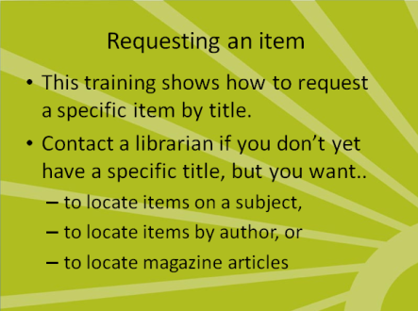 | To request an item, you must know the exact title before you begin.  For information about finding items by a particular author, items on a particular subject, or magazine articles, get in touch with a librarian at your neighborhood library.  The unformatted text indicates that the narrator should read this text in the final tutorial recording.
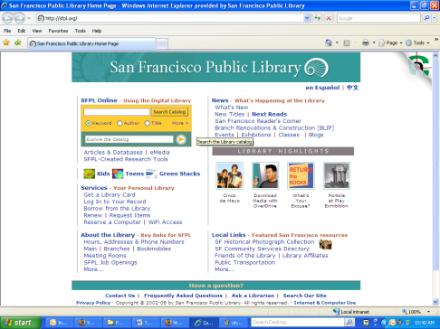  This screenshot shows which webpage should display during a particular passage of narration. | From the Library's home page, type in the title of a book, movie, or CD into the search box and then click on the "Title" button to indicate that you want to do a title search for the book. Type “omnivore’s dilemma” into search box. Next click “title” radio button.  The italicized text indicates how the person recording the screen should move the mouse and the exact search terms to use in the demonstration. Also include the URL if it is from a non-SFPL site.

Appendix A – Tutorial Topic Proposal Example
An example of a completed tutorial request. The responses to the questions and requirements are italicized.
- About the tutorial
  - Proposer: Joshua Norton
  - Topic: Using the OPAC to Request a Book
  - People and/or unit to draft the tutorial: Information Services
- Use the questions below to establish the need for the proposed tutorial. Bring your responses to the Service Innovations Task Force for discussion.
  - File size is an issue – tutorials that are much longer than five minutes will be problematic for slow connections. Three minutes is a good goal.
    - Can this topic be presented in less than five minutes? Yes, if limited to simple request.
    - If not, can it be broken into smaller pieces? N/A
  - SFPL regularly tailors content (programming, websites, etc.) to specific groups. Online tutorials are prioritized in the same way.
    - Which audience does your tutorial idea address? People who can find an item in the OPAC but don’t know how to request; people with moderate information literacy skills who can easily view and learn a specific computer skill.
    - Is an online tutorial the best way (or at least a good) way to address this audience? Yes – the demonstration can be viewed repeatedly; can be viewed in the environment in which the skill will be leaned; tutorial can be shown to users by staff.
    - What are some challenges involved in addressing this audience (i.e. language, computer proficiency, information literacy skills)? OPAC available in Spanish and Chinese; basic understanding of OPAC necessary to proceed with placing a hold.
  - In library instruction, it is important to identify concrete objectives for any learning opportunity. This practice gives a tutorial focus and keeps it us on point.
    - What are the learning objectives?
      - After viewing this tutorial, a user will:
        - Understand the procedure for requesting a known item through the SFPL OPAC.
          - Understand that library staff can assist in learning how to locate an unknown item.
        - Understand the procedure for entering a library card number and PIN, and selecting a location.
          - Know how to find their library card number and what to do if they don’t know their PIN
  - Creating a tutorial can take upwards of twenty hours of combined effort by several staff members to create. It is therefore very important that we establish and follow priorities to ensure the most effective use of our staff.
    - Does this content already exist is a suitable format elsewhere? If so, can our patrons access it without cost? No, because this is an SFPL-specific skill. Patrons would benefit from seeing our OPAC interface.

Appendix B – Applying the Fade Effect in PowerPoint

Apply the Fade animation in PowerPoint to each bullet point so that each point will fade onto the screen while the narrator speaks. To apply this animation, click on Custom Animations under the Animations tab in PowerPoint.

Highlight the text in the first bullet point on the first slide, then click on Add Effect, then Entrance, then Fade in the Custom Animation box on the right-hand side of the screen.
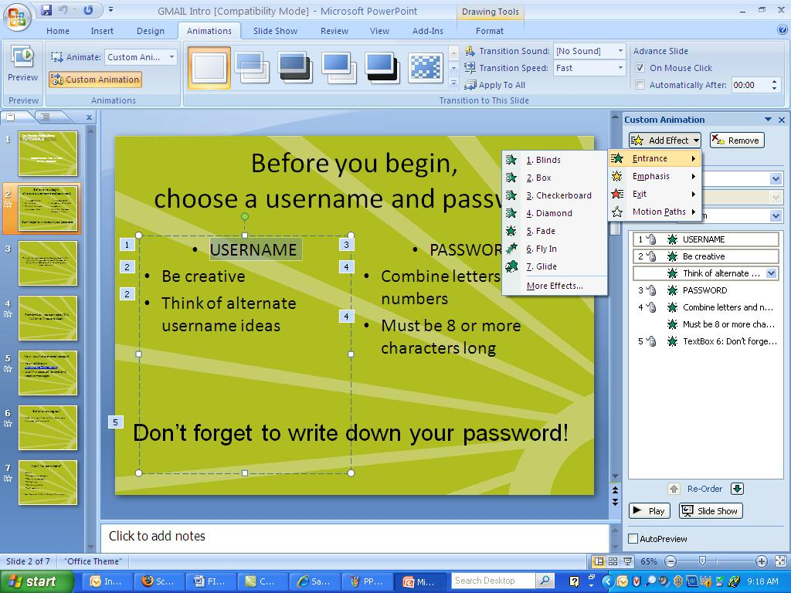

Repeat those steps for each bullet point.

Appendix C – Screenshots
A screenshot is a static image of a computer screen that has been saved as an image file. Screenshots are used in a script to indicate the visual content of part of the tutorial.
It is not necessary for the person drafting the tutorial script to worry much about the quality of a screenshot. The important thing is that the screenshot clearly conveys to the production team which page should be used to create the final version of the tutorial.
To create a screenshot:
- Bring up the target page on the screen.
- Press the Print Screen (Print Scrn.) key, located to the right of F12 on most keyboards.
- Open Microsoft Paint, found under Start menu – All Programs – Accessories
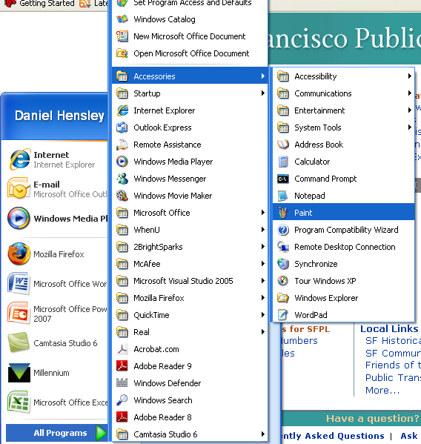
- With Paint open, press ctrl + V to paste the screenshot into the Paint file.
- Save the file as a JPEG. This image can now be imported to Word.
- To import the JPEG into your chart script, place the cursor in the appropriate cell in the table Word.
- Under the Insert tab, click Picture, then browse to the JPEG that you created in Paint.
- Word will paste a very large JPEG into the table; to resize it, grab the bottom right-hand corner of the picture with the left mouse button and drag it to an appropriate size.

Appendix D – File Structure Guidelines
Each tutorial has to go through several people during its creation. To prevent confusion and misplaced documents, each tutorial should have a project folder that follows the following structural guidelines:
Project Folder – (Named after the tutorial subject)
- Script Folder
  - Chart scripts in all languages
  - Unformatted scripts in all languages
  - Screenshots used for the chart script

- PowerPoints Folder
  - All PowerPoints used for the script and the tutorial recording
- Camtasia Working Folder
  - The CamProj file
  - All CamRec files

- Produced Tutorial Folder
  - Containing the files for the finished, produced tutorial

Appendix E - Screencast examples from other institutions
Cornell University's Olin Library: http://library.cornell.edu/olinuris/ref/oupodcasts.html

Stanford University's Cubberley Education Library: https://www.stanford.edu/group/cubberley/services/tutorials

Nashville Public Library (another III user):http://www.library.nashville.org/services/ser_training.asp

Examples from the Steve Garwood workshop:
http://screencasting.pbwiki.com/screencastexamples
http://www.stevegarwood.com/scils25/

Lansing Library, IL: http://www.lansing.lib.il.us/tutorials/items_due/items_due.html

Rockaway Township Free PL: http://www.rtlibrary.org/Howtos.html

Greg Notess' blog post on Public Library Screencast examples:
http://www.notess.com/screencasting/examples/public-library-examples/

Enoch Pratt Free Library, MD: Show-Me-Guides (screencasts): http://www.prattlibrary.org/findanswers/how_to.aspx?id=15078

Google UK's "Things to do" page of tutorials: http://www.google.co.uk/landing/thingstodo/
Flint Public Library "Charts & Graphs in Word" tutorials
http://www.flint.lib.mi.us/kidsweb/extras/makeachart/index.html

Appendix F - Screencasting resources
Wikipedia entry on "Screencast": http://en.wikipedia.org/wiki/Screencast

A Quick Guide to Screencasting for Libraries, from iLibrarian - an excellent set of resources & examples; See especially the last section:
http://oedb.org/blogs/ilibrarian/2008/a-quick-guide-to-screencasting-for-libraries/

Steve Garwood's InfoPeople Workshop on Screencasting in libraries:
http://www.infopeople.org/training/past/2008/screencasts/

"Mashable" technology blog post from Februrary 2008: "12 Screencasting Tools for Creating Video Tutorials" : http://mashable.com/2008/02/21/screencasting-video-tutorials/

Appendix G – Complete Script Example
Below find the three components of a completed script. This example is from the Reserve a Computer tutorial.
Unformatted Script Example: Reserve a Computer
Anyone with a San Francisco Public Library card can reserve a computer in any of the library’s locations. Each cardholder can use a computer for up to one hour every day.
These computers can be used to access the Internet and to use Microsoft Word and Excel.
In the Main Library, computer sessions last the entire allotted hour; in the branches, the sessions are 30 minutes long, and may be booked in two non-consecutive sessions.
You may book a computer from any public library using a catalog computer or from any personal computer connected to the Internet.
To book a computer, begin at the Library’s home page.
Click on Reserve a Computer under SERVICES.
A Box will appear reminding you to logout when you are finished; click OK
To reserve a computer, you will need to enter your library card number and PIN number.
The library card number can be found on the back of your library card.
Your PIN number is the password that you can use to access your library account. If you don’t know your PIN, or if you don’t have one, please call or visit your neighborhood library.
Type in your library card number and your PIN number.
By clicking on “submit” you are agreeing to abide by the library computer use rules. You can read these rules by clicking on Library Computer Use above the submit button.
When you are ready, click submit.
Click the arrow to the right of the box that says “Select a branch.”
Scroll down and select the library branch where you would like to use a computer.
Next, click on Search by PC Type – Select Desktop and click Submit
Note that you can book a computer for today, tomorrow and/or the following day. To make a reservation, click on the word available next to the day and time you want to reserve the computer
You will get a box letting you know that your booking was successful. Click on OK
Please note that you will be assigned a computer and that you cannot request to use a particular machine within a branch or at the Main.
Write down the computer name, date and the time so that you can find the computer at the appropriate time.

PowerPoint Example: Reserve a Computer
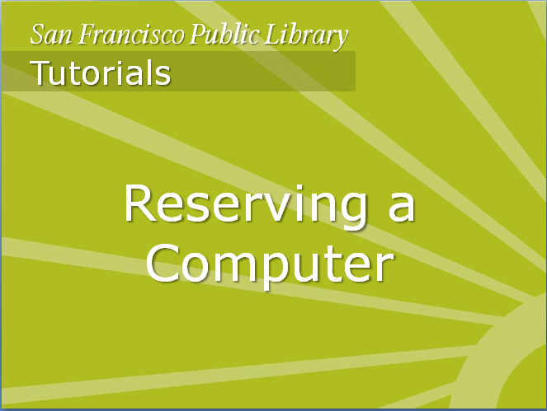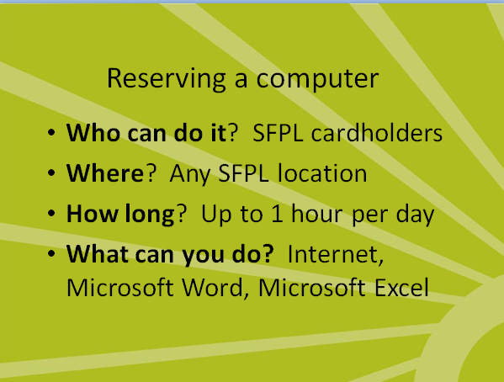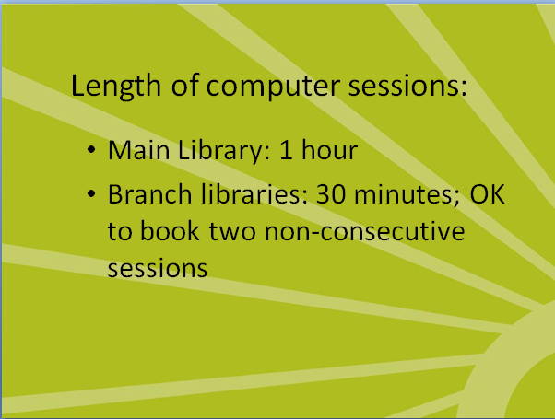
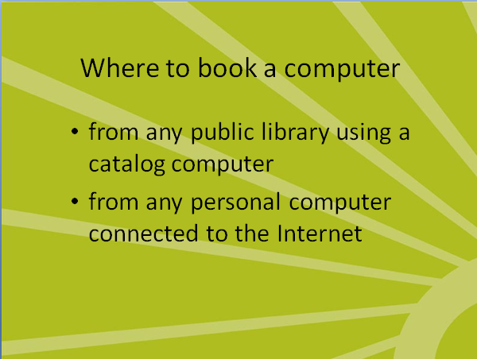
Chart Script Example: Reserve a Computer

 | This is a San Francisco Public Library Tutorial on Reserving a Computer.
Anyone with a San Francisco Public Library card can reserve a computer in any of the library’s locations. Each cardholder can use a computer for up to one hour every day.
These computers can be used to access the Internet and to use Microsoft Word and Excel.
In the Main Library, computer sessions last the entire allotted hour; in the branches, the sessions are 30 minutes long, and may be booked in two non-consecutive sessions.
(Callout box added later; no audio as it was added afterwards. Callout box reads:
“NOTE: Four branches offer 1 hour bookings: Excelsior, Mission Bay, Ocean View, and West Portal.”)
 | You may book a computer from any public library using a catalog computer or from any personal computer connected to the Internet.
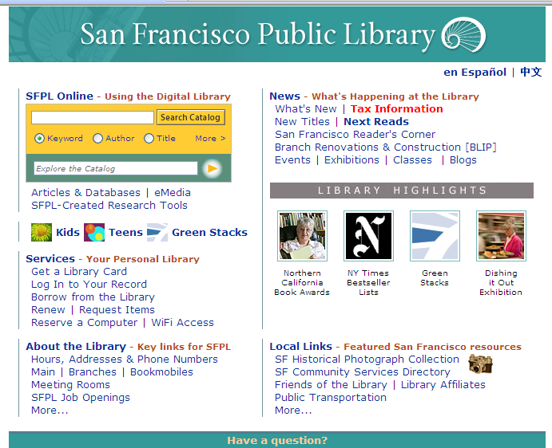 | To book a computer, begin at the Library’s home page.  Click on Reserve a Computer under SERVICES.
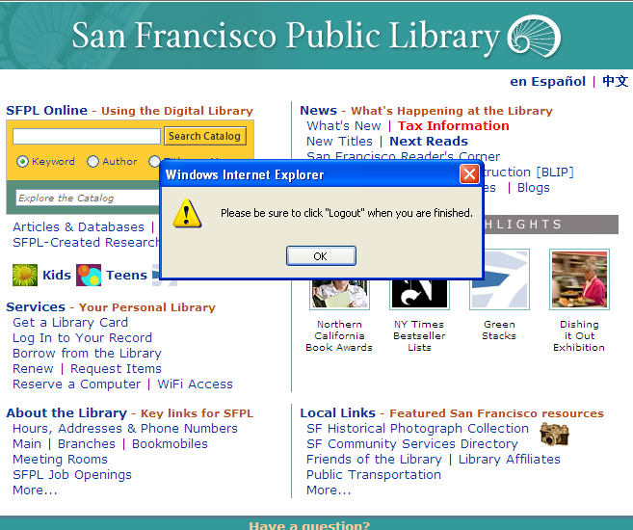 | A Box will appear reminding you to logout when you are finished; click OK
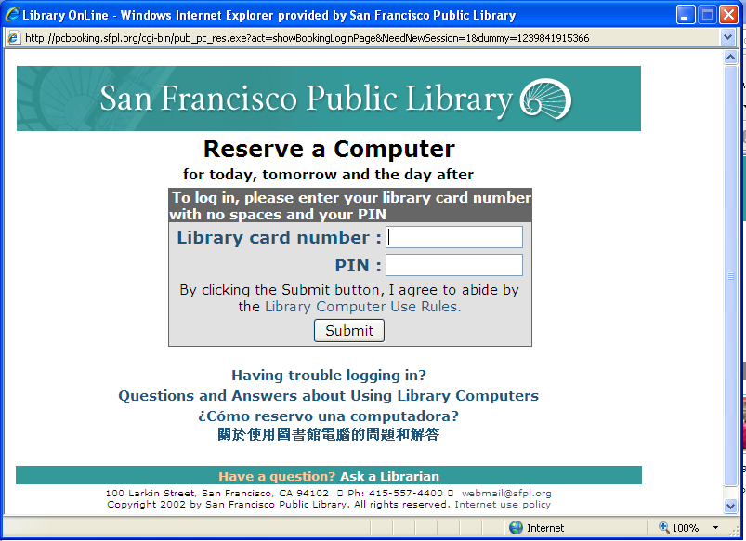 | To reserve a computer, you will need to enter your library card number and PIN number.  The library card number can be found on the back of your library card.  Your PIN number is the password that you can use to access your library account. If you don’t know your PIN, or if you don’t have one, please call or visit your neighborhood library.  Type in your library card number and your PIN number.  By clicking on “submit” you are agreeing to abide by the library computer use rules. You can read these rules by clicking on Library Computer Use above the submit button.  When you are ready, click submit.
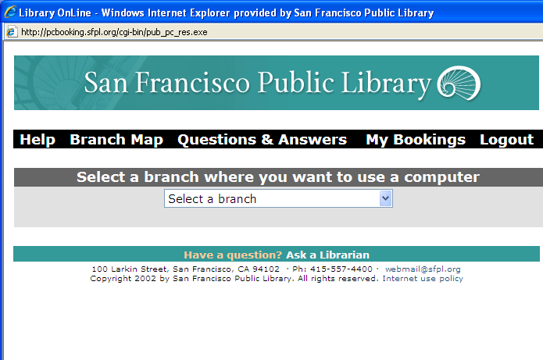 | Click the arrow to the right of the box that says “Select a branch.”  Scroll down and select the library branch where you would like to use a computer.
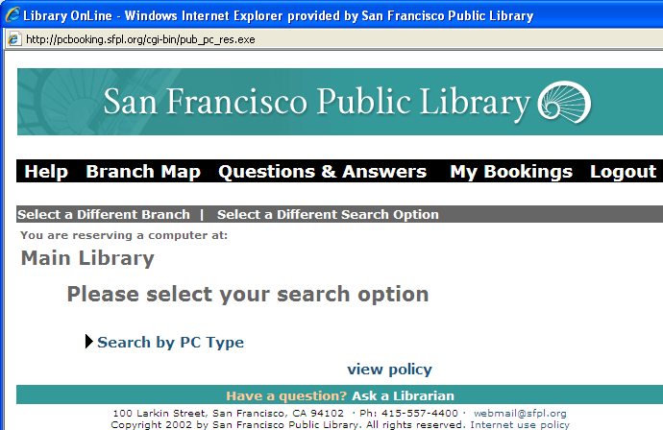 | Next, click on Search by PC Type – Select Desktop and click Submit
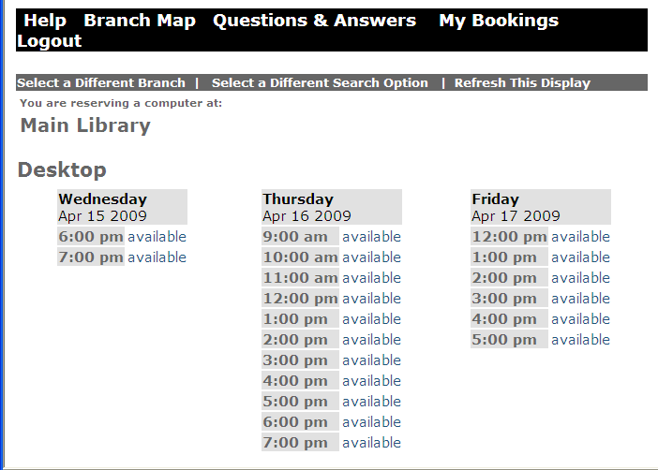 | Note that you can book a computer for today, tomorrow and/or the following day. To make a reservation, click on the word available next to the day and time you want to reserve the computer
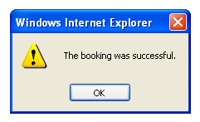 | You will get a box letting you know that your booking was successful. Click on OK
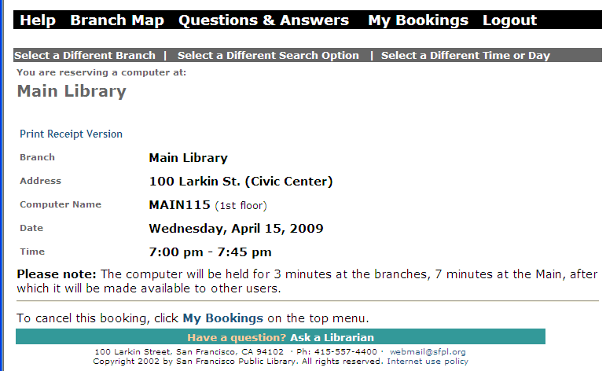 | Please note that you will be assigned a computer and that you cannot request to use a particular machine within a branch or at the Main.  Write down the computer name, date and the time so that you can find the computer at the appropriate time.  If you want to make multiple reservations, click on select a Different Time or Day  Remember to click logout at the top of the window and close the window at the end of booking for your security.  As a Reminder: The computer will be held for 3 minutes at the branches, 7 minutes at the Main, after which it will be made available to other users.
 | For more information about library resources, services, and contact information, please visit us on the web at www.sfpl.org.

