From November 24 to December 17, 2010, WebJunction and the State Library of North Carolina surveyed 35 public library staff in 12 states about their accomplishments, needs and priorities for building workforce recovery programs and services. Survey responses are used to help shape the Project Compass training curriculum, localized workshop curriculum and future online programs.
Question 1: What state and county is your library in?

Library staff in high unemployment states and counties were asked to participate in the survey. The following states responded to the survey:

- Alabama
- Florida
- Georgia
- Illinois
- Indiana
- Michigan
- New Jersey
- North Carolina
- Ohio
- Oregon
- South Carolina
- Tennessee

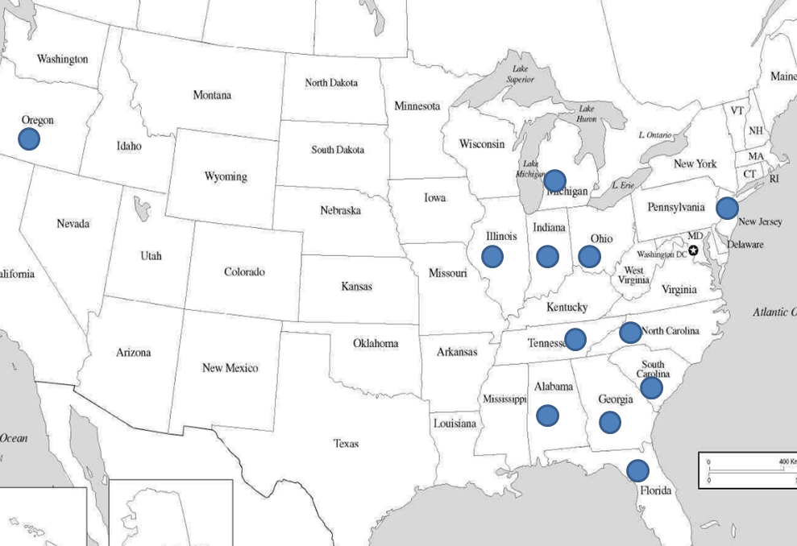
Question 2: On a day-to-day basis, what percentage of time do you spend providing direct service to your library customers?

Just about half of survey respondents spend more than 50% of their time at front lines.

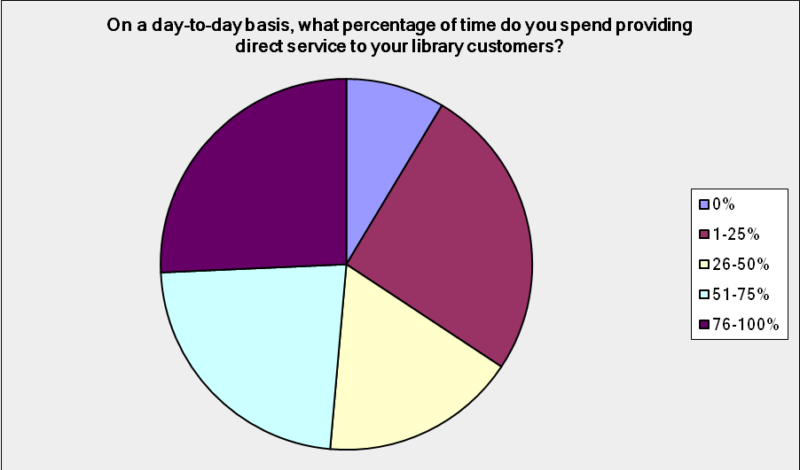

Question 3: Rank your library's priorities for providing your library users the following services from low (not important) to high (very important).
Providing direct assistance, databases and other resources to job seekers is a high priority for most public libraries.

Providing computer training and pursuing partnerships with other agencies is high priority for two-thirds of libraries.

More than half of libraries view providing services and programs to the unemployed as high priority.

One third of libraries make small business and financial literacy services and resources a high priority.

Answer Options | low priority | medium priority | high priority | N/A
Assisting job seekers | 1 | 3 | 31 | 0
Databases and resources for job seekers | 1 | 8 | 26 | 0
Computer training | 2 | 8 | 24 | 1
Partnerships with other government, school or non-profit agencies | 2 | 9 | 23 | 1
Networks, services and programs for the unemployed | 3 | 10 | 20 | 2
Financial literacy resources and programs | 3 | 19 | 11 | 2
Assisting local small business development | 4 | 17 | 12 | 2
Databases and resources for small business development | 5 | 16 | 12 | 2

Question 4: Rank your library's performance in delivering these services from low (we don't do this) to high (we do this very well).
Just over half of libraries feel they are high performers in direct assistance, resources, and databases for job seekers.

Just under half feel they are high performers in computer training and forming partnerships with other agencies. These areas were rated as high priority areas for libraries.

Libraries rate themselves as low to medium performers in areas of small business services and resources (medium priority), financial literacy programs and resources (medium priority), and services to the unemployed (high priority).

Answer Options | low performance | medium performance | high performance | N/A
Assisting job seekers | 4 | 12 | 19 | 0
Databases and resources for job seekers | 6 | 9 | 20 | 0
Assisting local small business development | 11 | 17 | 5 | 2
Databases and resources for small business development | 12 | 15 | 7 | 1
Computer training | 5 | 12 | 16 | 2
Partnerships with other government, school or non-profit | 2 | 16 | 15 | 1
Networks, services and programs for the unemployed | 9 | 17 | 8 | 0
Financial literacy resources and programs | 13 | 14 | 6 | 2

Question 5: Please tell us about any additional needs of the unemployed in your community and/or how your library has responded.
Additional needs fell into the following categories:
- Tools for patrons (e.g., GED materials, obtaining benefits, social security, etc)
- Technology upgrades
- Patron training
- Improved patron service (e.g., patrons over 55, ESL, disabled, etc)
- Space
- Community services (e.g., connecting patrons to food, health, housing, etc)

Additional responses fell into the following categories:
- Partnership with local workforce agency
- Additional workshops/training for patrons in (e.g., financial literacy, GED, ESL, etc)
- Providing job search resources online
- Providing additional computer stations

Question 6: In an ideal world where funding and staffing are unlimited, what services would you provide to address the needs of the unemployed/underemployed in your community?
Biggest items on the wish list: increased computer and internet access, and lots of training for patrons on (1) computer literacy, (2) full range of job seeking skills and other important skills like literacy and e-government. Only one respondent mentioned staff training, more mentioned the need for additional staff, space, and resources to be able to serve these needs effectively.

