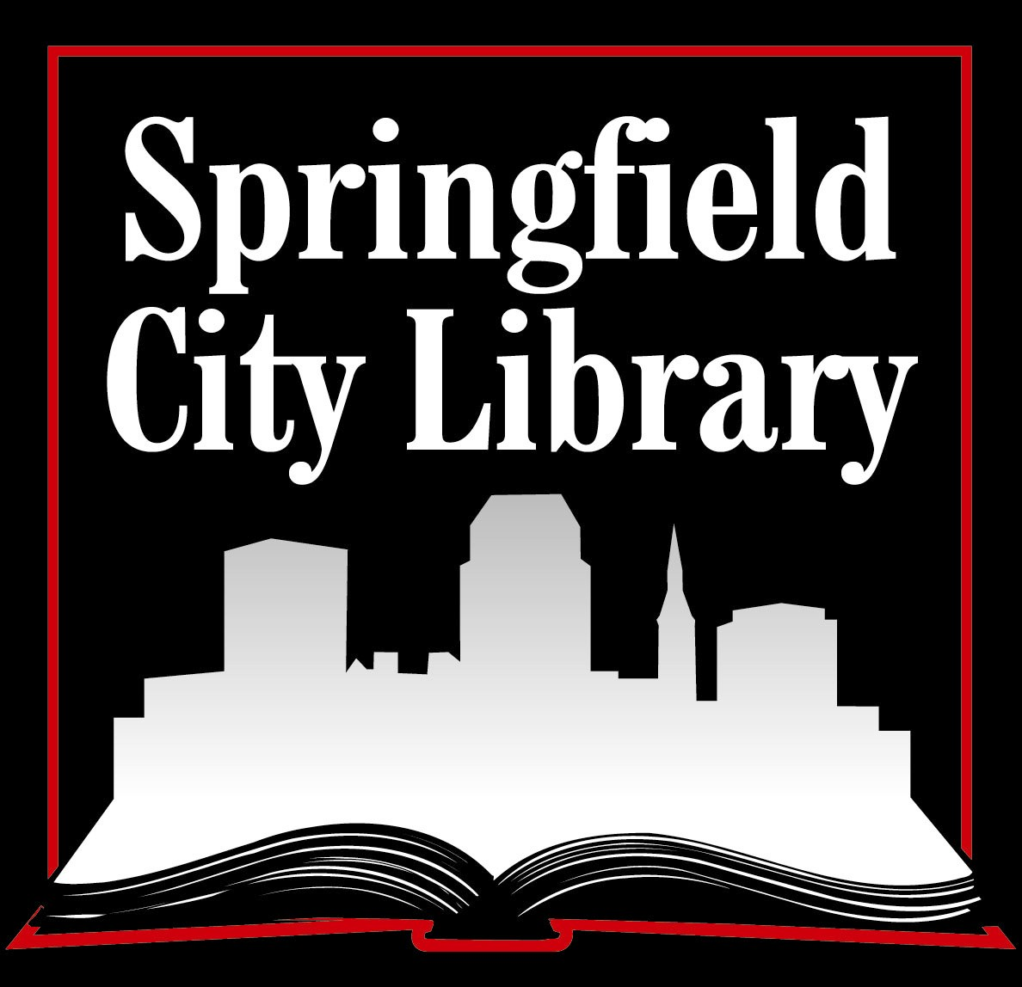
Springfield City Library – A Place for You!

Springfield City Library offers educational and entertaining programs for adults, teens, and children. In order to ensure the program calendar meets the needs and interests of the community, we are seeking your opinions about the kind of events you would attend at the Library. Please answer these questions, add any other comments you have, and return this survey by June 30th to any Springfield City Library location or mail to Jean Canosa-Albano, Springfield City Library, 220 State Street, Springfield MA 01103.

- Please describe yourself.
◻ Male ◻ Female Age: ◻ under 12 ◻ 12-18 ◻ 19-35 ◻ 36-49 ◻ 50-69 ◻ 70+

2. Do you live in Springfield? ◻ Yes ◻ No If Yes, what neighborhood: ________________________________

3. How often do you use Springfield City Library for study, entertainment, research, reading, computer use, or attending programs?

◻ Daily ◻ Weekly ◻ Monthly ◻ Once a Year ◻ Never

(if “never”, why?) _________________________________________________________________________________________

4. Please check branch or branches do you usually use, and circle the branches where you would be willing to attend programs.
◻ Central Library ◻ Brightwood ◻ East Forest Park ◻ East Springfield
◻ Forest Park ◻ Indian Orchard ◻ Liberty ◻ Mason Square
◻ Pine Point ◻ Sixteen Acres

5. What time of day do you prefer to attend a program?
◻ weekday mornings ◻ weekday afternoons ◻ weekday evenings ◻ weekends

6. How do you prefer to learn about programs, cultural events, performances and other things to do? Please check all that apply.

Newspapers | Radio/TV/Online | Community
◻ The Republican | ◻ Springfield City Library Website | ◻ My neighborhood council
◻ Valley Advocate | ◻ Cable Community Access station | ◻ From friends
◻ El Pueblo Latino |  | ◻ In my apartment building
◻ The Reminder | ◻ These TV stations (please list): | ◻ At the Library
◻ Ludlow Register |  | ◻ At my religious service
◻ Afro-American Point of View | ◻ These radio stations (please list): | ◻ Community bulletin boards
◻ Other Community newspapers (please list): |  | ◻ My child’s school
 | ◻ Other Websites: | ◻ Other:

7) Is there anything stopping you from using Springfield City Library?

(over )
8) Here are some ideas for programs that could be offered by Springfield City Library. Please mark the TEN programs you would be most interested in attending.

Art/Culture/Society
- The Titanic Museum | - Meet your government reps | - Dramatic presentations
- Comparative religion | - Magic shows | - Fashion show
- Film series | - Talks and slides about travels | - Local history and architecture
- Speeches by local personalities (please list): | - Musical performances (please list): | - Panel discussions on current events (please list):
Books/Literature
- Book discussion groups | - Storytimes | - Short story readings
- Anime and manga | - Author visits | - Poetry readings
- Storytelling for adults
Competitions
- Soduko tournament | - Board game tournaments | - Trivia contest
- Scavenger hunt | - Set a world record
Family/Wellness
- Parenting skills/discipline | - Health topics such as nutrition, healthcare and exercise | - Children’s health and safety
- Parenting topics such as living with teens, raising a bilingual child, etc…
Hobbies
- Urban gardening | - Photography | - Cooking demonstrations
- Inventions | - “Altered” fashion | - Drawing and cartooning
- Mythology | - Home décor | - Bike repair/tune-up
- Sewing, quilting & needlecrafts | - Collecting and appraisals | - Arts and crafts activities
- Online buying and selling | - Astrology, tarot reading | - Ghosts and paranormal activity
Learning
- Writing workshops | - Career exploration | - Animal programs
- GED and citizenship training | - How to buy a home | - Fundraising/grant writing
- Table top science experiments | - SAT preparation | - Science fair preparation
- Computer workshops | - Financial aid preparation | - Planning for life after retirement
- Research techniques and trends in book publishing | - Financial planning and money management | - Legal issues-the Homestead Act, health care proxies, writing a will
- Consumer protection topics such as using the Internet safely, learning about recalls | - Lecture by Merriam-Webster representative on topics such as new words | - Conversation circles, for English learners
- Creating digital films on your computer | - Getting into the music business | - Conversation circles (what topics interest you?)

9) OPTIONAL: If you would like to be contacted, please leave your name here or contact Jean Canosa-Albano, 263-6828, ext. 291 or jcanosa@SpringfieldLibrary.org

Name:
Phone:
E-mail address:
Please contact me about:

Thank you!

