The Power of Image: presenting with the brain in mind

Event Description: Understand how the brain responds to images, increase your recognition of the effect of images, and learn some basic principles and design guidelines to create more visual impact in your own presentations. Presented by Betha Gutsche, WebJunction Programs Manager.
What are your goals for viewing this webinar?
Personal Goals
Team Goals

Discussion Question
Look around your environment for an example of an image that evokes your emotions, either positively or negatively. What message is it intended to convey, e.g. is it trying to sell you something? Do you find it effective?

Exercise #1: reduce and simplify
The slide on the right communicates essentially the same message and data as the one on the left. Which graphic elements grab attention first? Which convey emotion? Discuss the effectiveness of each message.

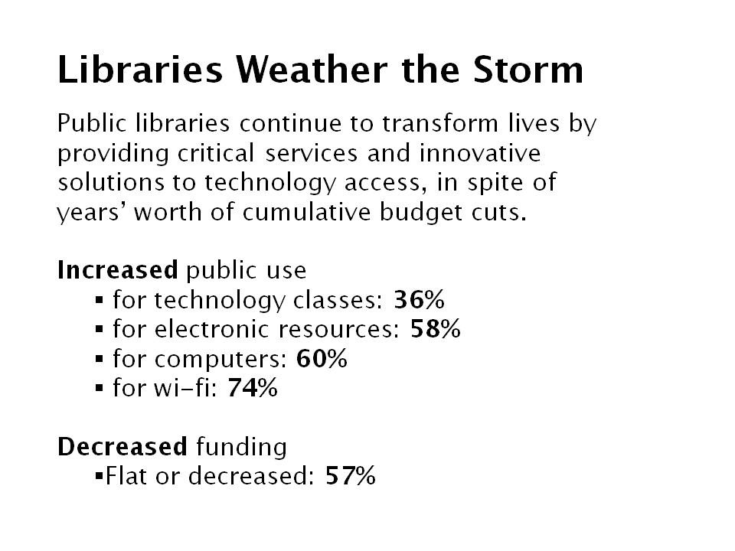
Exercise #2: image trumps text
Look at a PowerPoint presentation (your own or other) and find at least one instance where an image would work much better on its own than the equivalent text.

Exercise #3: avoid chart-junk
Chart-junk is everywhere. Find an example and identify the key data that you would highlight in a simplified slide like the one on the right.

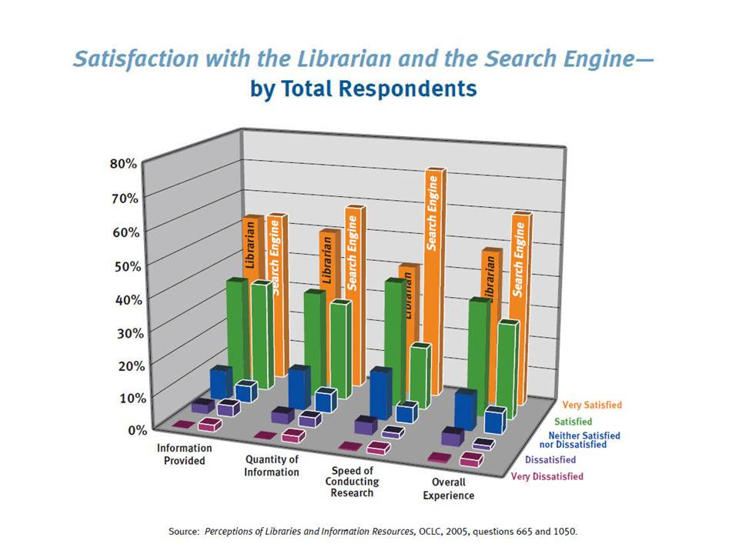 | 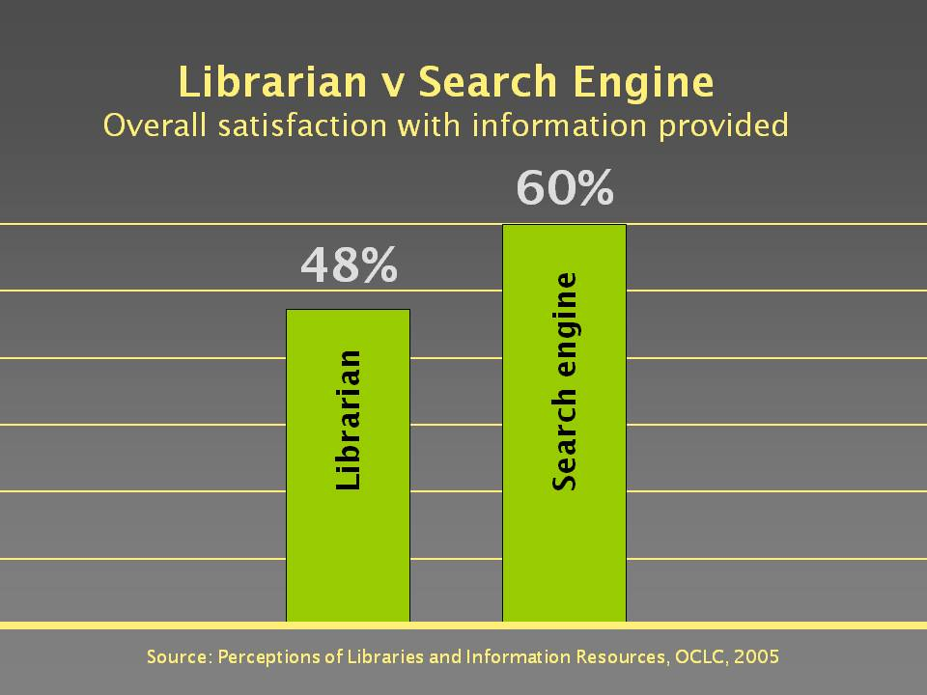

Exercise #4: the Big 4 design guidelines
How many instances of the Big 4 design elements can you find in this slide? List them on the right.
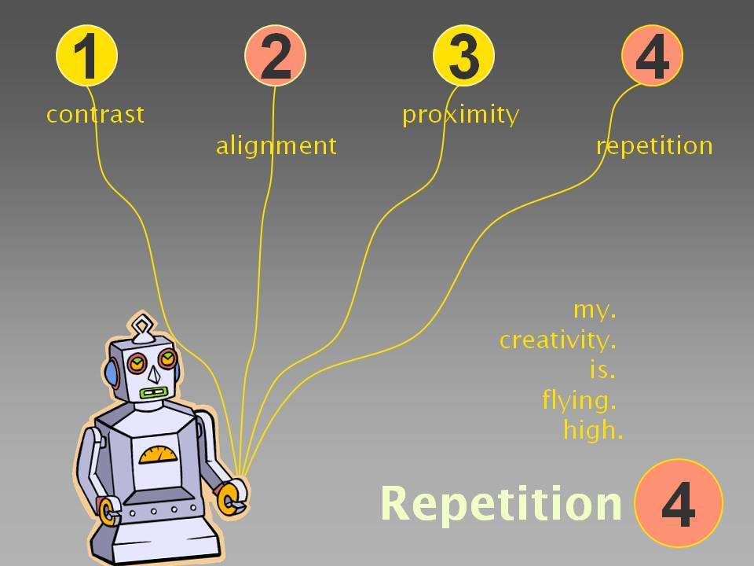

Exercise #5: alignment
Try the “alignment and order” exercise in the Practical PowerPoint handout.

Action Plan
How will you put the Power of Image principles and guidelines into action?

NOTES

