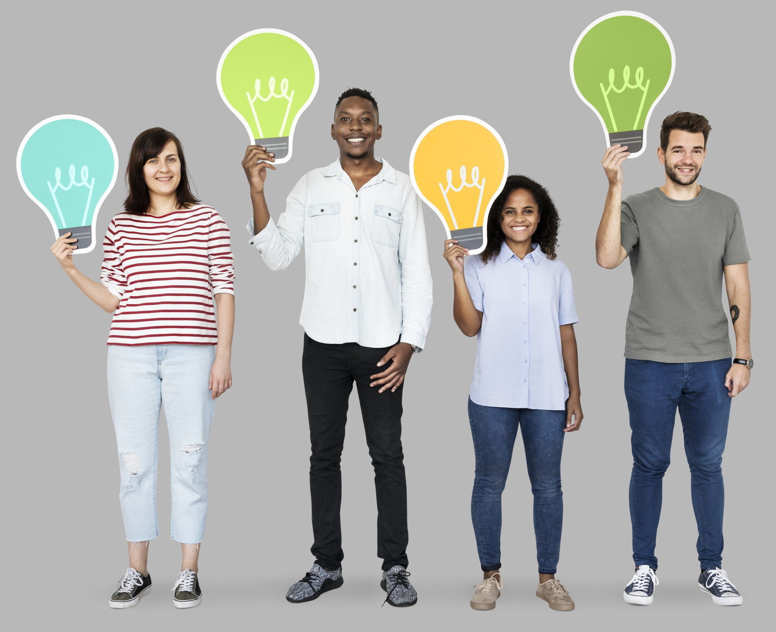

Learning Group Facilitation Guide

Learning Group Facilitation Guide

Introduction

What is a learning group?
A learning group is a study group where people learn together, often through one or more self-paced courses on a specific topic. The process is collaborative. Members set goals together, move through the material at the same pace, and meet regularly to discuss learning.

Why learning groups matter
Learning on your own can feel isolating and makes motivation difficult to maintain. A learning group connects you with peers who understand your work and challenges, creating space to share ideas, solve problems together, and determine how to apply what you're learning.
Learning together creates peer motivation and accountability, helping people apply new skills in their daily work. Diverse perspectives strengthen problem-solving and build team connection. Over time, learning groups model a sustainable culture where growth is valued and ongoing—not a one-time event, but a regular practice.
Self-paced courses and webinar recordings offer flexibility and quality without requiring an expert facilitator or trainer. When you combine self-paced learning with a group setting, you create space for discussion, accountability, and shared application—and the entire library benefits.

Facilitator role and duties
Learning groups need someone to bring people together, keep them on track, and create the conditions where learning can thrive. That person is the facilitator.
As a facilitator, you are not a teacher, and you don't need to be an expert on the topic. The job has two main parts, which can also be done by different people:
- Convene and coordinate the group: Handle the planning and logistics—things like scheduling and choosing a topic.
- Facilitate discussions: Build connections, model good learning habits, and create an environment where learning leads to action. This includes things like setting group norms, preparing discussion questions, and helping members connect what they're learning to their real work.

Planning and logistics
Before you launch your learning group, you'll make decisions across five key areas: why, what, who, where, and when. These decisions shape everything about your group—how it functions, who participates, and how successful it will be.
You don't have to figure it all out before you start, or even in that order. A co-facilitator might handle logistics while you focus on leading discussions, for example. The planning phase typically takes 4–6 weeks before your first meeting.

Why: Set your goals
What outcomes would success look like? How does this learning align with your organization's priorities? Answering these questions will help you determine your topic and design your group.
Setting clear goals gives your learning group direction and helps you measure impact. When you know what you're trying to achieve—whether it's improved practices, stronger team connection, increased confidence, or something else—you can design your group to support those outcomes. Goals also help you communicate the value of the learning group to leadership and stakeholders. They want to know what difference this will make.
Think about what success looks like for your library. Is it staff feeling more confident in a particular skill? Is it improved collaboration or communication? Is it better service to your community? Once you're clear on your goals, you can choose a topic and course that directly supports them.

Why: Make the case
To get support for a learning group, make the case to leadership. Start with the problem: What gap or challenge exists? What skills or knowledge do people need? Then explain how a learning group addresses it.
Emphasize the practical benefits: learning groups require minimal resources—mostly time and commitment. They don't need an expert facilitator or expensive training. They use the knowledge people already have. Highlight what success looks like: improved practices, stronger team connection, better retention of learning.
Most importantly, frame the learning group as a way to build a sustainable culture where learning happens regularly and is valued by the organization. By connecting the learning to your library's priorities, you can secure the buy-in and support your team's needs.

What: Choose your topic
Now that you've set your goals, decide what you'll learn about. Your topic should connect to your goals and be something your potential group members care about.
Choosing a topic is about finding the intersection of three things: what your library needs, what your team is interested in, and what learning resources actually exist. You don't need to pick something obscure or cutting-edge. Often the most powerful learning groups focus on foundational skills or practices that your team wants to strengthen.
When you're thinking about a topic, consider what would make a real difference in your daily work. Is there a skill people struggle with? A practice you want to improve? A challenge that keeps coming up? That's often where the best learning groups start.
Once you have a topic in mind, browse available courses or resources. WebJunction offers a free catalog of self-paced courses and webinars built for library work.

What: Pick your courses
Self-paced courses vary in length and time commitment. You might focus on a single course, combine several courses or webinars, or follow a multi-course learning path that's already designed for you. Once you pick a course or courses, you'll have a clearer sense of how long it will take, what topics you'll cover, and what to propose to your colleagues.
Not sure where to start? Here are two examples from WebJunction's catalog:
Short-term option: Libraries foster social connection: responding to the epidemic of loneliness and isolation is a one-hour webinar with a learning guide. Group members can watch independently, then meet for a one-hour discussion to connect the content to your library's work. This is a great starting point for a first learning group.
Longer-term option: Digital Collections Stewardship is a seven-part series designed for sustained engagement. With a clear learning path and built-in learning guide, it works well for groups ready to commit to deeper learning over several weeks.

Who: Build your group
Now that you've chosen your topic and course, think about who should join your group. Will this be people who work together in the same location? Maybe it will include others in your library system, or even just those doing similar work at different libraries.
Smaller groups of four to eight people tend to work best for discussion-based learning. In a group that size, everyone gets a chance to talk, and people feel comfortable sharing ideas. Logistics are also easier for a smaller group—it's simpler to find a time that works for everyone and to manage the space.
Think about who would benefit from this learning and who would bring valuable perspectives to the group. You might invite people from different departments or roles, so the group has diverse experiences to draw from. You might also think about whether you want a co-facilitator to help share responsibilities—someone to handle logistics while you focus on discussions, or to divide the work based on your strengths. Remember, neither of you needs to be an expert on the topic.
Consider how you'll spread the word and whether you need to get buy-in from leadership. If people need to attend during work hours, you'll likely need support from their supervisors. If you're inviting people from across your library system, you'll likely need support from leadership.

Where: Pick your space
Where you meet matters. You have three options: in person, online, or blended.
In person works well when everyone is from the same location and you want to take advantage of being physically together. This can be the most desirable option if location and scheduling make it possible. You can do activities that require being in the same room, and people often feel more connected when they meet face-to-face.
Online works well when participants are spread across a larger area since no one has to travel. You'll need a solid tech setup and intentional ways to keep people engaged, but online meetings offer flexibility and accessibility for people with different schedules or mobility needs. In many situations it is the most convenient, though some people will miss the in-person interaction.
Blended learning combines both in-person and online elements. It takes more coordination, but it offers great flexibility. For example, libraries in Texas used a blended approach when learning about WebJunction's course Supercharged Storytime. They met online regularly and then came together in person for special events to share ideas and go deeper on key concepts. This gave people the convenience of online learning and the stronger connections that come from meeting face-to-face.
No matter which you choose, think about accessibility from the start. Can people get there? Do they have the technology they need? Will anyone need accommodations like captions, large print, or tech support? Asking these questions early prevents barriers later.

When: Set your schedule
Timing involves two things: scheduling your meetings and planning what will happen between them.
For a short course or a single webinar, you may only need one session. For longer or multiple courses, you'll likely meet multiple times as your group works through the material. Think about how often your group will meet and how long each meeting will be. Weekly meetings keep momentum going but require more commitment. Monthly meetings give people more time to complete the course material but can feel disconnected.
In most learning groups, members need to plan their own time spent in the self-paced course, and maybe other activities between meetings. As the facilitator, you should make sure the expectations about time spent outside of meetings are clear and there is group consensus about them. If the course is short, this may mean everyone completes it before meeting to discuss the entire course. For longer or multiple courses, you may break the learning into smaller segments between sessions. If you are unsure about the pacing, a good approach is to plan the first learning time and discussion session, then agree as a group on how much more time you need for the rest.

Facilitation
Now that you've planned your learning group, it's time to facilitate it. Facilitation happens in three phases: Prepare, Facilitate, and Follow Up. Each phase is important for creating a successful learning experience.
In this section, you'll find guidance for each phase, along with practical strategies for setting group norms, planning discussions, managing different formats, and keeping momentum going after each session.

Phase 1: Prepare to facilitate
Preparation is where you lay the groundwork for a successful learning experience. Before your first session, you'll plan your discussions, adapt the learning to your group's needs, and prepare your space. The time you invest here will pay off when you're facilitating.

Plan discussions and activities
One of the biggest benefits of a learning group is the chance to discuss ideas and practice skills together. As the facilitator, you'll want to come prepared. Before your first session, spend time with the learning content to identify: learning objectives, key topics, and opportunities for reflection and workplace application. Once you've pinpointed these elements, create discussion questions and activities that help learners connect the content to their own experience.
Many courses include learner guides with reflection questions and activities built in—these provide a shared language for group discussions and concrete ways to apply learning together.
If your course doesn't include a guide, use these strategies to craft your own questions and activities:
- Review the learning objectives and section titles to spot natural discussion points
- Look for concepts or examples that connect to your library's context and work
- Create discussion questions that invite learners to share their experiences, perspectives, and challenges related to the content. Consider using these frameworks for questions:
  - Have you experienced [context from this course]? What happened?
  - How might [skill or idea] play out in [specific context]?
  - What would make [recommended best practice] difficult to implement here?
- Design activities that give learners a chance to practice skills and reflect together. Activity ideas include:
  - Group brainstorms
  - Role-playing scenarios
  - Think-pair-share prompts (where small groups think together and then share with the group)
  - Quick-write reflection prompts
Consider sharing your planned questions with the group before the session so they can come prepared with examples and ideas of their own.
Example 1: For a course on serving people experiencing homelessness, ask learning group members to prepare by reviewing your library's policies related to patron conduct and safety. At the meeting, ask participants to share their experiences and challenges in applying these policies equitably and with dignity. Work together to propose solutions that balance safety with inclusive service.
Example 2: For a course on how to conduct a reference interview, arrange for learning group members to pair up and practice conducting a simulated interview with each other. Then come together as a whole group and reflect on the practice—what worked well, what could be improved?

Adapt learning to your group's needs
Your learning group won't look like anyone else's. Think about what's true for your situation. Are you meeting in person, online, or a mix of both? Are people from the same library, or are they spread across different locations? What do your group members already know? What might get in their way?
The format shapes your logistics, but here's the good news: the way you facilitate stays the same no matter what. You're still setting group norms, preparing discussion questions, and helping people apply what they're learning. What changes are the tools and setup.
In person - Look for physical activities the group can do, whether going to another space in the library or pairing off for conversations or role-play.
Online - Online facilitation requires intentional moves to keep people engaged and make sure everyone can participate. Especially early on, some participants may be more reserved.
Blended means you're managing both in-person and online elements. Consider when to bring the group together in person. Meeting in person at the beginning helps people get to know each other and relax, which improves online conversations later. Meeting in person at the end works well for courses that build toward a shared goal or project.
The key is flexibility. You can adjust as you go based on what you learn about your group.

Prepare the space
Your space sets the tone for learning. The specific setup depends on your format.
In-person space: Arrange seating so people can see and hear each other (circle or U-shape is better than rows). Make sure the room is comfortable (temperature, lighting, no distractions). Have water and any materials people will need. Test any technology (projector, speakers) before people arrive. Arrive early to set up and greet people as they arrive.
Online space: Choose a platform and decide which tools you'll use—chat, breakout rooms, screen sharing. Test your platform before the meeting. Make sure your internet connection is strong. Minimize distractions in your physical space. Have your agenda and discussion questions visible to you. Arrange tech support so people know what to do if something goes wrong. Log in a few minutes early so you can greet people.
Online discussion spaces for connecting between sessions: To deepen learning and help people integrate ideas into their practice, consider providing a way for group members to stay connected between sessions. This might include discussion questions that invite reflection, a space to share challenges or wins from applying what they're learning, or a place to ask questions that come up in their work. If possible, use something everyone is familiar with, like email or a group chat. Provide clear directions on how to access it and what you'd like people to share.

Phase 2: Active facilitation

Your group is up and running; now it's time to show up as a facilitator. This phase is about guiding your group through the learning with intention and care.
Create a welcoming atmosphere
Your group members come with different experiences, backgrounds, and reasons for joining. Your job is to create an environment where everyone feels like they belong and can see how the learning connects to their own goals.
In your first session, agree to clear goals for what your group will accomplish learning together. Then create group norms together—shared agreements about respect, openness, and confidentiality. Begin each session with a brief check-in, so people feel seen and connected before diving into the content. Acknowledge contributions often and sincerely. These small moves send a big message: every voice matters, and you're all in this together.
Sample norms to consider:
- Listen to understand, not just to respond
- Take responsibility for your own learning and support that of the group
- Help us stay on time
- Respect all ideas and experiences
- Maintain confidentiality about what's shared in the group

Kick off the discussion
Start each session with a clear agenda so people know what to expect.
Then, open with a question that gets people thinking and draws on their experiences. Good opening questions are accessible and interesting. Give people a moment to think before you invite responses. A strong opening sets the direction for the whole discussion and signals that their experience matters.

Guide the conversation
Once the discussion is underway, your job is to guide it, so it stays focused, moves forward, and includes everyone. Pay attention to the energy in the room.
- Keep it moving: If discussion stalls, ask another question or share an observation. If one person is dominating, gently redirect. If the conversation goes off track, acknowledge it and bring it back. (You might say: "That's interesting—let's note that in our parking lot and come back to it if we have time.")
- Make it inclusive: Invite quieter people to share, use pair discussions so everyone gets a chance to talk, use the chat (in online meetings) for people who prefer to write, and validate different perspectives.
- Deepen the thinking: When someone shares, ask a follow-up question to show you're listening and help the group learn more. You can also break into pairs to discuss a question or scenario. This gives people more time to talk and often leads to deeper thinking. After pairs discuss, come back together and share key insights.

Be a co-learner
You don't need to be an expert. In fact, being a co-learner—someone who is also learning and growing—makes you a better facilitator.
Remember, you're not the teacher. You are learning right alongside your group while modeling good learning habits:
- Share your own experiences. Talk about how the course material applies to your own work. This models vulnerability and shows that learning is a journey for everyone.
- Ask genuine questions. If you're curious about something, ask. This models curiosity and shows that not knowing is okay.
- Admit uncertainty. If you don't know the answer to a question, say so. You can look it up together or note it for next time.
- Model curiosity. Show genuine interest in what people are learning and thinking. Ask questions because you want to understand, not to quiz them.
When frustrations or disagreements come up, listen first. Then reframe them as opportunities for the group to work through together. Turning the moment back to the group takes the pressure off you to resolve it and draws on the experience already in the room.

Connect the learning
Help your group connect the course content to their real work. You might open with a prompt like: "Now that we've explored X, let's look at how to apply it in the library.
Ask questions that draw on their experience and get people thinking:
- "What's one challenge you face with this?"
- "How do you see this showing up in your work?"
- "What would change if you tried this approach?"
Listen to their responses and ask follow-up questions that help them dig deeper. You're not looking for "right" answers; you're helping the group discover how to apply what they're learning to their work.

Close each session with intention
How you end your meeting matters. A good closing helps people consolidate what they've learned and prepares them for the next session.
- Summarize the key takeaways. At the end of the meeting, summarize the main ideas or insights from the discussion. You can invite the group to help by asking: "What's one thing you're taking away from today?" or "How might you use this in your work?"
- Manage the parking lot. Keep a running list of questions or topics you didn't get to. Decide together how you'll address them next time, or consider addressing them in online discussion between sessions.
- Set expectations for next time. Before you wrap up, remind everyone of the schedule and topics for the next session, so people know what to expect and how to prepare.

Phase 3: Follow up
The session is over, but your work as a facilitator isn't quite done. This phase is about reflecting, improving, and keeping the momentum going.

Gather feedback
After a session or two, check in with your group. Keep it simple: "What's working well?" "What could we do differently?"
You can gather feedback through a short survey, email, or one-on-one conversations.
The important thing is to listen without getting defensive. Use what you hear to improve future sessions. Small changes based on what people tell you can make a big difference. If you want to run the learning group again, this feedback also helps you make the case to leadership for continued support.

Reflect on impact
As your group wraps up, take time to reflect on what you've accomplished together. Consider:
- Did you meet the goals you set at the beginning?
- What did group members learn and apply in their work?
- How did the group connections strengthen your team?
- What would you do differently next time?
This reflection helps you understand the real impact of the learning group and informs how you'll facilitate future groups.

Sustain connection
Learning doesn't stop when the group wraps up. Stay connected, especially if your group meets online. Send occasional check-in messages: "How are you applying what we learned?" Share wins and challenges in a group chat or email thread.
At the end of your group's run, take stock of what worked. Talk with your group about what they'd want to explore next and invite members to suggest topics they've been curious about. Your first learning group doesn't have to be your last.
Do a final celebration or reflection session. Look back at what you've learned and how you've grown. Celebrate the connections you've built. Reflect on how you'll continue learning together. Staying connected keeps the momentum going and reminds everyone that the work they're doing in their libraries truly matters.

Conclusion

You're ready
You have everything you need to start a learning group. You don't need to be a perfect facilitator or an expert in the course material. You just need to care about your group's learning and be willing to show up for them.
You know your library. You know how to identify what your team needs. You understand how to listen and create space for people to learn together. That's what makes a learning group work. Now it's time to put it into practice.

Your first group
Pick one course that aligns with what your team needs. Invite four to eight people who are curious. Choose a time and format that works for your situation. Then start. As you move along, you and the group will discover what works and what needs to shift. Use that to improve next time. Learning groups work because of the people in them, not because of perfect planning.

You have what you need
As you move forward, you're not starting from scratch. We've built resources to support every step:
- The planning worksheet helps you map out your timeline, choose your format, and stay organized as you work through the key planning questions (WHY, WHAT, WHO, WHERE, WHEN).
- The facilitation worksheet guides decisions about how you'll facilitate your learning group across all three phases—preparing, active facilitation, and follow-up—and helps you plan discussions and activities based on your course content.
- The learning group checklist brings together planning and facilitation elements into a timeline checklist so you can stay on track.
And remember, the WebJunction course catalog is free and built for library staff learning. Use what helps. Skip what doesn't. These tools are here to make your job easier, not to add more to your plate.

Learning together
Learning groups aren't a one-time event or a box to check. They're a way of working together that builds over time. When your team learns together, they become more connected, more creative, and better equipped to serve your community. That matters. Your work matters.
As you move forward, remember: the magic happens because of the people in the room. Their curiosity, experience, and willingness to learn alongside each other make the group successful. Now it's time to bring them together. Your team is ready to learn together.

Glossary
Accessibility: The practice of designing products, devices, services, and environments so that everyone can use them.
Blended learning: A meeting format that combines in-person and online elements. This can mean simultaneous hybrid meetings where some participants attend in person while others join online, or sequential blended learning where the group primarily meets online with occasional in-person gatherings. Blended formats offer flexibility but require additional coordination to ensure a consistent experience for all participants.
Co-facilitator: A second person who shares facilitation responsibilities with the lead facilitator. A co-facilitator might help with logistics, technology support, or leading portions of the discussion, allowing the two facilitators to divide the work based on their strengths and availability.
Facilitator: A person who brings a group together to learn. A facilitator handles planning and logistics, guides group discussions, and helps members connect and apply what they're learning—all while learning alongside everyone else .
Group norms: Shared agreements about respect, openness, and confidentiality.
Learning group: A study group where people learn together, often through one or more self-paced courses on a specific topic.
Learning path: A curated sequence of courses or webinars organized around a specific topic or skill. Learning paths are designed to build knowledge progressively, which makes them a natural fit for longer-term learning groups.
Self-paced course: An educational format where learners control the speed and schedule of their own studies.
Webinar: An online educational presentation that is broadcast live and can be recorded for later viewing.

Planning worksheet
Use this worksheet to make decisions about your learning group. Write out your responses to each of the five key areas. You'll refer to these decisions as you prepare and facilitate your group.
Why: Make the case
What problem are you trying to solve or what gap are you trying to address?
How will you present this learning group to leadership or as you recruit peers?

Why: Set your goals
What outcomes or impacts would you like this learning to have?
How does this learning align with your organization's priorities?

What: Choose your topic
What topic will your group learn about?

Why is this topic important to your team or organization?

What: Pick your courses
What course or learning resource will your group use?
Why did you choose this course? (topic, format, accessibility, etc.)
How long is the course, and what is the time commitment for your group?

Who: Build your group
Who will you invite to your learning group? If you need to recruit participants, how will you do so?
Who will be your co-facilitator (if applicable)?

Where: Pick your space
How will your group meet (in-person, online, or blended)? Identify your location or platform(s). If using virtual tools, test them ahead of time to make sure everything works.
What accessibility considerations have you addressed?

When: Set your schedule
Establish your meeting schedule: How often will you meet? How long will each meeting be? When will you start and end, and how many total meetings will you have?
How much independent learning time will people need between meetings?

Facilitation worksheet
Use this worksheet to make decisions about how you'll facilitate your learning group. Write out your responses for each phase of facilitation. You'll refer back to these decisions as you prepare and facilitate your group.
Phase 1: Prepare to facilitate
For each meeting, what will you do to prepare? (Review content, identify learning objectives, develop discussion questions, plan activities, etc.)
How will you adapt your facilitation to your meeting format (in-person, online, or blended)?
Will your group stay connected between meetings (through email, a discussion forum, or group chat)? If so, what will that look like?

Phase 2: Active facilitation
What group norms will you establish? (What kind of culture do you want to create?)
What opening question or activity will you use to kick off discussions?

How will you keep the conversation focused, inclusive, and moving forward? (Consider: How will you handle stalls? Dominating voices? Off-topic moments?)
How will you make sure all voices are heard in your group? (Consider: Pair discussions, chat, inviting quieter people to share, validating different perspectives)
What does being a co-learner mean to you? How will you model this in your group? (Consider: Sharing your own experiences, asking genuine questions, admitting uncertainty, modeling curiosity)
How will you close each meeting? (Summarize key takeaways, manage the parking lot, set expectations for next time)

Phase 3: Follow Up
How will you gather feedback from your group? (Check-ins, surveys, one-on-one conversations)
What will you reflect on after your group wraps up? (Did you meet your goals? What did members learn and apply? How did connections strengthen your team? What would you do differently?)
How will you keep people connected between meetings and after your group ends? (Check-in messages, share wins/challenges, final celebration or reflection session)

Learning group checklist
Use this checklist to stay on track as you plan and facilitate your learning group. Check off items as you complete them.
Initial planning phase (4–6 weeks before first meeting)
☐ Identify your topic and course
☐ Identify and invite group members
☐ Confirm co-facilitator (if applicable)
☐ Choose your meeting format (in-person, online, or blended)
☐ Select meeting dates, times, and location/platform
☐ Get buy-in from leadership and stakeholders

Course preparation phase (2–3 weeks before first meeting)
☐ Review course content
☐ Identify learning objectives and key topics
☐ Prepare discussion questions and activities
☐ Test technology (if online or blended)

Before each meeting (2–3 days before)
☐ Review discussion questions, activities, and facilitation notes
☐ Finalize the agenda
☐ Prepare your space
☐ Collect and confirm supplies and materials
☐ Send reminder email with date, time, location/login, technology requirements, and agenda

During each meeting
☐ Set up a welcoming environment
☐ Greet participants as they arrive
☐ Start with a clear agenda
☐ Establish or review group norms
☐ Begin with a check-in
☐ Guide the discussion to keep it focused, moving, and inclusive
☐ Close with key takeaways, manage parking lot, and set expectations for next time
After each meeting
☐ Gather feedback from participants
☐ Note what worked and what to adjust
☐ Send follow-up email with resources and next steps

At the end of your learning group
☐ Gather feedback on the overall experience
☐ Reflect on impact (goals met, learning applied, team connections, what you'd do differently)
☐ Plan a celebration or reflection session
☐ Share outcomes with leadership and stakeholders
☐ Reflect on what you learned as a facilitator

Facilitation quick tips
Five reminders
- Don’t worry about having all the answers.
- Ask more questions than you answer.
- Leave space for silence.
- Focus on participation, not perfection.
- End every meeting with one clear takeaway.

