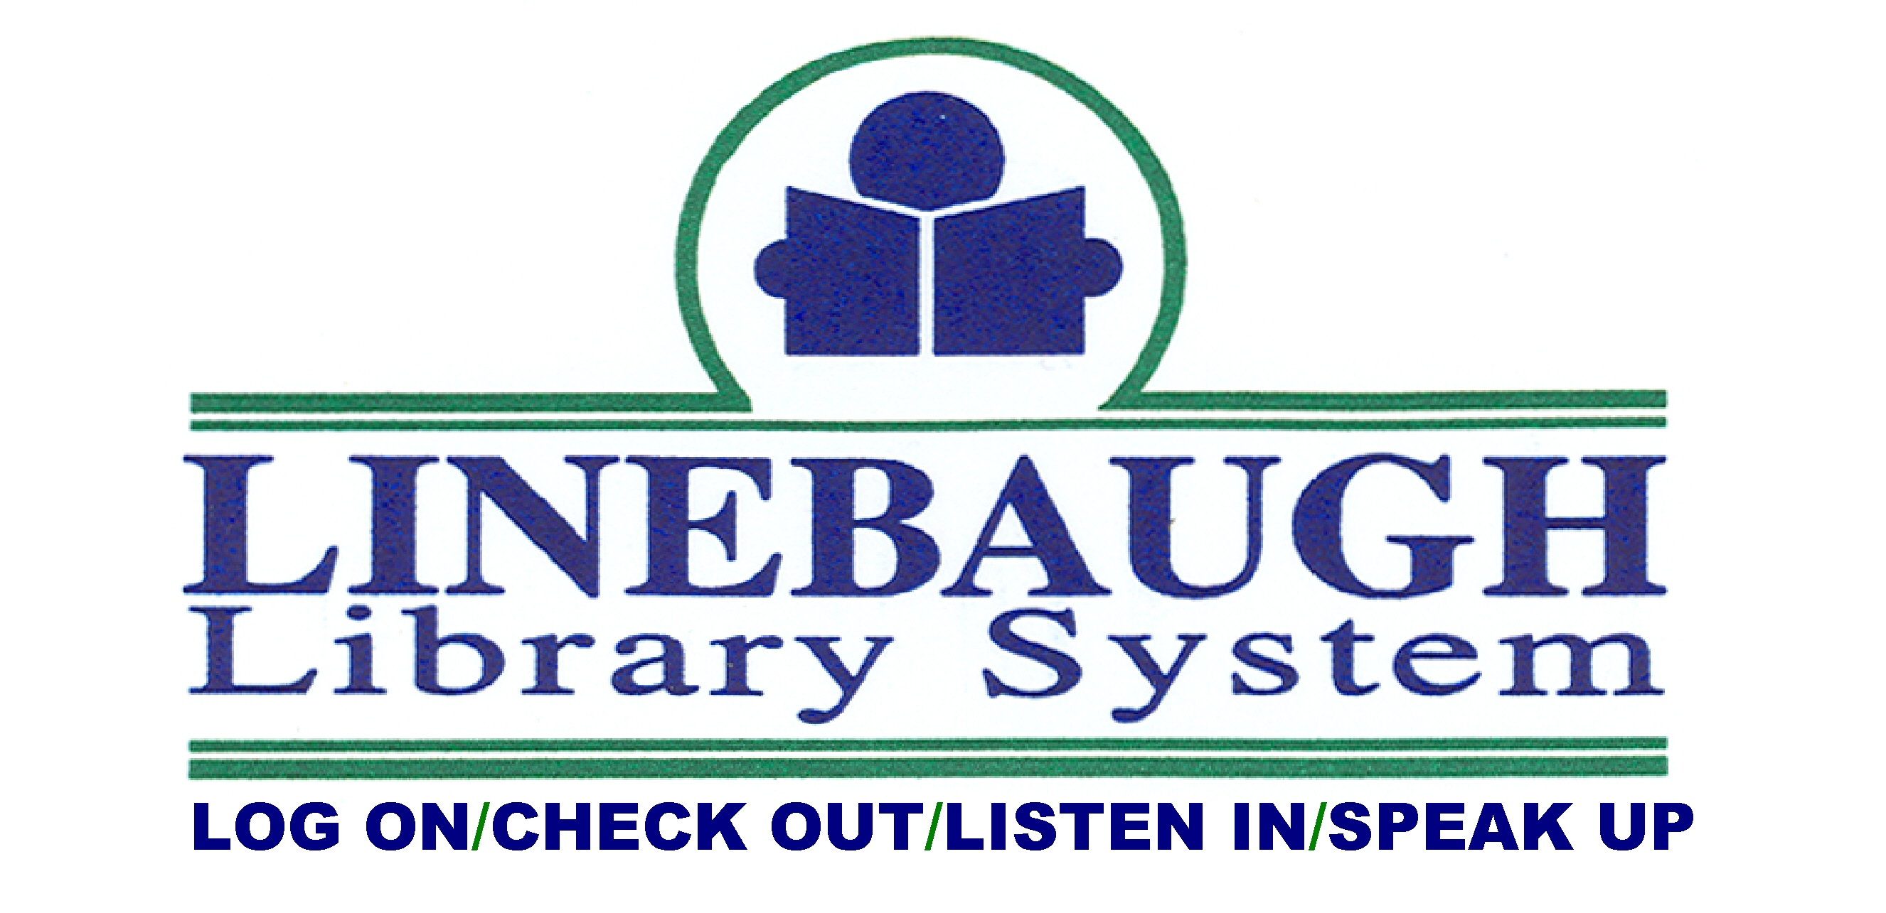

FOR IMMEDIATE RELEASE: [DATE]
CONTACT: [STAFF NAME], 615-893-4131, ext [###], [EMAIL@linebaugh.org]

PRESS RELEASE TITLE [Make it short and snappy.]

[The press release should be written with the most important facts at the top, and background detail or explanations later in the text. The first paragraph should contain the most essential details and/or selling points. Make sure your reader would get the message, if s/he only read this one paragraph. Usually the first sentence should aim to grab the reader’s attention; the second sentence provides a factual summary.]
[Body of release starts here. Additional details, quotes, etc.]
[The final paragraph (below) is our Boilerplate – an identifying paragraph used in every release. Revise the 1st sentence with branch details, or for system-wide releases use: Linebaugh Public Library System has two branches in Murfreesboro, branches in Eagleville and Smyrna, and a Bookmobile.]
Linebaugh Public Library is located at 105 W. Vine St. in Murfreesboro. The Library is the cornerstone of our community, enriching lives through free resources for learning, fun, and opportunity. For more information, call 615-893-4131 or visit www.linebaugh.org.
- end -

OTHER INFO
- Press releases must be approved by the director before being sent to media.
- If the press release is related to fundraising, the budget, or other financial issues, please try to incorporate this message (change wording if needed; you could use it in a quote, for example):
Without a library, Rutherford County will lose a place for people to connect, economic development opportunities, and jobs.

