
What Can You Do On Facebook?
You can Chat Live to any of your “Friends” who are online.
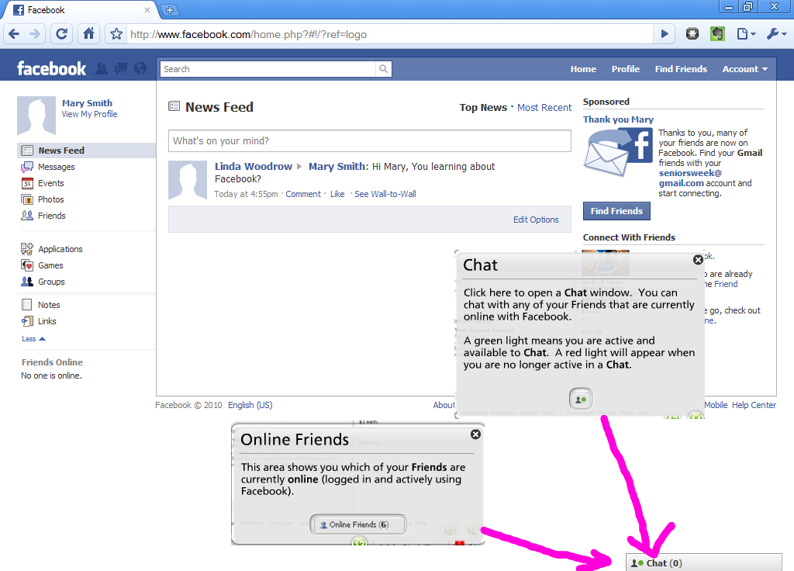
You can leave messages about your news, so all your “Friends” will see it next time they log into Facebook. Like “I’m doing a Facebook class right now”.
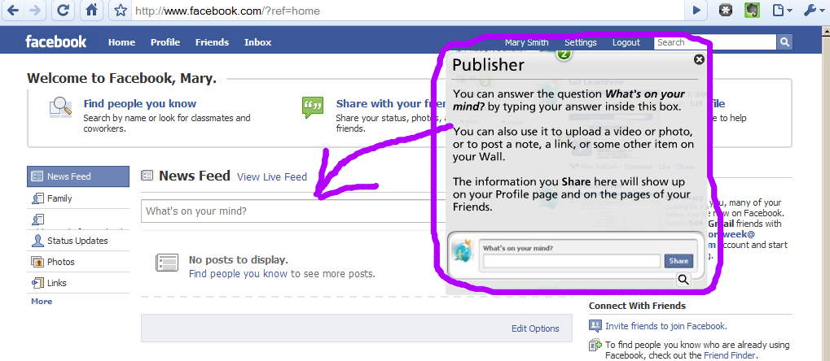
You can see what your friends’ news is, and comment or reply to it.
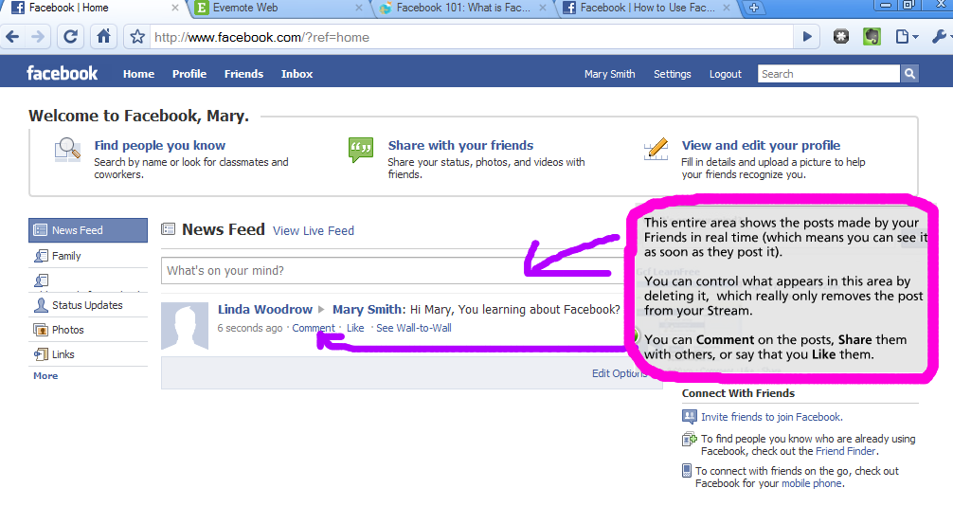
You can send private messages to your friends. Just Click on your Friend’s name and you will get an option to send them a message.
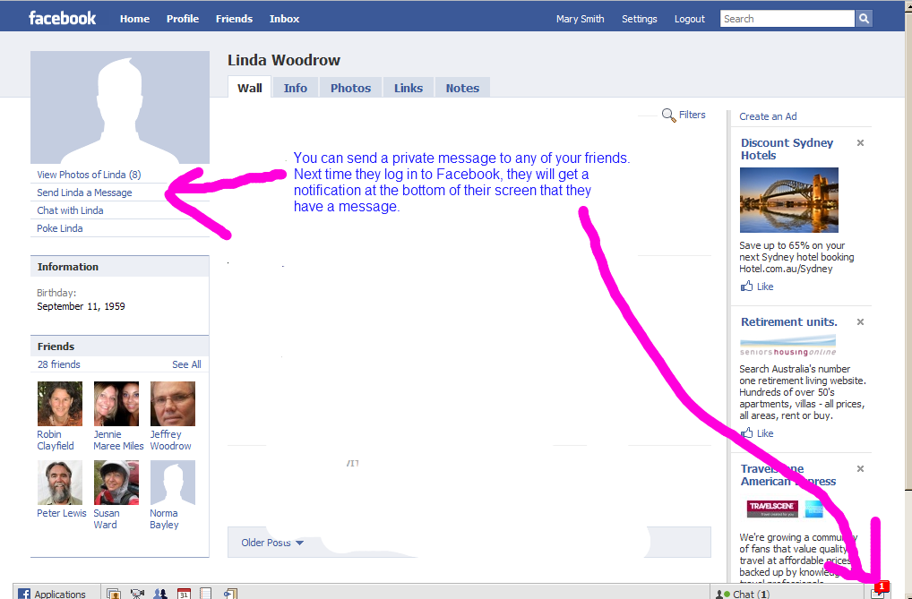
You can post your photos and videos for your friends to see.
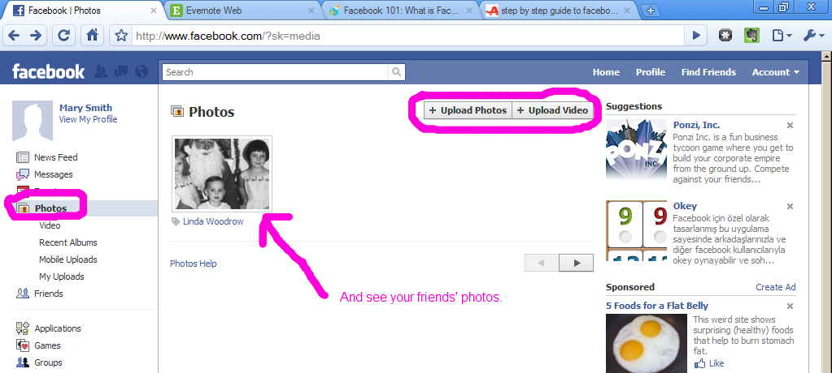
You can play games and quizzes, send your friends cards or virtual gifts, add your horoscope…
(You may need to go to Account/Application Settings to enable)
