Chinese Story Time  中文兒童故事會 --- 西雅圖公立圖書館 | 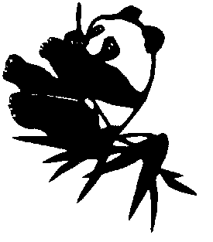
謝謝您的光臨。麻煩您用幾分鍾的時間回答下面幾個問題。多謝您的幫助！

1. 您對本次活動滿意嗎？

2. 您有什麽意見和建議？

3. 請告訴我們您是怎麽知道今天的活動的，請選擇符合的條款。

_____ 圖書館内的宣傳  _____ 公立學校  _____ 中文語言學校  _____ 家庭或朋友  _____ 教會  _____ 社區組織  (請標明)_________________ | ____ 圖書館的網站  ____ 電視上的宣傳  ____ 報紙上的宣傳 ___西城時報  ___西華報  ___其它報紙  __________________  ____ 其它方面的宣传(請標)________________  __________________________________
4. 您是否經常來圖書館…參加活動_____ 借書和還書_____ 其它(請標明) _____

5. 您的孩子幾嵗了？

6. 您的郵編號碼是_____？ 經常使用的圖書館是_____?

7. 您是用以下哪种語言？

國語(普通話) _____ 廣東話_____ 英語_____ 其它_________________________



Chinese Story Time

中文兒童故事會 --- 西雅圖公立圖書館
Thank you for attending today’s program. To assist us in planning future events, please take a moment to answer the following questions.

1. Did you enjoy today’s story time? What did you like best about the program?

2. What suggestions do you have for improving the program?

3. How did you hear about this program? Check all that apply:
_____ Library sign or contact  _____ Public school  _____ Chinese language school  _____ Friend or family  _____ Church  _____ Community organization  (Please name)_________________ | ____ Library website or email  __ Television  __ Newspaper ___Seattle Chinese Times  ___Seattle Chinese Post  ___Other paper______________  __ Other (Please describe) ________________  ____________________________________

4. How often do you use the library? ___________

For what purposes?

_____Programs _____Library Collection _____Other___________________________

5. How old are your children?

6. What is your zip code?

7. What languages do you speak?

_____Mandarin _____Cantonese _____English _____Other_______________

