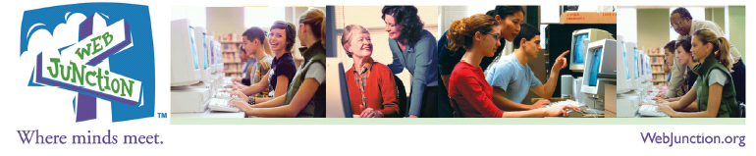

Spanish Language Outreach Program

Action Plan Template – Three Activities

Activity 1:

Need Being Addressed
Target Audience
Potential Partnerships
Action Steps
Marketing to Target Audience
Evaluation Plan: Success Indicators/How to Demonstrate Impact
Activity 2:

Need Being Addressed
Target Audience
Potential Partnerships
Action Steps
Marketing to Target Audience
Evaluation Plan: Success Indicators/How to Demonstrate Impact

Activity 3:

Need Being Addressed
Target Audience
Potential Partnerships
Action Steps
Marketing to Target Audience
Evaluation Plan: Success Indicators/How to Demonstrate Impact

Congratulations! You have completed your outreach action plan for all three of your selected activities. As you further develop and implement your overall plan, remember that the community at WebJunction is here to support your work. You can access resources related to serving Spanish Speakers at: http://www.webjunction.org/explore-topics/spanish.html.

