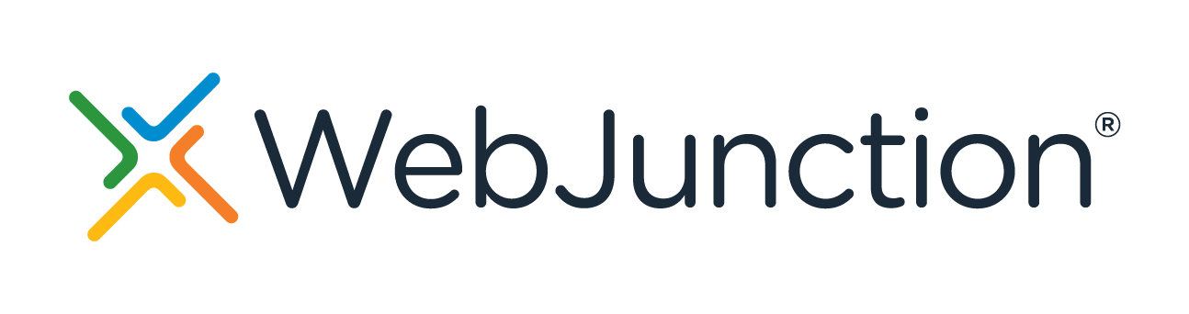
Building Community Relationships for Better Library Services
https://www.webjunction.org/events/webjunction/building-community-relationships.html

Many libraries are increasingly focused on planning library services collaboratively with their communities. Connected Learning, Participatory Design, and Community Led-Libraries are becoming standard practice, but to successfully embark on that work, the first (and ongoing!) thing library staff need to do is build robust and meaningful connections within their communities. In this session, we will explore strategies for finding community partners and building relationships with them with the goal of truly working in collaboration with people they serve. We will discuss strategies for small rural libraries up through large urban systems. You'll hear from library staff who have successfully started doing this work in their own communities with partners who serve all ages. You'll also learn about the importance of this work and why it needs to be supported by administrators and supervisors.
Presented by: Sara White, Stephanie Zero, Elissa Burnley, and Rachel Beckman
What are your goals for viewing this webinar?
Personal Goals
Team Goals
Community assessment
How do you decide who to approach in the community?

Reaching out
How do you reach out and start to build a relationship with a community you don’t share an identity with?

Ideal community relationship
How would you describe an ideal community relationship in your work?

Repairing relationships
How do you go about refreshing or revitalizing a relationship that has been broken or lapsed in some way?

Overcoming relationship challenges
What is a challenge you face in relationship building, and how do you overcome that?

Action Plan: (include next steps, when, who, etc.)

Outreach Contact Tracking Template
Partner/Company | Name of Group
Main Company Contact Information | Direct Email Address or other contact information in case of turn over
Contact Name | Person you are working with at organization
Contact Email | Contact’s email
Contact Phone Number | Contact’s phone number
Library Staff Contact | Library staff person who is working with this partner
Area of Partner’s Interest/Goals and Target Audience | What does the partner hope to achieve?
Partner’s Preferred Method of Contact | Do they prefer email/phone/meetings?
Last Contact Date | When did you last work with them or last contact them?
Previous Partnerships Events | Have you worked with this partner previously?
Notes | Anything else to remember.

Outreach Event Tracking
Tracking outreach efforts is crucial for evaluating the impact and effectiveness of these initiatives.
Event/Program Name | A descriptive title for the outreach activity.
Date and Time
Location
Type of Outreach and Target Audience | Categories such as presentation, school visit, etc.
Description of Event
Number of Participants
Staff Involved
Resources Used | Document any materials, equipment, or resources used for the event.
Objective or Goal or KPIs | How you are measuring if this outreach was a success for your org
Marketing or Promotions | How was the event advertised?
Partner Organization | Who did you work with? In what capacity?
Notes

Weekly Librarian Outreach Plan and Notes

General to Do (In Building)
-System-Wide Teams
-Updates:
-Programming
-To-Do:
-Upcoming Dates:
-Other In-building Work:
Outreach To-Do
-February 1st, Classroom Presentations, 8:45-10:51.
-Presentation on research skills.
-February 3rd, Classroom Presentations
-8th grade classes: Presentation on what makes a good book report.
-9th grade classes: Presentation on what makes a good book talk.
-February 6th, Career Fair
-February 7th Meet with Big Brothers Big Sisters 11-12
-Small Business Support
-Local Professionals Coffee Chat, second Tuesday of the month
-Schools
-Reach out to:
-Librarians – partnerships? (Continuing contact)
-Administrator of Alternative Learning (First time contact)
Outreach Follow-Ups to do
-Follow up with local WorkSource contact: Resume writing workshop? Weekend or weekday?
-Middle School Outreach: Check on availability for 3 day presentations
-Spanish Language Elementary Club
-Leadership class Library project

Outreach Done
-January 18th 9th grade class research presentation – went well! Students really took in the information, and had a bit of time at the end of class to put into practice what they’d learned.
-Monday, 23rd 2:45-3:45 Teen Drop-In Shelter Visit
-Tuesday, 24th Senior Center Art Show Planning Meeting
-Monday, January 30th 3:30-4:30 PM, met with Middle School teacher and librarian re: book club support.

Steering Thoughts / Program Ideas
-Starting Drop-In Business Coaching?
-Resume Writing Program?
-Summer Teen Book Club

