Sustainable Libraries Learner Guide

Sustainability 101
Session Description: Start here for an overview of our profession’s newest core value, Sustainability, as adopted by the American Library Association in 2019. Identify the four characteristics of a sustainable library and learn how the triple bottom line definition of sustainability can be used to adapt library operations, service and program design, and partnerships in our community, to respond to the impacts of climate change. This webinar will focus on introductory concepts that will set the stage for the other offerings in this series.
“Climate change is the single greatest threat to global health, a ‘code red for humanity,’ and is this generation’s grandest challenge.”
– Sustainability in Libraries: A Call to Action, American Library Association
In 2019, the American Library Association adopted sustainability as a core value of the profession in acknowledgment of the severe need for collective action on the topic of climate change called for by the United Nations Intergovernmental Panel on Climate Change (IPCC).
At the time, the latest IPCC report, written and edited by 91 scientists from 40 countries who analyzed more than 6,000 scientific studies, found that the immediate consequences of climate change were far more dire than they had initially predicted, and called for a transformation of the world economy at a speed and scale that has “no documented historic precedent.” Subsequent reports from the IPCC have had a continued sense of urgency. In 2022, the UN Secretary-General issued a “code red for humanity,” urging influential leaders to act with more determination on the topic of climate change. Upon issuing the latest IPCC report in 2023, the chair of the IPCC Hoesung Lee noted, “We are walking when we should be sprinting. The pace and scale of what has been done so far and current plans are insufficient to tackle climate change.”

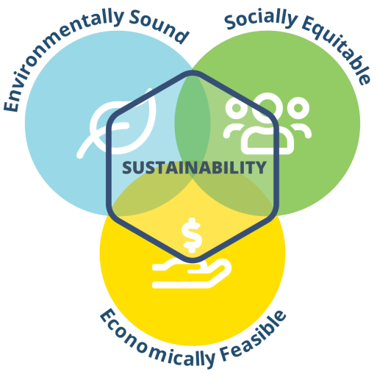
The triple bottom line

Image source:
Sustainable Libraries Initiative

The Sustainable Libraries Initiative (SLI) was formed to help library leaders reimagine their work in order to leverage their influence to help communities be more sustainable, resilient, and regenerative.
Climate change is not just an environmental issue. It is closely tied to our economic choices and has deep roots in issues related to equity, diversity, inclusion, and justice. It is a systemic problem that requires solutions that take into consideration the intersections of our everyday decisions.
To this end, the American Library Association and the Sustainable Libraries Initiative have adopted the “triple bottom line” framework to provide clarity in the desired outcome for a word that is commonly used in many instances. This framework seeks balance at the nexus of environmental stewardship, social equity, and economic feasibility. The framework can be scaled for decisions large and small in a library setting as well as for defining the sustainability of an organization, product, or community.

REFLECTION
To be truly sustainable, an organization must embody practices that are environmentally sound AND economically feasible AND socially equitable.
Why are these three practices of sustainability important to a community?

Why are these three practices of sustainability important to a library?

Four attributes of a “Sustainable Library”
According to the Sustainable Libraries Initiative, libraries are sustainable when they are:
- Strong and authentic institutions
This means a library needs to be sustainable “from the inside out.” The Sustainable Libraries Initiative advises libraries to consider first their own policy, operational, budgetary, personnel, program, service, and partnership design choices using the triple bottom line framework. By building authenticity in our own internal choices, we can be stronger, more reliable allies with like-minded people, agencies, and organizations in our communities.
- Catalysts for civic participation and social cohesion in communities
Libraries must make deliberate choices to assume a nonpartisan role in our communities that encourages a participatory democracy and knits a stronger social fabric. The Sustainable Libraries Initiative urges libraries to embrace the opportunity to actively educate their constituents about how they can be involved in decision-making matters on a local, national, and global scale, while applying the principles of equity, diversity, and inclusion to ensure justice is at the heart of decisions made about the future of our communities.
- Working on climate mitigation (reducing greenhouse gas emissions)
Libraries must take responsibility for reducing their carbon footprint and lead by example in our communities. The Sustainable Libraries Initiative provides tools and guidance to help libraries set carbon reduction goals and to deploy strategies to reduce greenhouse gas emissions caused by library facilities, transportation choices, and food waste decisions.
- Active participants in climate adaptation (strengthening community resilience)
Libraries can provide valuable assets that help to build community resilience in the face of disruptive events amplified by climate change. The Sustainable Libraries Initiative encourages libraries to focus not only on disaster preparedness—for example, strategies to help the library resume operations after a severe weather event, an extended power outage, or a disruption such as a cyberattack—but also to contribute to building up a community’s resilience before disruptive events occur. Community resilience work can take many forms, including strengthening the food supply chain, creating redundancies in communication systems, allowing for library infrastructure to become part of emergency management solutions in the form of heating/cooling stations, and serving as resource drop-off/pick-up points.

REFLECTION
The first of the four attributes of a sustainable library calls upon library leaders to help their institutions be sustainable from the inside out by living their values out loud.
What are things your organization is already doing that exemplify this attribute? Consider such things as your policies, facility operations, purchasing practices, and service and program design.

What could your organization be doing differently to live those values out louder?

Climate Action Planning (Part 1): An Introduction
Session Description: Climate action requires a focus on reducing greenhouse gas emissions combined with increasing community resilience, all through a lens of climate justice. Join this webinar to find out where your time and energy can be best spent in the face of the overwhelming nature of climate action. Learn from library practitioners that have been early adopters of climate action through the award-winning Sustainable Library Certification Program, to help organize your own thinking on how to implement a climate action plan at your library that will have the biggest impact locally and globally.

Climate action defined
Climate action is being called for with great urgency, but where to start? The United Nations’ Sustainable Development Goals create a framework with 17 categories, and the weight of each category can be different from institution to institution and from region to region.
To simplify things, let’s start with this formula:
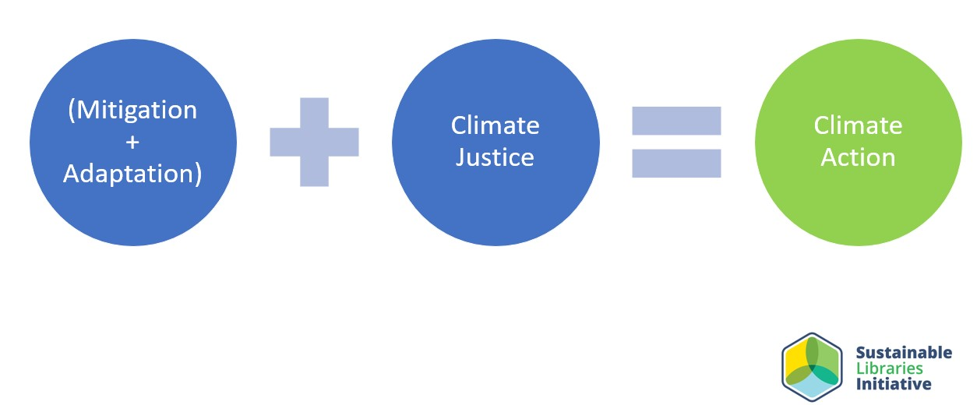

Image Source: Sustainable Libraries Initiative

(Climate Mitigation + Climate Adaptation) + Climate Justice = Climate Action
Climate action requires attention to both mitigation (reduction of greenhouse gas emissions) and adaptation (strengthening community resilience) while ensuring that justice is served through all future decisions.
Climate change mitigation
Climate change is driven by the increased presence of gases that trap heat in the atmosphere which are called greenhouse gas emissions (GHG). The U.S. Environmental Protection Agency (EPA) provides the following examples of GHGs:
- Carbon dioxide (CO₂): Carbon dioxide which enters the atmosphere through burning fossil fuels (coal, natural gas, and oil), solid waste, trees and other biological materials, and also as a result of certain chemical reactions (e.g., cement production). Carbon dioxide is removed from the atmosphere (or "sequestered") when it is absorbed by plants as part of the biological carbon cycle.
- Methane (CH₄): Methane is emitted during the production and transport of coal, natural gas, and oil. Methane emissions also result from livestock and other agricultural practices, land use, and by the decay of organic waste in municipal solid waste landfills.
- Nitrous oxide (N₂O): Nitrous oxide is emitted during agricultural, land use, and industrial activities; combustion of fossil fuels and solid waste; as well as during treatment of wastewater.
- Fluorinated gasses: Hydrofluorocarbons, perfluorocarbons, sulfur hexafluoride, and nitrogen trifluoride are synthetic, powerful greenhouse gases that are emitted from a variety of household, commercial, and industrial applications and processes. Fluorinated gases (especially hydrofluorocarbons) are sometimes used as substitutes for stratospheric ozone-depleting substances (e.g., chlorofluorocarbons, hydrochlorofluorocarbons, and halons). Fluorinated gases are typically emitted in smaller quantities than other greenhouse gases, but they are potent greenhouse gases. With global warming potentials (GWPs) that typically range from thousands to tens of thousands, they are sometimes referred to as high-GWP gasses because, for a given amount of mass, they trap substantially more heat than CO₂.
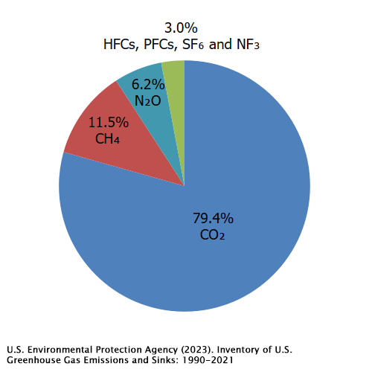

Carbon footprint
The Carbon Trust defines a carbon footprint as “the total GHG emissions caused directly and indirectly by an individual, organization, event or product.” It is calculated by summing the emissions resulting from every stage of a product or service’s lifetime (material production, manufacturing, use, and end-of-life).
Carbon dioxide is, by far, the most prevalent GHG. The main human activity that emits carbon dioxide is the combustion of fossil fuels (coal, natural gas, and oil) for energy and transportation. The top two areas where libraries can reduce their carbon footprint is by making different choices related to:
- Transportation
The largest source of CO₂ emissions is the combustion of fossil fuels such as gasoline and diesel to transport people and goods.
- Electricity
The second largest source of CO2 emissions is the combustion of fossil fuels to generate electricity.
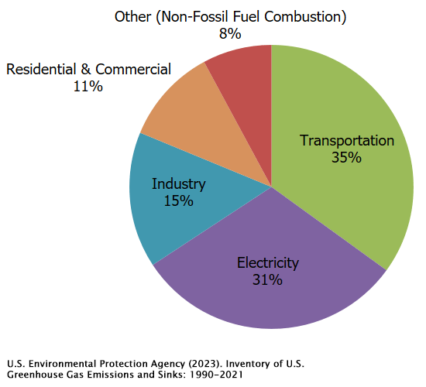
Libraries in the Sustainable Libraries Initiative’s Sustainable Library Certification Program have been deliberately working to benchmark and reduce CO₂ emissions. Examples from libraries in that program include:
- Having an energy audit conducted to ensure the building envelope is well insulated and does not allow for too much air infiltration/exfiltration.
- Ensuring routine preventative maintenance on HVAC equipment
- Prioritizing net zero energy goals through renewable energy sources in facility planning.
- Mandating the purchase of ENERGY STAR rated products.
- Ensuring equipment and lighting are turned off when not needed.
- Ensuring that facility plans work to preserve or create shade for facilities to lessen the need for air conditioning.
- Converting fleet vehicles and bookmobiles to more fuel-efficient options or electric vehicles
- Investment in electric vehicle (EV) charging stations, better yet, solar powered EV charging stations.
- Working with officials to ensure public transportation routes stop at the library.
- Amending purchasing policies to prioritize locally sourced goods and services to reduce transportation distances and invest in the local economy.
Climate change adaptation
Climate change adaptation means taking action to prepare for and adjust to both the current and projected impacts of climate change. Adaptive capacity requires us to moderate potential damages through disaster preparedness and community resilience work. This can and should happen at the personal, institutional, and community level.
Personally: Library workers should have their own preparedness plans in place. This could include ensuring you have an emergency kit at home stocked with key supplies such as water, food, battery-powered or hand crank radio, flashlight, and first aid kit. For a Basic Disaster Supplies Kit visit https://www.ready.gov/kit. It is also wise to have an evacuation plan, a family communication plan, and a designated family meeting place. For more information and resources to help you develop these plans visit https://www.ready.gov/. Heat waves are predicted to hit much of the world at least three times more often as climate change worsens. Working to become more heat tolerant is an unfortunate reality. Hydration, clothing choices, the availability of shade outside and air conditioning and fans inside can all make a very big difference in someone’s heat tolerance.
Institutional: All libraries should have written disaster preparedness plans that address physical and operational infrastructure as well as workforce resilience.
Physical/Operational Plans: These can take the form of a traditional disaster plan, a continuity of operations plan (COOP), or a Pocket Preparedness Plan, but one way or another, as a team, your workplace should be thinking through the most likely disasters and how your organization will recover from them and get back to business to help support your community. Support for the community can come in many forms: as first restorers – available to help with information needs, hosting FEMA workers, a source for electricity and running water to serving as cooling or warming centers, but none of this is possible without a resilient workforce.
Workforce Resilience: There are three core indicators of long-term resilience in the workforce: (1) A sense of security at work; (2) A strong sense of belonging with the employer; and (3) A level of adaptability and motivation among employees that facilitates reaching their full potential. Short-term resilience requires disaster planning training for individuals: how they can be prepared at home; how they can participate to carry out a library’s disaster preparedness and recovery plans; having a clear understanding of how the library’s leadership envisions itself in helping the community in the aftermath of a disaster.

“The ability of citizens to sort fact from fiction, understand the difference between science and opinion, build empathy for their neighbors, and work together on problem solving are all fundamental aspects of community resilience.”
-Stricker & Aldrich, Information Services Today an Introduction (3rd ed.)
Community: Community resilience planning is essential, and libraries should be a part of planning as well as contributing before, during and after disaster strikes. Strong connections with the first responder community, participation in efforts such as Community Emergency Response Teams (CERT) and being a part of the National Voluntary Organizations Active in Disasters (NVOAD) network can strengthen communities and ensure your library is a relevant and responsive part of the community’s disaster preparedness efforts.
Climate change adaptation is explored more deeply in the “Climate Action Planning (Part 2): Disaster Preparedness and Community Resilience” entry in this series.

Climate Justice
The Center for Climate Justice at the University of California notes that climate justice connects the climate crisis to the social, racial, and environmental issues in which it is deeply entangled. It recognizes the disproportionate impacts of climate change on low income and BIPOC communities around the world, “the people and places least responsible for the problem.”
Climate action also calls for a rapid, if not radical and disruptive, shift to an economy that is sustainable. However, this shift needs to be a “just transition” to create an economy that is as fair and inclusive as possible to everyone concerned, creating decent work opportunities, and leaving no one behind. The IPCC defines just transition as follows: "A set of principles, processes and practices that aim to ensure that no people, workers, places, sectors, countries or regions are left behind in the transition from a high-carbon to a low carbon economy."
In the book Libraries and Sustainability: Programs and Practices for Community Impact, the authors explore the extrapolation of the “Doughnut Economics” theory for libraries to think like 21st-century economists to cocreate a habitable world centered on our wellbeing. The authors encourage libraries to model the way to move away from “business as usual” to a transformative economy that is regenerative and distributive by design, rather than extractive and exploitive.
Climate justice also calls for immediate action as it relates to climate change adaptation work to incorporate equity, diversity, and inclusion thinking in disaster preparedness and disaster recovery planning.
This topic is explored more deeply in the Climate Justice entry in this series.

REFLECTION
Climate action can take many forms, but the most impactful actions are tied to (1) reducing greenhouse gas emissions, and (2) helping communities adapt in the face of the impact of climate change.
How can your institution reduce its carbon footprint?
How can your institution ensure that its workforce is prepared for severe weather events?

How can your institution ensure that its workforce is resilient?
What environmental injustices exist in your community?

Climate Action Planning (Part 2): Disaster Preparedness and Community Resilience
Session Description: This panel discussion will feature practitioners with deep experience in preparing both libraries and communities, for the impacts of climate change. Our panel will speak to traditional disaster preparedness, business continuity planning, community resilience work, and preparing communities for severe weather events and the increased likelihood of food supply interruptions. While libraries are not first responders, they should be connected with the emergency management community and be positioned as part of both the short-term and long-term “first restorer” network as disruptions amplified by climate change happen with more frequency.
Over the next three decades, climate change will increase the frequency and severity of weather extremes and lead to geographic and ecological challenges in every region of the United States. Damage caused by the impact of climate change will have cascading effects on interdependent critical sectors, such as food production, telecommunications and transportation, and disproportionately impact already vulnerable and disadvantaged groups.
Libraries must embrace a systemic approach to build a culture of resilience to prepare for what is already happening and what is to come. Just as in 2021, when Executive Order 14008 was issued which directed all federal agencies to place “the climate crisis as the forefront of foreign policy and national security planning,” libraries must place the climate crisis at the forefront of institutional disaster preparedness, strategic planning, facility planning, and staff development.
Definitions:
Disaster preparedness
The U.S. Department of Homeland Security and the Federal Emergency Management Agency (FEMA) define preparedness as "a continuous cycle of planning, organizing, training, equipping, exercising, evaluating, and taking corrective action in an effort to ensure effective coordination during incident response."
Community resilience
Community resilience is the sustained capacity for communities to withstand, adapt to, and recover from adversity and disruption. The concept is associated with increasing social support networks and social cohesion and minimizing risks, miscommunication, and trauma.

Recommended steps
❶ To create a foundation of shared principles, a good place to start is with education for staff and other library stakeholders responsible for decision and policymaking. Climate literacy and sustainability training should be core training for both library workers and library trustees.
❷ Next up will be institutional planning, a traditional disaster plan is a standard all libraries should strive for. There are many examples and templates freely available online and cited below. Seek out those best suited for the size and scale of your institution. These plans focus on the facility and the salvage of materials and equipment.
❸ Staff readiness should be a component of disaster preparedness for a library. Ensuring staff are personally confident about disaster preparedness plans both in the workplace and at home can be the difference between keeping people safe, optimally implementing your disaster recovery plans and being closed to the public for extended periods of time. It is also a humane way to help staff emotionally prepare for the predicted disruption caused by climate change, empowering them to embrace the reality of what is coming and combat fears around the unknown.
❹ Contributing to a community’s resilience should be a primary strategic goal in the library’s long-range plan. How we build collections, design programs, and seek out partnerships should all be tied to our community’s ability to thrive in the face of disruption. This will require data and research to understand a community’s vulnerabilities and assets. Applying library science in a way that brings the strengths of your library to the service of the community’s resilience is a worthy, and necessary, legacy.
❺ Ensure the library is connected to the emergency management community as well as other nonprofits that contribute to preparedness, crisis management, and disaster recovery in your community. Libraries are clearly part of the mix given FEMA’s designation of public libraries as an essential service and vital community information hub, but you may need to raise people’s awareness of the library’s strengths before they are needed in a crisis or disaster.
Libraries in the Sustainable Libraries Initiative’s Sustainable Library Certification Program have been deliberately working to increase their readiness to manage potential disasters and disruptions in their institutions while being a primary contributor to community resilience. Examples from libraries in that program include:
- Ensuring disaster preparedness plans are up-to-date given recent predictions of severe weather-related emergencies.
- Creating “Continuity of Operations Plans” (COOP) and Pocket Preparedness Plans that help them operationalize disaster preparedness plans.
- Expanding their Library of Things collection to include items folks may need in the aftermath of a disaster such as hand crank radios, walkie talkies, and portable solar panels.
- Offering programs such as “Citizen Preparedness,” to help families plan evacuation routes, pack a go bag, and develop family communication plans should disaster strike their communities.
- Celebrating the local First Responder community through kids thank you card programs and appreciation events.

REFLECTION
Does your library have a disaster preparedness plan? Does it address likely scenarios predicted by the impact of climate change in your geographic region?

What activities or training would help library workers in your institution feel more prepared to act with confidence in the face of a disaster that may befall the library?

What/Who are some key agencies in your community that are working on disaster preparedness? Disaster recovery?

How can your library contribute to ensuring civil and human rights are upheld in emergency management plans?

Climate Justice
Session Description: Climate justice recognizes the disproportional impacts of climate change on the people and places least responsible for the problem: systematically oppressed communities and communities of color. Libraries that approach climate action through the lens of climate justice can accelerate necessary work in communities to ensure all are heard in disaster preparedness and emergency management work. Learn how to think like a 21st century economist and how libraries can help lead the way to a just transition of our communities to strengthen community resilience and livability not just in the aftermath of climate change-driven disasters, but well before they ever happen.
Climate change exacerbates existing inequities in our global and local societies, climate justice calls for a recognition of this at the heart of climate action planning at all levels.
Internationally
The concept of climate justice acknowledges that because the world’s richest countries have contributed most to the problem of climate change, they have a greater responsibility to take action and to do so more quickly. There are also concerns that efforts to mitigate climate change by wealthier countries will place an undue burden on already vulnerable populations who may bear the brunt of economic shifts that change the use of natural resources for mitigation strategies (e.g., mining for batteries for electric vehicles and solar panels; shifts away from mining coal).
Closer to home
The recent resurgence of the social justice movement has close ties with climate justice because climate justice IS social justice. As we consider the marginalized and vulnerable populations in our communities it is easy to see how climate change will more direly impact these communities. The lack of resources to evacuate in the face of a storm, to afford air conditioning in the face of increased and extended heat waves, and to afford rising costs for fresh fruits and vegetables as food systems are disrupted by climate change are all examples of how social injustice exacerbates the impacts of climate change. In the United States, lack of access to generational wealth, grown over time thanks to a system that excluded BIPOC communities and marginalized women throughout history has resulted in a climate underclass that find their very mortality to be challenged in the face of the worsening climate situation that has been driven by a consumer-driven culture that cares little for the impact on the global environment.
Where to start
As the famous conservationist John Muir is quoted as saying, “When we try to pick out anything by itself, we find it hitched to everything else in the Universe.” This describes the issues surrounding climate justice very well and is the driving reason behind the adoption of the triple bottom line definition of sustainability by the Sustainable Libraries Initiative and the American Library Association. Finding the balance among environmental stewardship, economic feasibility, and social equity is the key to climate justice.
Given the systematic nature of climate justice it can be hard to decide where to start when an entire economic system feels designed to reward and protect those who already have wealth without regard to the environmental and social impact.
One of the four characteristics of a Sustainable Library as defined by the Sustainable Libraries Initiative calls for libraries to embrace the role of being a catalyst for social cohesion and civic participation in their communities.
Social cohesion
- Respect, Empathy, and Understanding
- Strength of Relationships
- Sense of Solidarity
- Social Capital through Social Networks
Civic participation
- Voting
- Volunteering
- Participating in Group Activities

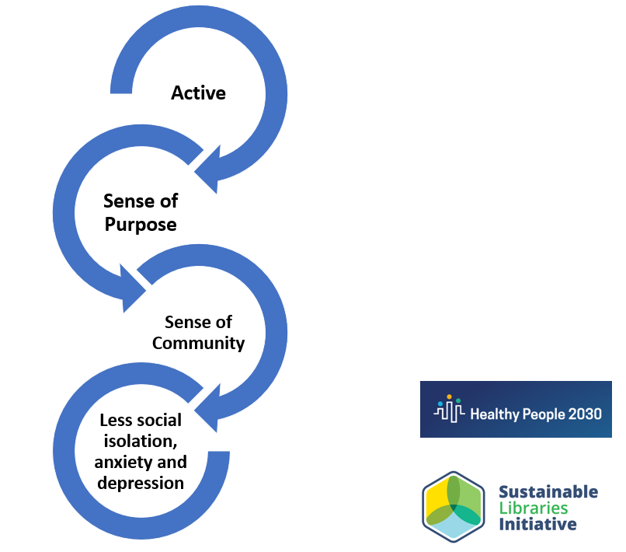

Libraries in the Sustainable Libraries Initiative’s Sustainable Library Certification Program have been deliberately working to increase their participation as a catalyst for social cohesion and civic participation. Examples from libraries in that program include:
- A focus on food justice in the form of community supported agriculture on library property, community refrigerators, free pantries hosted by libraries, seed libraries and gardening tool lending libraries.
- Collaboration with municipal transportation departments to make public transportation more accessible and affordable.
- Participation in National Voter Registration Day.
- Community service projects such as those catalyzed through The Great Give back in New York State, each library in the state is encouraged to host a community service project that brings people together to improve their neighborhoods – from a creek clean up to serving as gathering points to collect items for shelters to pet adoption events, New York’s libraries catalyze good things.
- Serving as a cooling or warming center in their community

REFLECTION
How has your library helped to bring neighbors/students together that wouldn’t otherwise socially interact with one another?

How does your library encourage civic participation?

Who is working on the topic of food insecurity in your community?

How can your library adjust purchasing and material usage habits to ensure your choices are not negatively impacting someone in another part of the world?

Living Our Values Out Loud: Programs that Walk the Talk
Session Description: From zero waste events to upcycling to refreshments, how we choose to carry out our work in libraries says a lot about our values. We can’t just pay lip service to sustainability—we need to practice what we’re talking about! This webinar will be an inspiring discussion with a panel of practitioners who have found ways to design, implement, and evaluate library programs using frameworks that better represent their library’s values, such as the triple bottom line definition of sustainability and the United Nations’ Sustainable Development Goals.
The first of the four characteristics of a Sustainable Library as defined by the Sustainable Libraries Initiative calls for libraries to be strong and authentic institutions that live their values out loud. Why we do what we do should be reflected not only in what we do, but how we do it. Strategic alignment of a library’s long-range goals with the community’s ability to thrive is a local and global issue. Serving as a model operationally as well as through the content and programs we curate in our spaces should go hand-in-hand.
Programs have grown to be one of the most popular services libraries offer over the past twenty-five years. Staff that specialize in designing programs are constantly iterating and innovating to create meaningful experiences that are engaging as well as educational.
Why we offer what we offer and how to talk about it
Programming, regardless of what age it is for, should tie back to strategic goals identified in a library’s long-range plan. For a community to thrive your library may have identified that social cohesion is incredibly important, or that student success is an “all hands on deck” endeavor, or that a growing population of aging adults are suffering from social isolation - regardless of what your particular community’s needs are, library programming should be done with purpose, within meaningful intent that has an impact.
Measuring the impact of what we offer is essential. Is the library contributing to the social well-being of a community? Has an individual’s life been changed by the work we are doing? Are we respecting the triple bottom line definition of sustainability in all our choices? Identifying the frameworks within which we evaluate our work is a major body of study and an important aspect of storytelling for libraries.
Sustainable Development Goals (SDGs)
A new attribute of the Public Library Association’s groundbreaking (and free!) outcome-based evaluation tool, Project Outcome, lines up beautifully with sustainability work in libraries. Starting in 2023 users are able to link their program surveys to the United Nations’ Sustainable Development Goals (SDGs).
“The 2030 Agenda for Sustainable Development, adopted by all United Nations Member States in 2015, provides a shared blueprint for peace and prosperity for people and the planet, now and into the future. At its heart are the 17 Sustainable Development Goals (SDGs), which are an urgent call for action by all countries - developed and developing - in a global partnership. They recognize that ending poverty and other deprivations must go hand-in-hand with strategies that improve health and education, reduce inequality, and spur economic growth – all while tackling climate change and working to preserve our oceans and forests.” -United Nations
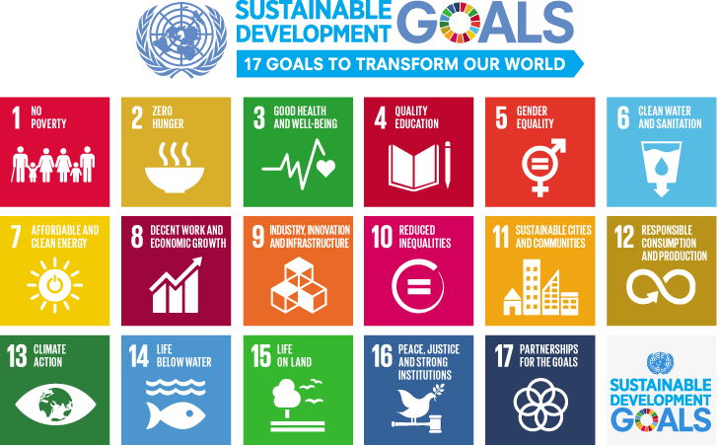
Talking about why we do what we do and the impact of our good intentions is essential to ensure libraries are connecting with their communities and demonstrating relevance and value.
The American Library Association’s Task force on United Nations 2030 Sustainable Development Goals has created helpful resources to get you started with the SDGs such as:
- What are the SDGs? What is the role of libraries? What can you do? fact sheet (PDF file)
- Create your own SDGs library chart! (Word Document) - You can now create your own SDG library chart by downloading the Word file and adding your library's projects.
- Create your own SDGs poster: size 8 1/2 x 11 | size: A4 (PDF files)
- Download and edit your own SDGs bookmarks: style 1 | style 2 (PDF files) | Printable bookmarks with crop marks: Style 1 | Style 2 (PDF Files)
For more information on Project Outcome’s new feature to connect library program outcomes with the SDGs, check out the “Capturing Library Contributions to the Sustainable Development Goals with Project Outcome” webinar recording.
Social Wellbeing
Another approach a library can use to connect the impact of their good intentions with community needs is by using the framework of social wellbeing. From the recent results of the Institute of Museum and Library Services’ report, ”Understanding the Social Wellbeing Impacts of the Nation’s Libraries and Museums,” to the State Library of Victoria’s industry-leading strategic framework, “Libraries for Health and Wellbeing,” we can see the simple yet elegant focus on social wellbeing as the secret ingredient to community resilience. Individuals, neighborhoods and communities with social connection, mental wellbeing, and physical health should be able to come together to make strong decisions and policy for their neighbors to adapt in the face of climate change.
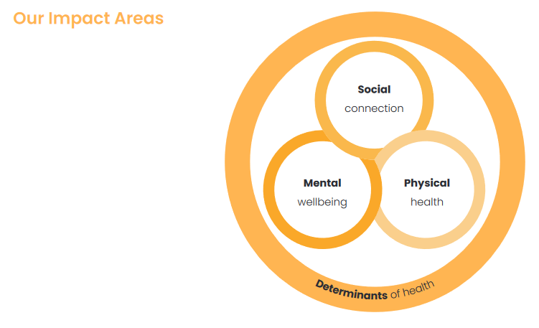
Image Source: “Libraries for Health and Wellbeing: A strategic framework for Victorian public libraries towards 2024,” State Library Victoria & Public Libraries Victoria, https://www.slv.vic.gov.au/sites/default/files/LFHAWB-vFIN-web_0.pdf
Libraries in the Sustainable Libraries Initiative’s Sustainable Library Certification Program have been deliberately working to increase the impact of their programs by using the triple bottom line definition of sustainability to guide choices about their goals through programming. Examples from libraries in that program include:
- Promotion of a love of reading and self-directed learning through collection curation, displays, book clubs, quiet reading and study spaces in library facilities and the defense of intellectual freedom
- Citizen Science programming
- Organizing or participating in community-wide Juneteenth celebrations
- Creation of makerspaces to encourage creativity and collaborative problem-solving in the community
- Hosting Repair Cafes and Fix-It Clinics to support neighbors helping neighbors to repair household items, technology, and clothing.
How we offer it
In “Let “Green” Creep,” a now landmark article written by Louise Shaper for Library Journal in 2010, the connection between intention and impact when it comes to how we operate library facilities was made. In her tenure as the library director for the Fayetteville Public Library (AK), Shaper led the construction of the first building in Arkansas to be registered for the U.S. Green Building Council’s LEED (Leadership in Energy & Environmental Design) certification, the nation’s most used and respected standard for green buildings.
However, as the staff and public lived in the building once it was constructed she had to admit, the community values that drove the construction of the greenest building in the state were not evident in its operation. The staff were giving away plastic book bags, they were using bottled water and plastic cutlery, cups, and dishes for events, PCs and monitors were left on 24/7. She prioritized living the values that drove the construction of that LEED-certified building throughout its operation.
This same thinking needs to be applied to library programs. As more and more libraries offer programs that address key sustainability issues such as eco-literacy, preparedness, kindness, local business development, food security and more are we walking the talk? Or just talking the talk?
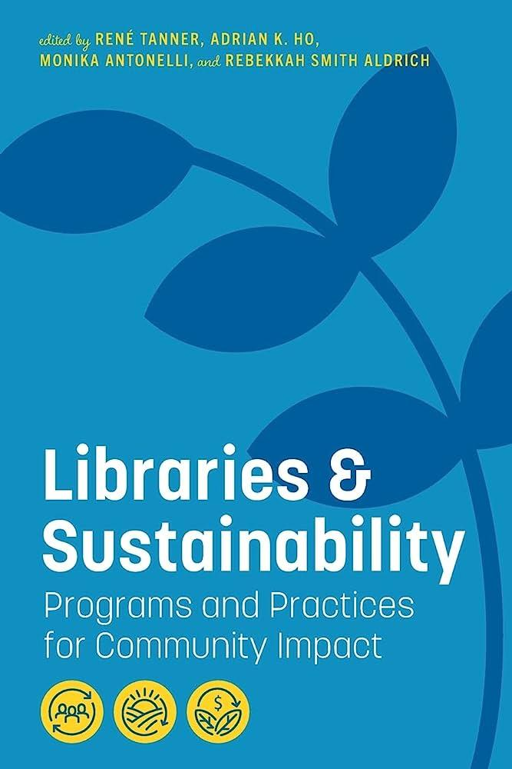
In the book Libraries & Sustainability: Programs and Practices for Community Impact, two chapters are devoted to the topic of sustainability in programs:
- Sustainable Event Planning for Libraries and Library Organizations by Evan Meszarsos and Mandi Goodsett
- Modeling Sustainable Choices: Practical Suggestions for Librarians Working with Children and Families by Larissa M. Clotildes
All three authors focus on how we carry out the wonderful program ideas that we think will be engaging and educational for our community members. The choices that are made serve as models, unspoken cues for the values of the library. Choices made about programs can involve purchasing materials for craft projects, procuring and serving food, managing waste, and transportation to the event, among other things.

Key questions to help planners think about program implementation:
- Is the location of the program accessible? Are you clear in offering accommodations at your program?
- When planning craft programs can you use recycled materials?
- When hosting events with food, where did the food come from? Was it locally sourced? Is it healthy for participants? How will leftovers be disposed of?
- Events with food require hospitality items such as plates, cutlery, napkins and cups. Are there reusable options? Recyclable options? Compostable options? What would it take to produce a zero waste event?
- Do you have to have a physical giveaway for a program? Can you create opportunities to support local businesses instead or offer experiences rather than “stuff”?
These are just a few questions to practice applying the triple bottom line definition of sustainability to program production at your library.

REFLECTION
How does your library measure the impact of programs?

Are there ways programs that are offered at your library could lessen their environmental impact?

Stronger Together: Collective Impact and Climate Action Programming
Session Description: Libraries are catalysts and conveners for climate action in our communities. This webinar will feature practitioners who are having a collective impact through collaborations with others in the community, to address the pressing challenges related to climate change. Join these practitioners to hear practical ideas for how to ensure that good intentions have a positive impact on our communities.
The Center for the Future of Libraries has identified collective impact as a key trend for libraries to be aware of and participate in:
Complex social issues—hunger, poverty, violence, education, health, public safety, the environment—involve many different factors, and responses to these issues include many different community organizations. Organizations working in isolation and/or individual projects have not significantly addressed or changed many of these issues.
In 2011, John Kania and Mark Kramer published an article in the Stanford Social Innovation Review defining collective impact as “the commitment of a group of important actors from different sectors to a common agenda for solving a specific social problem.” The authors propose that projects that use a collective impact model experience large-scale social change from better cross-sector coordination, as opposed to traditional models that leverage isolated intervention by individual organizations.

Through the Sustainable Library Certification Program, the Sustainable Libraries Initiative encourages libraries to form partnerships to amplify climate action in their communities. Repair cafes, community-supported agriculture, and the Library of Things are all ways libraries create opportunities for community members to understand that they are stronger when they work together.

REFLECTION
Libraries are part of an ecosystem. Identifying like-minded partners and collaborators can be an early step with a big payoff.
Are there others at your library you can work with to amplify climate action?

What existing community partnerships could you build on?

Who are the leaders and influencers in your community?

Which organizations in your community have similar goals?

Resources

CLIMATE ACTION LITERACY
- Basics of Climate Change (U.S. Environmental Protection Agency)
- Climate Change Impacts (National Oceanic and Atmospheric Administration)
- Environmental Justice (U.S. Environmental Protection Agency)
- U.S. Climate Resilience Toolkit

SUSTAINABLE LIBRARIES INITIATIVE
- Sustainable Libraries Initiative website
- eNewsletter
- Road Map to Sustainability App
- Presentations from Libraries in the Sustainable Library Certification Program

SUSTAINABLE LIBRARY CERTIFICATION PROGRAM
- Sustainable Libraries Certification Program FAQ
SUSTAINABILITY AND LIBRARIES
- American Library Association (ALA) and Sustainability
- Sustainability in Libraries: A Call to Action
- Resilient Communities: Libraries Respond to Climate Change
- ALA Sustainability Round Table Resources

ADDITIONAL RESOURCES
- Library Map of the World, Sustainable Development Goal Stories, International Federation of Library Associations and Institutions (IFLA)
- Resources from the Environment, Sustainability and Libraries Section (ENSULIB) of the International Federation of Library Associations and Institutions (IFLA)
- Resources from the European Bureau of Library, Information and Documentation Associations (EBLIDA)
- The Green Libraries Manifesto, CILIP

DISASTER PREPAREDNESS AND COMMUNITY RESILIENCE
- Librarian’s Disaster Planning and Community Resiliency Guidebook and Workbook, New Jersey State Library
- Disaster Preparation & Planning Resources, Australian Library and Information Association
- Ready.gov
- Become a Climate Resilience Hub

FURTHER READING
Aldrich, Rebekkah Smith. 2018. Resilience. Chicago: ALA Editions.

———. 2018. Sustainable Thinking: Ensuring Your Library's Future in an Uncertain World. Chicago: ALA Editions.

Carr, Mary M and Steven L Carr. 2019. The Greening of America's Libraries: LEEDing the Way. Chicago IL: Association of College & Research Libraries.

Dudley, Michael. 2013. Public Libraries and Resilient Cities. Chicago: ALA Editions.

Flaherty, Mary Grace. 2021. The Disaster Planning Handbook for Libraries. Chicago: ALA Editions.

Harrington, Eileen G. 2014. Exploring Environmental Science with Children and Teens. Chicago: ALA Editions.

Henk, Mandy. 2014. Ecology Economy Equity : The Path to a Carbon-Neutral Library. 1st ed. Chicago: ALA Editions.

Kirker, Christine M. 2020. 25 Projects for Eco Explorers. Chicago: ALA Editions.

Pun, Raymond and Gary L. Shaffer. 2019. The Sustainable Library's Cookbook. Chicago: Association of College & Research Libraries.

Tanner, René, Adrian K. Ho, Monika Antonelli, and Rebekkah Smith Aldrich. 2022. Libraries & Sustainability: Programs and Practices for Community Impact. Chicago Illinois: ALA Editions.

CITATIONS
“Collective Impact.” 2014. American Library Association 7 October 2014.
https://www.ala.org/tools/future/trends/collectiveimpact.

Denton, F., K. Halsnæs, K. Akimoto, S. Burch, C. Diaz Morejon, F. Farias, J. Jupesta, A. Shareef, P. Schweizer-Ries, F. Teng, E. Zusman, 2022: Accelerating the transition in the context of sustainable development. In IPCC, 2022: Climate Change 2022: Mitigation of Climate Change. Contribution of Working Group III to the Sixth Assessment Report of the Intergovernmental
Panel on Climate Change [P.R. Shukla, J. Skea, R. Slade, A. Al Khourdajie, R. van Diemen, D.
McCollum, M. Pathak, S. Some, P. Vyas, R. Fradera, M. Belkacemi, A. Hasija, G. Lisboa, S. Luz, J. Malley, (eds.)]. Cambridge University Press, Cambridge, UK and New York, NY, USA. doi: 10.1017/9781009157926.019

IPCC, 2018: Summary for Policymakers. In: Global Warming of 1.5°C. An IPCC Special Report on the impacts of global warming of 1.5°C above pre-industrial levels and related global greenhouse gas emission pathways, in the context of strengthening the global response to the threat of climate change, sustainable development, and efforts to eradicate poverty [Masson-Delmotte, V., P. Zhai, H.-O. Pörtner, D. Roberts, J. Skea, P.R. Shukla, A. Pirani, W. Moufouma-Okia, C.
Péan, R. Pidcock, S. Connors, J.B.R. Matthews, Y. Chen, X. Zhou, M.I. Gomis, E. Lonnoy, T. Maycock, M. Tignor, and T. Waterfield (eds.)]. Cambridge University Press, Cambridge, UK and New York, NY, USA, pp. 3-24, doi:10.1017/9781009157940.001.

IPCC, 2023: Climate Change 2023: Synthesis Report. A Report of the Intergovernmental Panel on Climate Change. Contribution of Working Groups I, II and III to the Sixth Assessment Report of the Intergovernmental Panel on Climate Change [Core Writing Team, H. Lee and J. Romero (eds.)]. IPCC, Geneva, Switzerland, (in press). https://www.ipcc.ch/report/ar6/syr/.

Kania, John and Mark Kramer. 2011. “Collective Impact.” Stanford Social Innovation Review 9, no. 1: 36–41. https://doi.org/10.48558/5900-KN19.

Plume, Brad. 2023. “Climate Change Is Speeding Toward Catastrophe. The Next Decade Is Critical, U.N. Panel Says.” New York Times 20 March 2023.
https://www.nytimes.com/2023/03/20/climate/global-warming-ipcc-earth.html.

United Nations. 2021. “IPCC report: ‘Code red’ for human driven global heating, warns UN chief.” UN News 9 August 2021. https://news.un.org/en/story/2021/08/1097362.

U of California. Center for Climate Justice. https://centerclimatejustice.universityofcalifornia.edu/

https://www.nature.com/articles/s43247-022-00524-4
“DEI and Workforce Resilience,” by Hadeil Ali and Naz Subah, “Innovation for Resilience: A Focused Study on Workforce, Climate, Supply Chain and Cyber Resilience,” Center for Strategic & International Studies, March 2023
Understand Exposure | U.S. Climate Resilience Toolkit
Billion-Dollar Weather and Climate Disasters | National Centers for Environmental Information (NCEI) (noaa.gov); Climate Change and Social Vulnerability in the United States: A Focus on Six Impacts (epa.gov)
“What Do We Mean by ‘Community Resilience’? A Systematic Literature Review of How It Is Defined in the Literature,” by Sonny S. Patel, M. Brooke Rogers, Richard Amlôt, and G. James Rubin, 2017, http://currents.plos.org/disasters/index.html%3Fp=28783.html
https://www.dhs.gov/civil-rights-emergencies-and-disasters
My First Summer in the Sierra , 1911, page 110.

