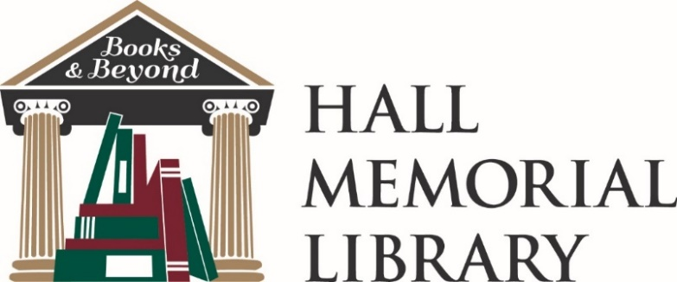
93 Main Street, PO Box 280 | Ellington, CT 06029 | 860.870.3160

LIBRARY OF THINGS BORROWER’S AGREEMENT AND USE POLICY

- Patrons must be 18 or over to borrow items Things from Hall Memorial Library’s Library of Things.
- Prior to borrowing Things, all Patrons must: (a) sign the Waiver and Indemnification Form; and (b) sign this Borrower’s Agreement and Use Policy.
- By taking possession of any Thing, the Patron is certifying that they are capable of using that Thing in a safe and proper manner.
- The Patron is solely responsible for items checked out from the Library Things.
- Patrons may borrow only one Adventure Kit at a time.
- All Things borrowed must be returned to the Library’s Front Desk. Adventure Kits must be handed to a Library staff member to be checked in.
- Things have varying loan periods; Adventure Kits go out for 14 days, Lawn Games for 7 days. Please be sure to review your checkout slip for item due dates.
- If a Thing is returned late, the Patron will be responsible for a late fee of $5.00 per day for every day the Library is open until the Thing is returned. Late fees will accrue to a maximum of $25
- The Library may replace Things that are severely delinquent (overdue), holding the Patron responsible for the full replacement cost. If the Thing is declared lost the patron will be responsible for the full replacement cost.
- Things may be reserved by Patrons for a 24-hour hold.
- Patrons may not renew Things.
- The Patron agrees that the Library is not responsible for any manufacturing defects in quality of workmanship or materials inherent in any borrowed Things, and is not responsible for any other defective conditions of the borrowed Things.
- All Things must be returned in the same (or better) condition as when borrowed. All Things must be returned clean.
- The Patron agrees that if any borrowed Thing becomes unsafe or in a state of disrepair, they must immediately discontinue its use and report any damage to the Library immediately.
- The Patron agrees to pay for the loss or damage to any Thing and further agrees to accept the Library’s assessment of fair restitution for damage, soiled condition, delinquency in returning the Thing, and/or loss of items in part or total. This restitution amount could equal the full replacement cost of the Thing.
- The Library reserves the right to refuse the loan of any Thing at its discretion.

The Library reserves the right to make exceptions to any aspect of this policy due to special circumstances.

Signature__________________________________________________________ Date_______/__/__________

Name (print)________________________________________________________________________________

Signature is valid for one year
Form created April 27, 2022

