Understanding Eviction and How Libraries Can Help - Learner Guide

Housing insecurity and high rates of eviction were already a crisis in certain regions prior to the COVID-19 pandemic. Soaring unemployment levels and confusing moratoria have also aggravated the situation. Under normal circumstances, the eviction process is so complex that it can be difficult for landlords and tenants alike to understand and navigate. Over the last two years, additional layers of complexity were added as national, state, county, and municipal government implemented, rescinded, or modified an assortment of policies related to eviction. Join this webinar to understand the current state of the eviction crisis, recognize the basic stages of the process, and discuss options for preventing evictions through rental assistance. Learn how you and your library can sort through the maze and connect people to eviction-related information and services. You can make a big difference in the lives of these community members.
https://www.webjunction.org/events/webjunction/understanding-eviction.html
Presented by: Kristin Wong, Consumer Financial Protection Bureau and Deb Hamilton, Pikes Peak Library District (CO)
What are your goals for viewing this webinar?
Personal Goals
Team Goals
Overview of Eviction Landscape
What is surprising to you about the realities of eviction in the current landscape? What do you know about the impact of evictions in your library’s service area?

The Legal Services Corporation (LSC) Eviction Tracker provides access to multi-year trend data on evictions filings and related information for 884 counties in 21 states across the United States. Use the LSC Eviction Tracker Job Aide (pdf) to explore trends in your area.

What are you able to find out about eviction rates in your state? In your county?

Phases of Eviction
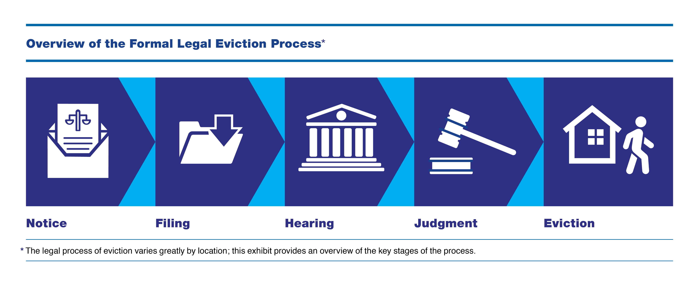
How does understanding the phases of the eviction process help you prepare to respond to patrons with eviction issues?

Civil Legal Reference
How confident are you in your understanding of the line between providing legal information and giving legal advice?

For more information, watch the 9-minute video on Legal Information vs Legal Advice.

For some practice, enroll in The Legal Reference Interview (Course 4 in the Creating Pathways to Civil Legal Justice series) and test yourself with the two interactive scenarios at the end of the course.

Partners and Referrals
What partners and relationships with legal aid agencies do you already have to help with the general civil legal issues of your patrons? Who are potential partners to address housing insecurity and eviction prevention in your community?

1.

2.

3.

Partnering with Legal Service Providers (Course 3 in the Creating Pathways to Civil Legal Justice series) will help you identify providers and partners to better serve your community’s general civil legal needs.

Eviction Prevention: Rental Assistance
When CDC moratorium on evictions ended in August, the Emergency Rental Assistance Program (ERAP) was established to help renters stay housed. Billions of dollars are being distributed through state and local channels.

Using the Consumer Financial Protection Bureau (CFPB) site to Find Help with Rent and Utilities in your location, what did you learn that might help your patrons?

How might you help patrons with low digital literacy skills who need to complete and submit forms online? Whose help could you enlist, either internal or external, to provide tech support to patrons?

Action Plan
What are the first steps you might take to start helping patrons facing eviction? (e.g., take a course to enhance your civil legal reference skills, identify and call at least one potential partner in the arena of housing insecurity, etc.)

Eviction Resources for Libraries has been created to help you respond to your community’s eviction issues:
- Key resources
- Links to finding local information
- Housing help for special populations
- Finding general legal assistance in your area
- Links to eviction and moratoria data
- Stories of effective partnerships between libraries and legal agencies
- …and more
https://www.webjunction.org/news/webjunction/eviction-resources.html

