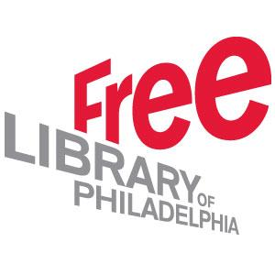

Webinar 1
Skills for Community-Centered Libraries:

Building Connections

Take and Turn

This project was made possible in part by the Institute of Museum and Library Services [Grant #RE-95-17-0089-17].

Take and Turn

Workshop 1: Building Connections

Within the first week back at work, fill out each box below on any work day(s) you like. Bring this assignment to the next workshop.

Team Roles—Which of your team roles did you use today? Which strength(s) did you use performing those roles? Did you stretch into a new role? How?
- Date:

Networking Introductions—Who did you talk to today? For what purpose? How did it go? What did you learn about this person? Could this person be a community asset for your library? How?
- Date:
- Person talked to:
- Next steps:

Take and Turn

Community Assets: A Game Plan

Get to know your community for yourself!
You’re going to create a game plan for taking a walk around your neighborhood library. While you’re walking, you’re encouraged to introduce yourself to people and find out how they use your library. If your library is located in a suburban or rural area, consider where you could go to connect with community members. Perhaps you can visit a strip mall where people do their shopping or local park. Each community will look different, so think of the spaces in your community that will allow you to meet new people.

There is no outcome to your introductions other than to learn someone’s name and make a personal connection with them about your library—remember that this is the first building block to creating relationships. Please talk with your supervisor about how to find the time for you to go on your community walk.

Possible dates for my community walk:

Possible friend/coworker who could come with me:

Ideas for specific community members/community assets I might engage with that would benefit our library programming:

Time I plan to spend walking:
(Be sure to block this time on your calendar if you keep one.)

If needed, alternate plan:

