“We’re Not Complete without You”: A Collaborative Art Project

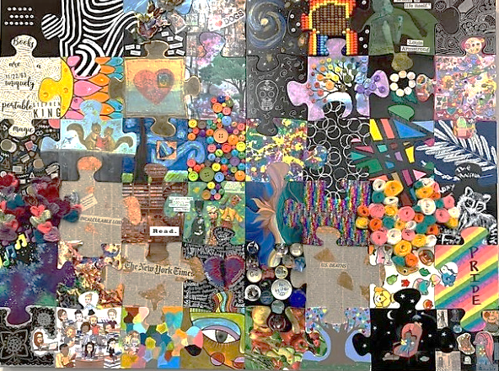
Decorate your puzzle piece on the SIDE WITHOUT THE WRITING. Use the grid letter/number on the back of the piece to see which way it will be displayed. This will be important if you have words or an image that needs to be turned a certain way. The finished puzzle will be assembled to hang near the Reference Desk.
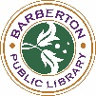

Rules:
- For adults and teens aged 16 and up.
- You may paint/Sharpie, decoupage, attach 3D embellishments, etc., but do not decorate the edges or alter the shape of the piece.
- No profanity, politics, or hate speech allowed.
- Puzzle pieces must be returned to the library by 1/12/21.

“We’re Not Complete without You”: A Collaborative Art Project

Decorate your puzzle piece on the SIDE WITHOUT THE WRITING. Use the grid letter/number on the back of the piece to see which way it will be displayed. This will be important if you have words or an image that needs to be turned a certain way. The finished puzzle will be assembled to hang near the Reference Desk.

Rules:
- For adults and teens aged 16 and up.
- You may paint/Sharpie, decoupage, attach 3D embellishments, etc., but do not decorate the edges or alter the shape of the piece.
- No profanity, politics, or hate speech allowed.
- Puzzle pieces must be returned to the library by 1/12/21.

