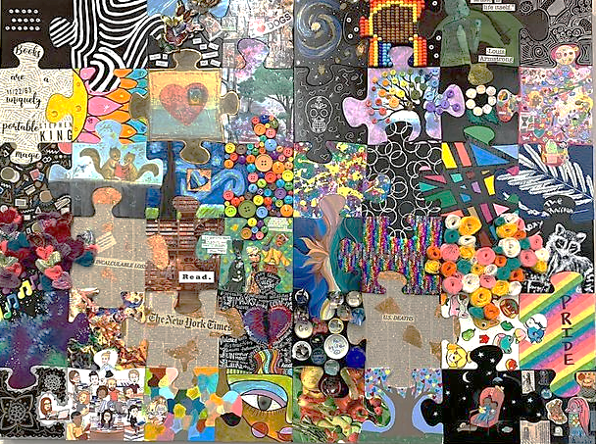
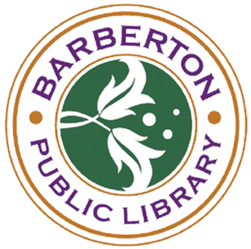
“We’re Not Complete without You”: A Collaborative Art Project

Attention Artists & Crafters: Please join us for a collaborative art project! As we continue to practice social distancing for the safety of our community, it's important to remember that we are in this together, even if we are separate. Join other BPL patrons in creating a large 48 piece wall puzzle (24” x 36”) to be displayed in the library. Stop by the Reference Desk to claim a blank puzzle piece and decorate that piece in a way that represents you as an individual. Limited pieces are available; one piece per person. For adults and teens aged 16 and up.

Pieces may be picked up beginning December 10, 2020 and must be returned to the library by January 12, 2021. The finished puzzle will be assembled to hang near the Reference Desk.

Rules:
- For adults and teens aged 16 and up.
- You may paint/Sharpie, decoupage, attach 3D embellishments, etc., but do not decorate the edges or alter the shape of the piece.
- No profanity, politics, or hate speech allowed.
- Puzzle pieces must be returned to the library by 1/12/2021.

