Help Teens Build Financial Well-being at Your Library - Learner Guide
https://www.webjunction.org/events/webjunction/help-teens-build-financial-wellbeing.html
Event Description: As children grow, their potential to manage money and understand financial concepts grows as well. The knowledge, skills, and behaviors kids learn when they are young lay the groundwork for their financial well-being as adults, and libraries can play a role in building these important financial literacy skills.
The CFPB released youth financial education content with a robust set of activities for teen financial education programing. While designed for a classroom, these activities can be translated into youth financial education programing in your library. A robust search feature provides access to free high school activities to teach the building blocks of financial capability on topics ranging from saving for short-term goals, to preventing fraud and identity theft, to budgeting and managing credit. Join us to learn how to help your teen patrons become empowered to navigate their financial futures.
Presented by: Leslie Jones, Rachel Grimes, and Kristin Linscott.
What are your goals for viewing this webinar?
Personal Goals
Team Goals
Assess Teen Financial Literacy Skills Gaps
Before you begin to meet local teen financial literacy needs, explore existing level of financial competencies and existing education being offered through local schools.

Explore your state’s information in these resources:
- National Financial Capability Study http://www.usfinancialcapability.org/
- Next Gen Personal Finance has a “Got Finance?” tool, https://www.ngpf.org/school-search/
- Champlain College, National Report Card on States’ efforts towards FinED. It is updated every two years. The last version was release in December 2017. https://www.champlain.edu/centers-of-experience/center-for-financial-literacy/report-national-high-school-financial-literacy

How is teen financial literacy being addressed/not addressed locally? How else can you develop an understanding of current status? How does teen financial literacy align with your organizational mission?

Explore the Building Blocks of Financial Capability
CFPB has researched the childhood origins of financial capability and well-being to identify those roots and to find promising practices and strategies to support their development. Explore the Building Blocks of Financial Capability and identify areas for your programming focus.

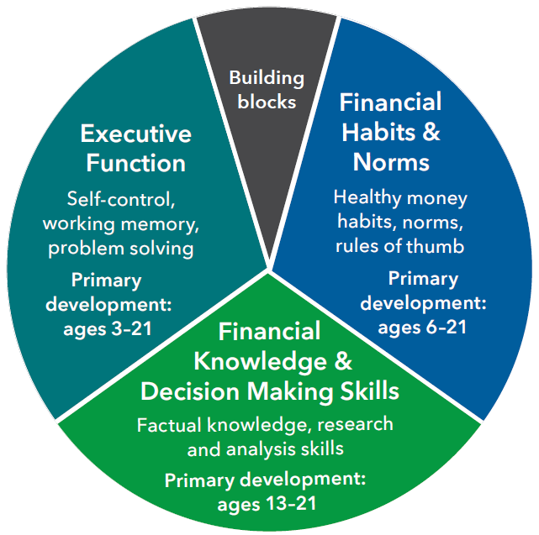

Explore the development, milestones, Instructional strategies, and Learning activities for each of the building blocks:

Executive function

Financial habits and norms

Financial knowledge and decision-making skills

Designing Programs

Explore CFPB’s financial literacy activities database and identify possible programs for your library. Each activity comes with a teacher/instructor guide and supporting student material. Use these available filters in searching:

Building blocks: Financial Habits and Norms and Financial Knowledge and Decision making skills

Activity Characteristics (Activity type) – Small group or Whole class

Activity Characteristics (Teaching Strategy) – Direct instruction, Gamification or Personalized instruction

Activity Characteristics (Activity duration) – probably 15-20 minutes or 45-60 minutes would work best

1.

2.

3.

4.

5.

Identifying Partners
Working with partners on programming and services for developing teen financial literacies is a great way to align with community priorities and expertise. Review CFPB’s Community partnership guidebook for libraries (PDF) and beginning on p. 12, use the Program Planning Worksheet to identify specific program needs and possible community partners.

And when you’ve identified a program and potential partner, use the Program Partner Outreach Form on p. 15 to clarify roles and responsibilities.

Action Plan: (include next steps, who, when, etc.)

