Group Notes at ALA Midwinter session, Return to the Real: The Library as Social Connector. See all resources here on WebJuction: [oc.lc/socialconnector](https://oc.lc/socialconnector)

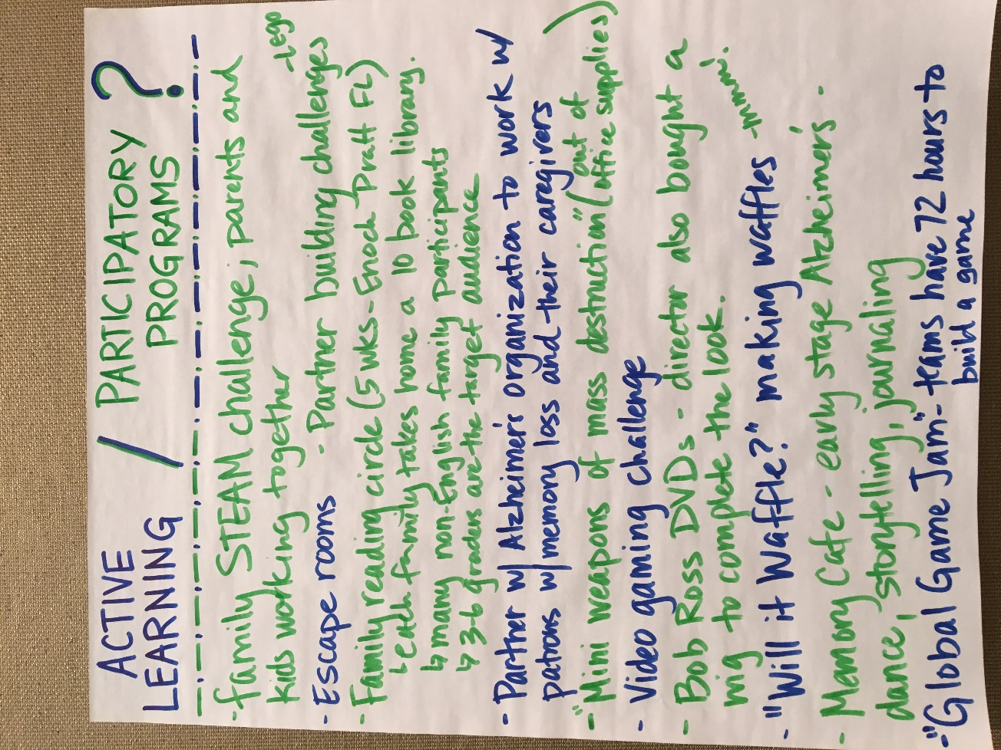

The group worked through these steps together to SOCIALIZE the program:



