Library Programming for Adults, From Start to Finish - Learner Guide
https://www.webjunction.org/events/webjunction/library-programming-for-adults.html

Event Description: Adult programming at your library can bring the community together in meaningful ways but finding the ideal program and attracting the right audience can be overwhelming. This webinar will teach you to plan events and programs from start to finish, including identifying potential partners, getting community input, and successful marketing. Learn how to deliver quality, budget-friendly programs that will bring in the crowds without reinventing the wheel. From choosing dates and times to selecting events that get results, you’ll hear practical tips on everything it takes to launch adult programs your community will love.

Presented by: Cara Romeo
What are your goals for viewing this webinar?
Personal Goals
Team Goals
Assessing Community Makeup and Interests
Before you identify potential programs for your library, take a closer look at your community and their interests.
- What type of events are happening in your community? Arts, sports, cultural, activities?

- Who attends those events? Families, singles, 20-30’s somethings, senior citizens, college students?

- What can you learn about them from existing programming? E.g., large attendance at family evening or Saturday programs, millennials attending film screenings and cooking classes but never coming to a book club.

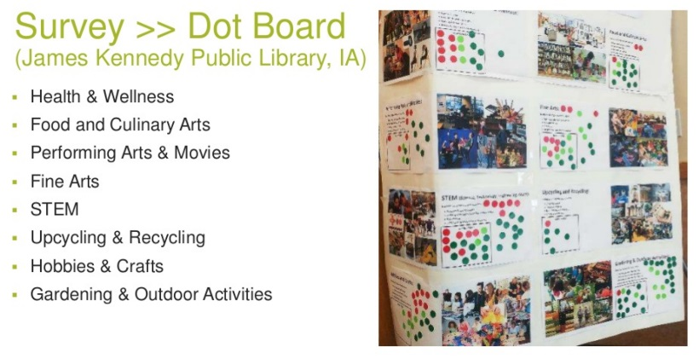
- Consider asking the community to help prioritize programming topics using a dot board like this one at the James Kennedy Public Library.

(See more on community discovery and ideation: https://www.slideshare.net/oclcr/community-discovery-and-ideation-creating-smart-libraries)

Potential Programming Partners
With limited resources, staff and budgets, reaching out to potential community partners can be a great way expand your library’s programming. Consider non-profits, government agencies and educators that you might connect with for potential programs and identify who from your team could make those connections. For an extended list of options, review potential partners for collaboration in WebJunction’s Community Partnership and Collaboration Guide.

4.

Determine Your Program
Using what you’ve learned about your community and potential partners identify programs of interest and consider the following as you determine the best approach.

- Program Topic(s):

Format: Hands on class, demo, discussion, seminar, informal interactions or other?

- Library goal satisfied with program:

- Target audience(s):

- Space needed:

Staff and volunteers needed:

- Date & Time:

- Budget (including marketing):

- Take registration or require fee:

- Marketing timeline and channels:

Marketing Plan
Now it’s time to spread the word far and wide! Consider all the following channels as you develop your marketing plan.
Traditional Media (free or paid ads)
- Newspaper
- Radio
- TV/Cable

Social Media
- Facebook
- Twitter
- Instagram
- YouTube

Online Resources
- Library Website
- Library calendar
- Community calendar

Print Materials
- Newsletter
- Posters
- Postcards
- Materials for inside and outside library

Remember to ask programming partners to repost your marketing efforts on their social media channels and on their websites and calendars, and leave printed materials at their locations!

Action Plan: (include some simple next steps, along with who, when, etc.)

