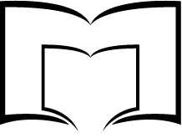
Opening
June 2nd, 2018!
Millvale Tool Lending Library

Open Saturdays, 10:00 am - 12:00 pm
Tuesdays, 6:00 pm - 8:00 pm
Fridays, 10:00 am-12:00 p.m.

The Tool Lending Library is a new resource available to all adult Allegheny County residents, provided by the Millvale Community Library.

Through the Tool Lending Library you can check out a wide variety of tools for one week at a time for free using your library card!

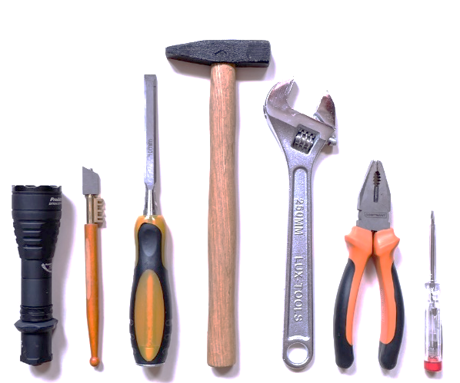
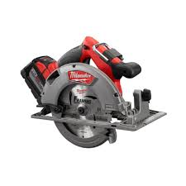

Hand Tools, Yard Tools, Gardening Tools, Masonry Tools, Bike Tools,
Mechanic Tools, Power Tools, and Cleaning Supplies
are all available through the Tool Lending Library!

Contact:
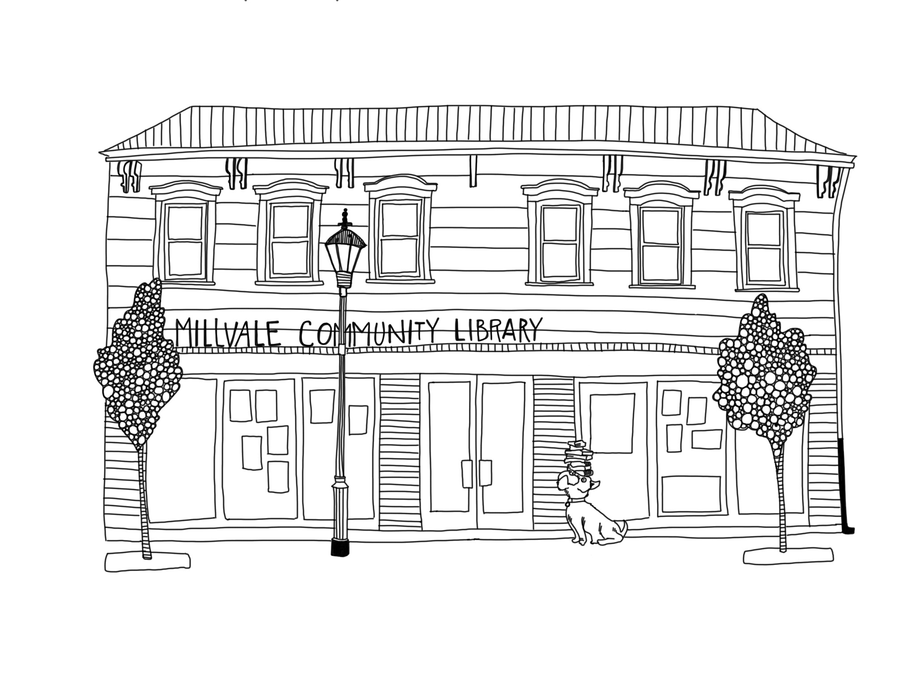
Millvale Community Library
213 Grant Ave.
Millvale, PA 15209
412-822-7081
www.millvalelibrary.org

