Learning on the Go-Go-Go!
Learner Guide

Session Description: When an active library keeps staff busy all day, who has time to stop and learn? Yet the ever-changing and emerging needs that keep us busy also make learning imperative. Join this interactive session to explore resources and strategies for integrating learning into your work day, and motivating others to do the same. Using a learning plan, you’ll be able to take charge, prioritize and manage your learning flow. Taking a flexible approach to lifelong learning is a great way to have fun and to apply new skills that benefit and impact you, the library and your community.
Presented at ARSL 2018 by: Jennifer Peterson, WebJunction Community Manager, OCLC
What are your goals for attending this session?
Personal Goals
Team/Community Goals
Meet the Modern Learner
Review the Profile of a Modern Learner in 2018 (https://www.elucidat.com/blog/modern-learner-profile-infographic/) built on the 2014 research and infographic (Bersin by Deloitte) and check off those qualities below that currently align with your own experience:

- Overwhelmed and distracted
- Keen to learn
- Wants personalized, timely, quality content
- Learns as needed, anywhere, anytime
- Turn to my phone
- Prefers learning to be on the job
- Most values quality, ease of use and relevance in online learning
- Seeks out learning on soft-skills
- Motivated to learn because I want to do better and be more productive

Understand Your Motivation
What motivates you?

Explore what motivates others in article, Anytime + Anywhere = Never: Motivating the Self-Directed Learner (https://www.webjunction.org/news/webjunction/anytime-anywhere-never-sda.html)

As a first step in growing as a self-directed learner, identify those factors that motivate you, and keep them front and center, revisit when you get stuck and update when you find new motivation!

And be sure to jot down contact information for your new CONFERENCE BUDDY!

On Learning Plans
Review the 5 assumptions about adult learning from Knowles’ Principle of Andragogy
outlined in, Personal Learning Plans: a Tool for Engaging and Retaining Talent, by Christy Ciezki & Nisha Kharé (https://associationdatabase.com/aws/NCDA/pt/sd/news_article/28851/_self/layout_details/false)

- The need to be self-directed increases as self-concept develops
- Experience becomes a key resource for learning and also impacts how individuals have developed their preferred style of learning - learning is very individual
- Adults' readiness to learn is influenced by a perceived need in their own life situation, which is unique and varies among individuals.
- The orientation toward learning shifts toward problem-centeredness and learning which can be applied.
- Motivation to learn becomes internal - children respond to external motivators (parents'/teachers' expectations, grades, etc.), but adults' deepest motivation is intrinsic (increases in self-esteem, responsibility, creativity and self-fulfillment).

Knowles also identified three important reasons for self-directed learning:
- Individuals who take the initiative to learn on their own enter learning more purposefully, with greater motivation, and learn more deeply and permanently;
- Self-directed learning aligns with the natural process of psychological development, which is to take greater personal responsibility in one's life; and
- Many new developments in education place responsibility on learners to take initiative in their own learning. In the past decade, the use of learning contracts has gained greater acceptance, as research on self-directed learning has led to the need for appropriate learning resources. Employers have also come to demand increasing flexibility and autonomy of workers, as well as the ability to reflect on one's practice as a professional.
Creating a Self-Directed Learning Plan

Because self-directed learning is such an individualize experience, there is no set template for an effective learning plan. Explore some of the options below and experiment; it doesn’t need to be set in stone!

We recommend Rachel Dobb’s 5 Step DIY Self-Directed Learning Plan (http://rachel.we-are-low-profile.com/blog/5-step-self-directed-learning-plan/) as a good place to start.

- Understand your motivation. You can start to do this by asking yourself some questions:

- What am I curious about? And what would I like to understand better?
- How would I like to challenge myself by learning something new?
- What is important to me about learning ____________?
- How does learning ____________ relate to other things I’d like to achieve in my work / life / relationships with others?

- In what ways will learning ____________ allow me to feel more confident / better equipped for my work / life / relationships with others?

- How could I use my new knowledge or skills to help other people / contribute to new projects?
- How does learning ____________ help me to feel more in control of choices I make around my work / my environment / other aspects of my life?

- How might my accomplishments in learning ____________ be recognized by others?

- Be clear & S.M.A.R.T. about what you are planning to learn
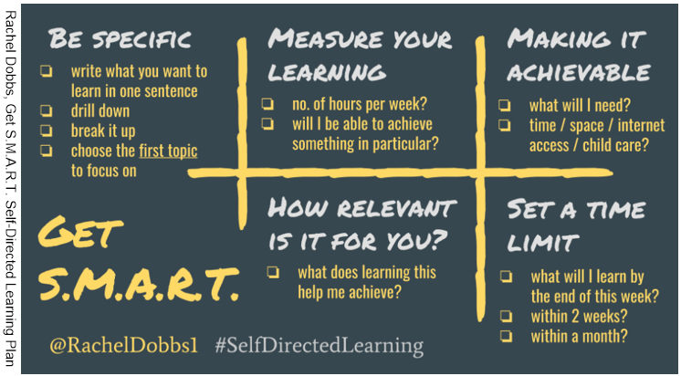
- Get organized with your time & tracking your learning. To track your learning, it is worth quickly recording the following things (in a notebook, or easily accessible document):
- What source have I been engaging with? (e.g. link to webpage, video, online course etc.)
- Quick Summary of what is being discussed
- What ideas have come up while watching / reading / engaging with this?
- What do I know now that I didn’t know before?
- Anything I’d like to research further? Or links to follow?

- Make a public commitment to your learning & buddy up

- Apply what you are learning in real-world projects

Explore additional resources on learning plans:
- https://www.mindtools.com/pages/article/personal-learning-plan.htm
- http://etale.org/main/2014/06/03/5-templates-to-use-for-self-directed-learning-projects/
- https://www.teamfluent.com/blog/how-the-individual-learning-plan-benefits-everyone
- http://communitylegalqld.org.au/files/self-directed-learning-record-template

Ways to Learn
Check off the ways you currently approach learning, and circle those methods you’d like to experiment with more in your learning:

- Reading
- Social media
- Listservs
- Discussions (online or Face2Face)
- Self-paced courses
- Webinars
- Face2Face Training
- Learning Together
- Pause and view shorter segments, self-paced courses and webinar recordings
- At staff or board meetings, set aside time for learning or share what you’re learning
- Staff or community initiative, e.g. 23 Things (https://en.wikipedia.org/wiki/23_Things), Bingo (see https://www.webjunction.org/news/webjunction/reading-conversations-RA-for-all-library-staff.html)
- Tap local resources, internal knowledge, cross-sector knowledge
- Self-directed achievement, see webinar with Tooele City Library (UT) (https://www.webjunction.org/events/webjunction/Self_Directed_Achievement.html)
- Cohort Learning and Learning Circles (see related resources https://www.webjunction.org/events/webjunction/the-webjunction-experience.html)
- Other:
- Other:

Learning Sources
Explore WebJunction, where learning is free to library staff and volunteers everywhere!
- WebJunction Topics https://www.webjunction.org/explore-topics.html
- WebJunction Live Webinars https://www.webjunction.org/events/webjunction.html
- WebJunction Course Catalog (Over 300 self-paced courses and webinar recordings) https://learn.webjunction.org/
- Social Library Series https://www.webjunction.org/explore-topics/social-library.html

Other Free Webinars (updated monthly by the Wyoming State Library) https://www.webjunction.org/find-training/free-events.html

Collection of Online Library Learning, shared in an Infopeople webinar, Creating Space for Online Learning: https://infopeople.org/sites/default/files/civicrm/persist/contribute/files/webinar/2018/5_18_18/Resources_SpaceforLearning_5_18.pdf

Notes on other learning sources to explore:

On Learning Organizations
Take the next step with your library’s learning and explore what it means to be a learning organization. With so many theories, resources and tools related to learning organizations, we recommend learning from the synthesis and tools provided by faculty at Harvard Business School.

Is Yours a Learning Organization?
Toolkit by David A. Garvin, Amy C. Edmondson, and Francesca Gino, 2008

- Article (with Video) https://hbr.org/2008/03/is-yours-a-learning-organization
- Learning Organization Survey: https://hbs.qualtrics.com/jfe/form/SV_b7rYZGRxuMEyHRz?Q_JFE=qdg
Collecting and analyzing organizational research over the past two decades, the authors reveal three broad factors essential for organizational learning and adaptability. They refer to these as the “building blocks of the learning organization” and identify subcomponents for each, revealed in these statements:
- Supportive learning environment. "An environment that supports learning has four distinguishing characteristics: psychological safety, appreciation of differences, openness to new ideas, time for reflection."
- Concrete learning processes and practices. "For maximum impact, knowledge must be shared in systematic and clearly defined ways. Sharing can take place among individuals, groups, or whole organizations. Knowledge can move laterally or vertically within a firm."
- Leadership that reinforces learning. "When leaders actively question and listen to employees ̶ and thereby prompt dialogue and debate ̶ people in the institution feel encouraged to learn."
Notes and Next Steps!

