Your logo

Illustration credit: Wikimedia Commons, public domain, MichaelPhillip

“Wikipedia + Libraries Inspiration Finder” by WebJunction is licensed under CC BY 4.0.

1. Cut out the large square.
2. Place your Inspiration Finder print-side down and fold the four corners to meet in the middle.

A close up of a logo

Description generated with very high confidence 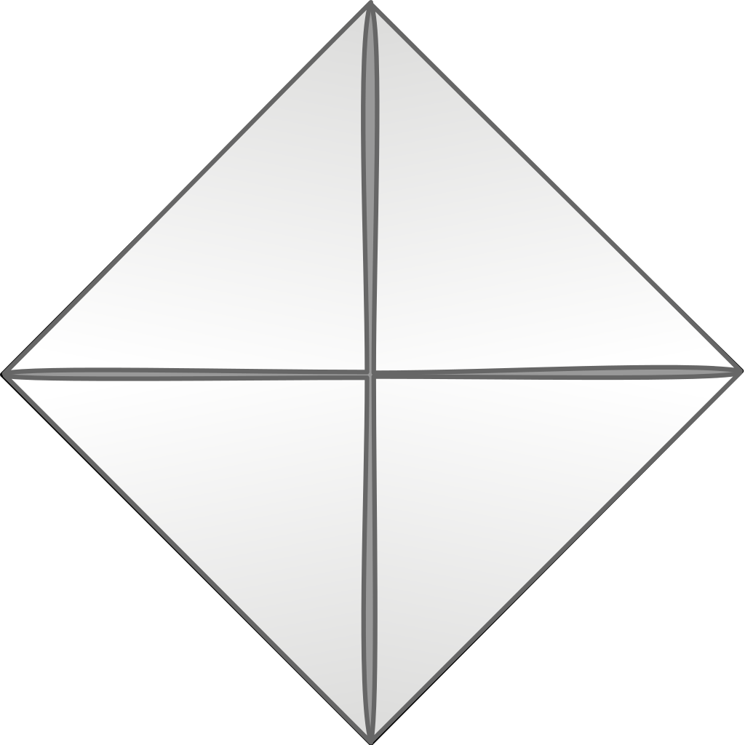

1. Flip paper over and fold the new corners to meet in the middle.

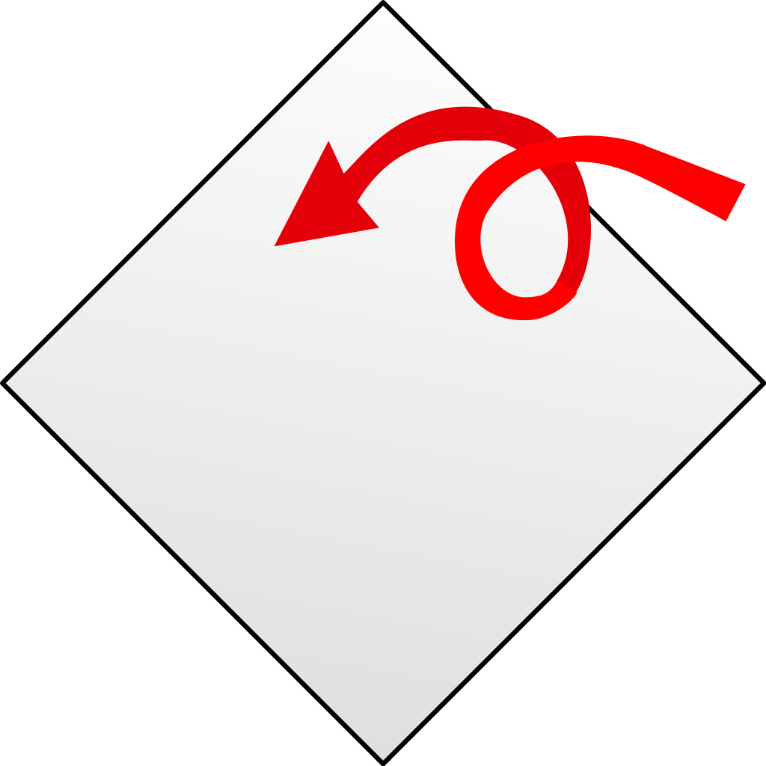 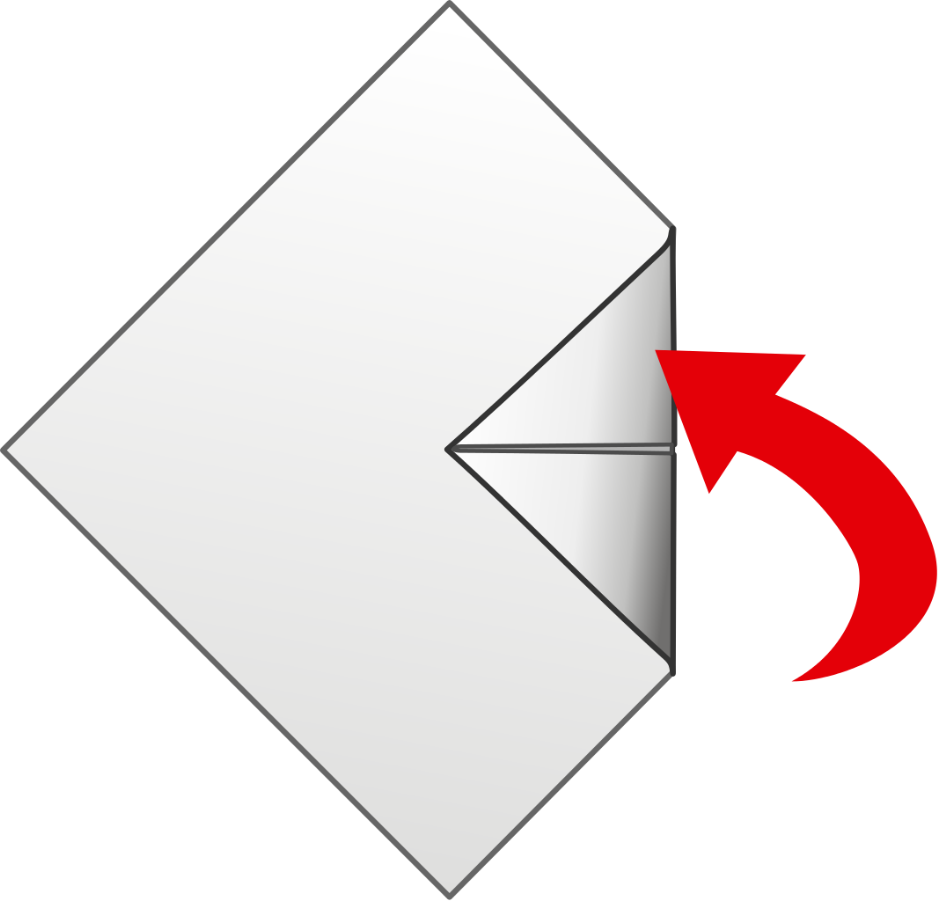

1. You should have a square. Fold the square in half to make a rectangle.

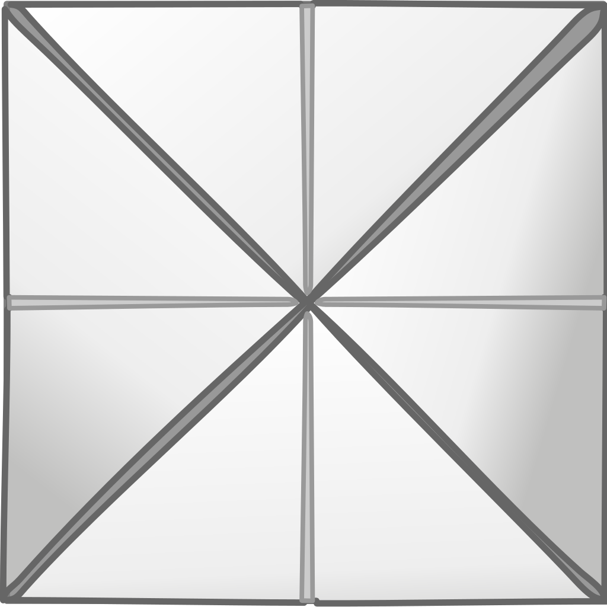 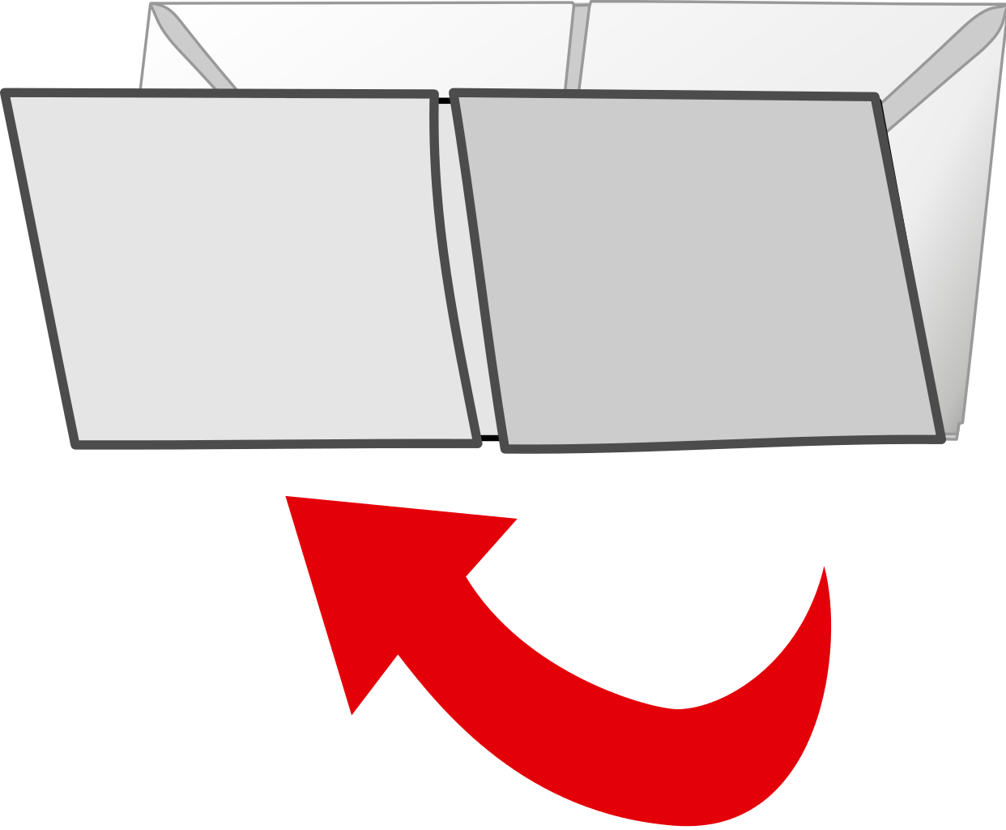

1. Place your thumbs and fingers underneath the flaps to operate. 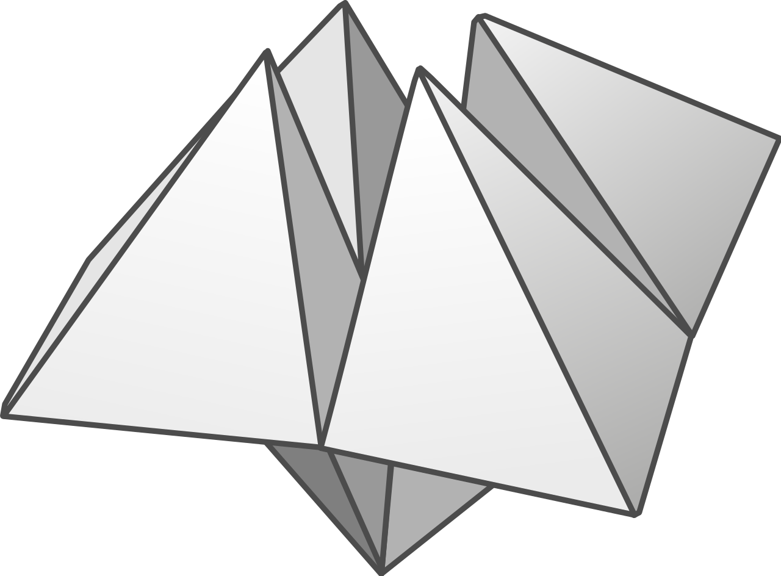

Insert message

Insert message

Insert message

Insert message

Insert message

Insert message

Insert message

Insert message

4

3

2

1

D

C

B

B

A

A

A

A

A

do

create

learn

read