Laying Out the Welcome Mat: Asset Mapping to Better Serve the Immigrant Community - Learner Guide
https://www.webjunction.org/events/webjunction/laying-out-the-welcome-mat.html

Event Description: As of 2016, more than 43 million immigrants were living in the US, and that number is growing. Immigration can breathe new life into the local economy as young workers replace retiring baby boomers, open new businesses, and become active consumers. Libraries can ease immigrants’ transition into the community by acting as a resource hub. Asset mapping encourages libraries to go out into their communities and uncover and assess the resources available to immigrants. The information they gather gives the insight libraries need to develop programming to serve these patrons and help them thrive. This webinar will discuss how asset mapping can facilitate community entry for immigrants by helping libraries better understand the needs of this population and address those needs through service and program development.

Presented by: Heather MacKenzie, Amanda Fullerton, and Kenneth Williment

What are your goals for viewing this webinar?
Personal Goals
Team Goals
Outreach vs. Community Led
Review the Public Involvement Continuum shared below and in the Community-Led Libraries Toolkit (p. 18) and consider/discuss how community led engagement differs from outreach. How can you begin to move along the continuum using your existing outreach efforts? How can you focus more on the community and not the library?
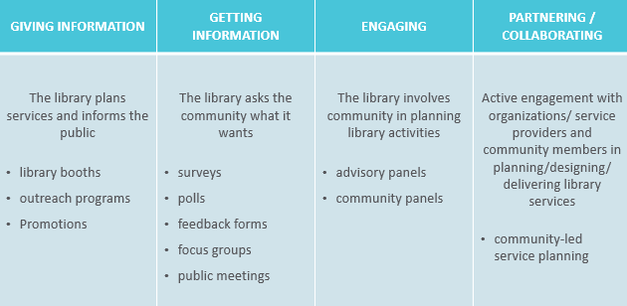
Community Scan
Who lives in your community? Where are newcomers from? What do you know about them? Do you want to focus on the entire newcomer community or just one specific group?

Who is counting or reporting on information and statistics about immigrants? Can they help in reaching the immigrant community or key stakeholders?

Consider the following:  - Country or countries of origin  - Length of residence in U.S.  - Facility with English language | - Educational level  - Economic level  - Level of acculturation  - Understanding of the library
Moving Toward Community-led Service Planning Process
As you build your community profile, and identify the needs, aspirations, assets, and challenges of specific groups, keep in mind the traditional vs. community-led service planning process outlined below and on p. 30 of the Community-Led Libraries Toolkit. Note that the two approaches will continue to function in tandem with one another and that depending on the work you are doing, you will use some and not the others. But remember that collaboratively planned collections, services, programs, and policies reflect community needs and incorporate community creativity and choices. Circle those approaches where you’d like to focus your efforts.
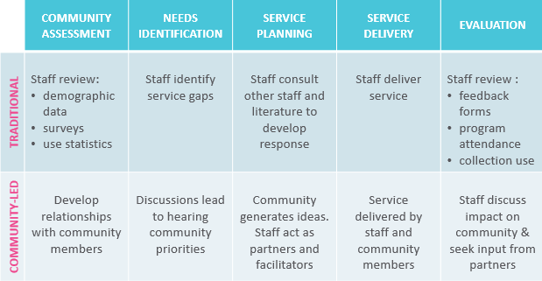
Community Entry Techniques
Explore and take notes about each the Community Entry Techniques described beginning on p. 35 of the Community-Led Libraries Toolkit. Check the techniques you’d like to focus on in your local efforts.

- Third-party facilitated approach (Service Provider)

- Door-to-door and Neighborhood Walkabout

- Word-of-Mouth

- Community Events

- Outreach Activity

Managing Asset Mapping Information
As noted in the 2012 article about Halifax’s asset mapping work: “When collecting information about organizations and considering how this information would impact library services, it was important to consider how the information could be shared within Halifax Public Libraries. In response, Halifax Public Libraries is currently developing an internal asset mapping database. This database will allow information sharing between branches and service areas. For instance, if a branch manager meets with a service provider from a local long-term care facility, members of the Halifax Public Libraries Regional Services to Older Adults team can access the information collected to determine if other partnership opportunities exist.”

How will your library’s asset mapping information will be collected, stored, shared and analyzed?

Shared Staff Commitment and Capacity
Confirm that staff involved in an asset mapping process understand the purpose. This will ensure staff buy-in and help to clarify procedural applications of the tool. Consider or discuss some of the ways to orient staff to asset mapping from a community development perspective. Who needs to be onboard? What sorts of adjustments in workloads or schedules need to occur to provide time for designated staff? How will job descriptions need to shift to allow staff to go out of the branch to collect information? What additional training would benefit staff moving into this work, including on cultural competence and relationship-building, and listening skills?

Action Plan: (include some simple next steps, along with who, when, etc.)

