Visualizing (and Finding!) Funding for Libraries
http://www.webjunction.org/events/webjunction/visualizing-and-finding-funding-for-libraries.html

Event Description: This webinar will introduce participants to a dynamic and freely available data-visualization tool, Visualizing Funding for Libraries that enables library professionals and supporters to search for institutional funding for libraries at national, state, and local levels. Participants will learn pro tips on navigating the tool and as well as next steps on how to pursue new funding opportunities. Data visualizations such as maps, network constellations, and partnership pathways showcase key networks of funders and recipients, as well as individual grants that highlight the library services and programs that are winning grants. Visualizing Funding for Libraries is a Knight Foundation News Challenge winning project.

Presented by: Kate Tkacik, Manager of the Funding Information Network, and Amanda Dillon, Manager of Knowledge Services, both from the Foundation Center.

What are your goals for viewing this webinar?
Personal Goals
Team Goals

Discussion/Reflection Question 1
Do you have any experience with fundraising or grantseeking? Think about individuals, foundations, government. Do you have working knowledge of your libraries’ funding strategy?

Activity 1
Using only the knowledge that you and your colleagues viewing the webinar share, create what you imagine your library’s revenue breakdown to look like. See below for an example.
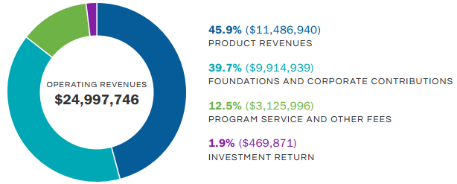

Discussion/Reflection Question 2
Find your library on the Visualizing Funding for Libraries data tool. Who has given your library a grant in the past? For what? Who are the other foundations giving grants in your region? Who else is receiving grants?

Activity 2
From these questions, look at which foundations may be good funding prospects. Look at the Pathways and Constellations features to see who you’re connected to. What are some of these foundations’ average grant size? What are their priority areas? How do you apply to them? (Hint: Look at their organization profile and website for more information).

Activity 3
Think about where grant funding fits into your library’s revenue model from above. Brainstorm a few projects that you’ve been thinking of implementing at your library that could be supported by a grant.

1)

2)

3)

Action Plan: (include next steps, who, when, etc.)
Share this information with your library’s leaders, decision-makers, and any fundraising support groups including friends of the library and library foundations.

