6 Steps to a Great Elevator Speech
Step 1 – Tell us your name . . . .
Step 2 – Tell us your positioning statement (4-6 words that uniquely define you in the market)
Step 3 – Tell us your brief career summary (last position, industry, a key accomplishment or two)
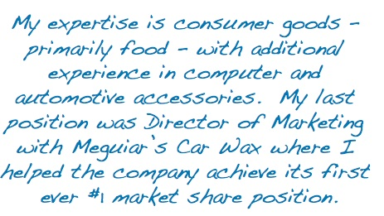

Step 4 – Tell us your work philosophy (how you work, what reinforces your true value)
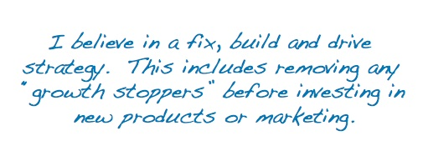
Step 5 – Tell us your specific job search objectives (target title, function, industry, geography, companies)
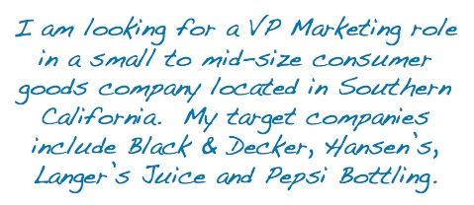
Step 6 – Tell us how you can help others (i.e. us)!
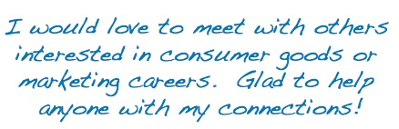
And that’s it! About 45 seconds. You can add or delete words to get down to 30 or up to 60 depending on the guidelines provided by your networking group.

