**Library CE Institute Workshop:   
Course Development Workbook**

The instructional designer **crafts** a learning **experience** that **guides** the learner through a **relevant context** to make decisions **applicable** to their **real-world work**.

—paraphrased from Tom Kuhlman

The instructional designer is also a project manager, a negotiator, and certainly a juggler. There are many elements to align, including people, in the process from course concept to completion. This workbook is intended to help you think through the integration of all those elements and be able to corral all the pieces into a successful whole. The workbook is presented in three sections.

**Pre-storyboard Phase 1**

* Topic focus
* Target audience
* Learning objectives

**Pre-storyboard Phase 2**

* Learning assets
* SMEs (Subject Matter Experts)
* Strategies and engagement techniques

**Storyboarding for Real**

* Putting all the pieces together into a coherent outline

Keep in mind that the process is iterative; you can go back and tweak or adjust prior decisions at any time as you add elements and think through the course outline more thoroughly. These workbook activities are designed to help you get the process rolling.



*The Library CE Institute is a partnership of WebJunction and Infopeople, generously supported   
by a grant from the Institute of Museum & Library Services (IMLS).*

# Activity: Pre-storyboard Phase 1

In this first phase, you will begin to define three elements—**topic focus**, **audience** and **learning objectives**.

All three elements are entwined and need to be considered in relation to each of the other two. This is not a linear step-by-step process. Think of it as more of a triangle of elements that you need to connect and balance.

**Topic Focus**

It is critically important to narrow your topic focus to something that is achievable within the timeframe of this program. The temptation to cover a broad swath of information is great. Remember the concept of “coursels,” or course morsels, which can stand alone as learning opportunities and be strung together for a more comprehensive curriculum. Create a strong first coursel and you may have the start of a potential course series.

Consider:

* What aspect of the topic will be addressed by training?  
  See Cathy Moore’s [Action Mapping Flowchart](http://blog.cathy-moore.com/wp-content/action-mapping-flowchart-v2.pdf) to help determine if training is the answer for a particular training goal: <http://blog.cathy-moore.com/wp-content/action-mapping-flowchart-v2.pdf>
* What aspect of the topic is most suitable to self-paced e-learning?
* What is the vital need to know information or skill set?  
  Use the “Find your 20%” chart to begin to get to the essence of the topic.

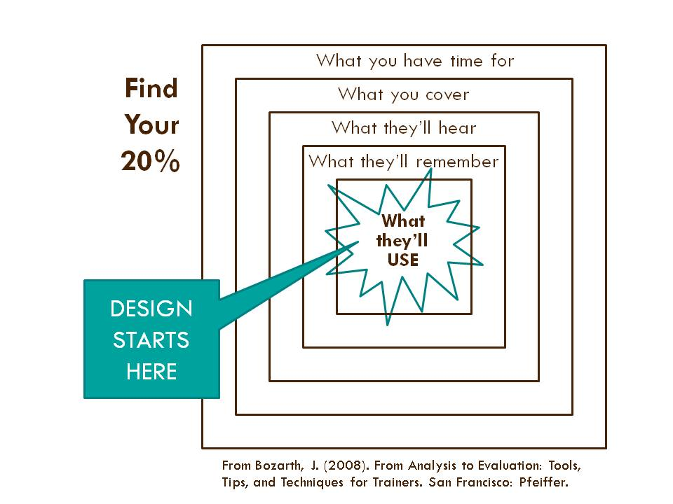

**Audience**

For the purposes of this program, it is necessary to think of your library staff audience on a national audience scale. However, it can be productive to think more particularly and locally, to describe personas of your prospective learners, and then to align these across your team.

Consider:

* Describe your learners in terms of their learning needs on this topic.
* What is their level of skill? Do you need to try to balance the instruction/information for multiple levels of skill?
* Anticipate questions your learners might have about the topic.

Keep in mind the characteristics of adult learning.

|  |  |
| --- | --- |
|  | 1. Self-directed: Adults are accustomed to moving through the world with some level of autonomy; they appreciate opportunities to explore. |
|  | 2. Past experience: Adults bring a rich array of past experiences to any new situation; the brain learns most powerfully when it can connect new information and concepts to that which is already known and understood. |
|  | 3. Relevance: Adults need to know why the new information is relevant; how it will make their lives and work better. |
|  | 4. Task-oriented: All ages—not just adults—learn by doing. Being able to practice or apply new information, including making mistakes, is the most effective way to solidify the learning. |
|  | 5. Immediate application: Especially in workplace learning, adult learners want to be able to apply new knowledge immediately for problem-solving. |

**Learning Objectives**

With a topic focus in mind and some understanding of your target audience, you can begin to define the learning outcomes—what your learners will understand and be able to do as a result of taking this course. Setting clear goals helps you design the instruction so that your learners are focused on the essential things.

Refer to:

* Infopeople’s guide to Writing Learning Objectives (handout)
* What’s the Goal?, Dirksen Chapter 3

Consider:

* What is the problem this course is intended to solve? Target the solution.
* What will learners be able to DO as a result of this learning?
* What is the observable change in performance desired? Focus on performance change rather than information learned.
* How does this training tie to organizational goals?

As a result of this course, learners will be able to…

1.

2.

3.

4.

5.

# Activity: Pre-storyboard Phase 2

Building on the elements defined in phase 1, it’s time to start thinking about the content for the course. There are many moving parts to play with, including **learning assets** and **supporting resources**, working with **subject matter experts**, and **strategies and engagement techniques**. All of this is in alignment with the topic focus, audience and learning objectives.

**Learning Assets**

Where are you on the continuum of creating a course entirely from scratch to working with existing content? Brainstorm what you know about existing learning assets that will help you avoid reinventing the wheel. Assets may include videos, screencasts, animations, recorded webinars, podcasts, PowerPoint or Presi presentations, and more. You may also want to provide supporting resources that won’t be part of the course but will extend the learning, either as pre-work or for continued exploration of the topic

Vet existing assets for:

* + - quality and authority
    - accessibility
    - copyright
    - format
    - currency and need for updating
    - need for modification

What assets are available on your topic?

|  |  |  |
| --- | --- | --- |
| **Asset (name & source)** | **How it fits with the topic** | **Modifications/updates needed** |
| 1. |  |  |
| 2. |  |  |
| 3. |  |  |
| 4. |  |  |
| 5. |  |  |
| 6. |  |  |

**SMEs (Subject Matter Experts)**

The WebJunction model uses a recorded webinar as the main source of subject matter expertise. This eliminates the back-and-forth communications and negotiations with SMEs in the course development phase but it still requires careful planning to produce a successful webinar.

* WebJunction shares best webinar production practices in their [Guide to Successful Webinars](http://www.webjunction.org/documents/webjunction/guide-to-successful-webinars.html)   
  (<http://www.webjunction.org/documents/webjunction/guide-to-successful-webinars.html> )

Infopeople works actively with SMEs to develop their online courses, as do many dedicated instructional designers. It can be a delicate working relationship.

* Tom Kuhlman (Rapid E-Learning Blog) has some words of wisdom and experience about [How to Overcome the Challenge of Working with Subject Matter Experts](http://www.articulate.com/rapid-elearning/how-to-overcome-the-challenge-of-working-with-subject-matter-experts/)  
  (<http://www.articulate.com/rapid-elearning/how-to-overcome-the-challenge-of-working-with-subject-matter-experts/> )

C:\Users\gutscheb\AppData\Local\Microsoft\Windows\Temporary Internet Files\Content.IE5\6I4SV274\MC900300954[1].wmfWho are your potential SMEs?

1.

2.

3.

4.

5.

**Strategies and Engagement Techniques**

This gets down to the real nitty-gritty of instructional design for self-paced e-learning: how will you amplify the basic content and information in order to engage your learners and help them apply and solidify the new skills and knowledge?

3 key principles

1. **Show** rather than tell
2. Design **experiences** not information
3. Provide a **relevant context** to connect the learning to the real world

Expanding on the principles (adapted from Cathy Moore)

* + - Design interactions to help learners practice the action(s) to gain skill or knowledge.
    - Chunk the content; think “bite-size.”
    - Provide realistic scenario/simulation of what they’d be doing on the job. Add realistic complications or nuances to scenarios.
    - Create challenges or problems to solve; make information an optional part of the activity for the user to access as needed.
    - Use different interactions throughout the course to keep learners engaged.
    - Insert knowledge checks after content chunks to help participants measure their learning incrementally. Use these checks or quizzes to engage the learner, not to punish.
* Provide feedback or answers to quiz questions in a way that enhances learning. Avoid unconstructive “correct” or “incorrect” feedback.

Brainstorm potential interactions, activities, scenarios, etc. to engage your learners in the topic and move them toward achievement of the desired learning outcomes. Leave it very open at this stage, introducing many possibilities and letting ideas flow.

# Storyboarding for Real

Now that you’ve brainstormed and considered the integration of the many elements of your course, you can get serious about outlining the actual course content. This is where you clearly define the content chunks, the sequence and flow, the insertion of knowledge checks and other interactions. Identify and assemble images or other media resources to be used. Sketch out the text or narration to accompany each segment.

**Course outline**

This is all about determining the sequence and flow.

* Break the overall content into chunks of learning, aiming for no more than 10 minutes per chunk.
* Determine the sequence that you think will give the learner an effective grasp of the topic.
* Include activities, interactions, simalutions, quizzes, etc. as content chunks

Focus on the learner here rather than on your own pre-conceived notion of the topic outline. In particular, be wary of SMEs’ determination of the content order. The Heath brothers, authors of Made to Stick, warn about “the curse of knowledge,” the tendency for those who are deeply knowledgeable about a subject to overwhelm the learner with A-Z, historic, detailed information. Get back to what the learner will be able to DO.

* Refer to Dirksen, p 68, for an inverted perspective on the Bloom’s Taxonomy tradition order of learning progression.

**Content Assets**

Add in content assets pertaining to each chunk of the outline. If they are existing, indicate the source and attribution for each asset for future reference. Indicate if the asset is new and needs to be created.

**Visuals & Design Elements**

Include images or graphic elements (photos, logos, charts, etc.) to include with each content chunk. Indicate the source and attribution for each element for future reference.

You may want to indicate other design elements if they are already determined, such as font, color schemes, or layout template. Otherwise, you can make all these choices in Storyline.

**Screen Text & Narration**

This is the place to be clear and consistent about what text will be included on each screen, noting there may be multiple screens for each chunk. This includes labels for buttons, activity feedback text, content of information supports, etc.

You may also want to have a voice narration for the course. It is best practice to write out the script verbatim. If it is too much to include in the template, indicate where to find it and indicate clear begin-and-end points to align with screen changes.

**Audio Track**

If you want to have music or other voice-over in the course, indicate the file name, source and attribution in this column. Also note the begin-and-end and critical alignment points with the rest of the content.