**Social Media Best Practices & Guidelines**

This document outlines best practices for taking full advantages of the social media tools provided in the toolkits and practical tips on how to utilize Twitter and Facebook to engage with target audiences.

**General Social Media Best Practices:**

* **Establish Your Voice.** Effective social media communication uses a frank and authentic tone, and offers informative, intelligent content.
* **Be proactive, stay flexible.** Use a calendar of events to proactively develop messages that can be anticipated (event launches, milestones etc.). However, it is most important to be flexible and show your relevance to current conversations. For example, posting around national or state library conference or local events in your community can help you gain traction with your audience.
* **Keep up with breaking news**. Interact with followers and participate in relevant and timely opportunities to engage with your target audiences.
* **Share stories.** Real, compelling stories are memorable, and resonate with people in ways that facts and figures don’t. The Pew findings are a great way to support success stories from your library.
* **Repurpose positive mentions.** Thank reporters and individuals for mentioning your initiative in their story on Facebook and Twitter. Always retweet or quote positive mentions of your initiative.
* **Drive traffic to the website.** Facebook and Twitter can be used to link readers to more information on your website, such as fact sheets and testimonials.
* **Use visuals.** Photos can add variety and freshness to personalize and humanize your issue. Short videos, including partners’ videos, can spotlight people or issues, or explain parts of your initiative. This content is compelling to readers and is more likely to be shared and repurposed. Consider sharing interesting infographics to convey information with complex comparisons, numbers or other measurements about health insurance.
* **“Like” and “follow” partners’ and influencers’ Facebook and Twitter pages.** And encourage them to return the favor. Once you’ve “liked” your partners’ pages, consider tagging them in posts, when appropriate, such as messages of support, congratulations, thanks, etc. These posts will appear on their feed or wall and be visible to an even larger audience.
* **Track progress.** Measure both quantitative milestones, such as number of new followers, as well as qualitative methods, including sentiment of comments and mentions.

*\*Please refer to Appendix A for a desk-side social media posting guide.*

**Twitter Best Practices**

The goal is to use Twitter to amplify media outreach efforts to reach influencersand to engageyour community in meaningful dialogue. One news piece can travel through social media, tweets, blogs and other posts, bringing information to a whole new audience; sometimes thousands with just a click. You can use Twitter to build relationships with key partners, stakeholders, your target audience, and anyone else you would like to reach with your message. Active monitoring can also effectively quell miss-information and direct people to the type of help they need.

*\*Please refer to Appendix B for a glossary of Twitter terms*

* **Share what you’re reading:** Post a link to an interesting blog post or news article and say something new or interesting about it.
* **Utilize multimedia content:** Photos and video clips illuminateyour story. Sharing pictures engages users more than any other type of content. Post images that communicate what you stand for.
* **Give an opinion** and ask what people think. Search for topics or issues that you are interested in on Twitter and if appropriate, engage in the conversation that’s happening.
* **Ask a question** and invite feedback. People love to have their voices heard.
* **Respond** to those who reach out to you or mention your Twitter handle (but don’t feel compelled to respond every time, especially if your response will be the same).
* **Post regularly:** Consistency is critical. Readers need a reason to return to your feed and to engage. One of the best times to tweet is 9 am, and one of the best times to be retweeted is 5 pm overall.
* **Be relevant:** Content is king. Your goal is to give people a reason to talk about your interests and work by sharing excellent content, interacting with followers in the same way you would chat in person with a colleague or friend.
* **Know your audience:** Get familiar with the community that you want to engage with and know that it will take time for your audience to get to know you.
* **Be connected:** Enter conversations and engage others through #hashtags and @direct mentions, especially to give credit where credit is due. Reach out to peers, colleagues and other thought leaders in health care or other areas. Follow accounts that tweet about the topics that matter to your audience, and participate by sharing ideas as responses to their posts.
* **Utilize hashtags.** Use designated hashtags to track conversations related to your issue. Incorporate hashtags used in the general conversation about your topic. The foundation is using the hashtag **#PewLibraries** to discuss the reports.
* **Retweet positive mentions.** Retweet positive quotes or mentions about your initiative and thank reporters and bloggers who write about you or your organization. (For quality control, always click through to view a link before retweeting.)

**Facebook Best Practices**

Facebook offers a powerful broadcast and engagement channel, as well as a place where people who hear about your issue through other outreach can go to reference information—housed in a social network they already visit regularly. Your Facebook page can be used for cross-pollinating content and strengthening relationships with partners, while also raising awareness of your initiative among a wider audience.

* **Use visuals**. Photo posts receive 39% higher than average interaction. If you want to share an important message, overlay it on a picture to gain more interaction.
* **Keep it short**. Posts with 80 characters or fewer receive 23% higher interaction.
* **Ask fans to share**. When asked, fans share posts 7x more, comment on posts 3x more, and like a post 3x more. Calls to action with the highest interaction rate include like, caption this, share, yes or no, and thumbs up. Calls to action with the lowest interaction rate are take, click, submit, check and shop.
* **Use long links**. Long URLs are better on Facebook (but not Twitter) – they receive 16% higher interaction than shortened URLs. Displaying a URL indicates the link’s final destination.
* **Ask questions**. Posts with questions receive fewer interactions overall, but 92% higher comment rates. Posts with a question at the end have 100% higher comment rates and 15% higher overall interaction that those with questions in the middle.
* **“Like.”** A simple first step is to seek out and “like” the pages of potential partners, stakeholders, and your target community. Additionally, ask partners to “like” your page on Facebook.
* **Post regularly.** Post 2-3 times per week, updating more often when promoting particular events. Posting too frequently can cause people to “unlike” or hide the page to clear clutter from their news feed.
* **Talk to people.** Mention press and partners in posts to grab their attention and potentially broadcast your message to their network. For example, @mention media outlets that reported a story, or @mention a partner organization and link to a positive story about a recent success.
* **Post local.** Share news about your initiative that is happening in your area. If your initiative is statewide, national, or even global, try to share posts that highlight different communities within your network.
* **Encourage conversations.** Listen to the sentiment of followers. Respond to comments, ask questions and thank them for any feedback.
* **Encourage partners to spread the word.** When applicable, ask partners to mention your initiative and link to the website. Provide template language partners can use.

**Appendix A**

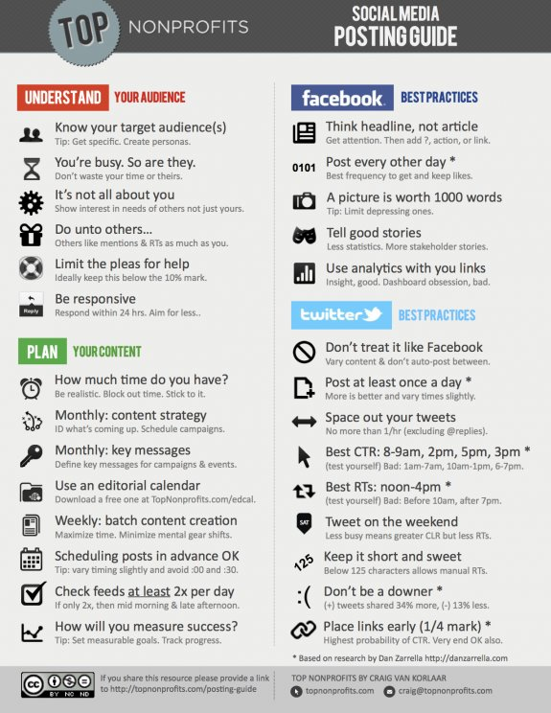

**Appendix B**

**Twitter Terms and Tools:**

* **Retweet (or RT)**: The act of forwarding another user's Tweet to all of your followers. People do this if someone has said something especially valuable and they want their own network to see the information too. (Example: RT @username: Check out this cool #infographic on health reform).
* **Modified Tweet (MT)**: A Tweet by another user that signals you have slightly modified the original Tweet. This is often used to spread news or share valuable findings on Twitter with your personal comments added.
* **@Reply**: A Tweet posted in reply to another user's message, usually posted by clicking the "reply" button next to their Tweet in your timeline. Always begins with @username.
* **Direct Message (or DM**): A private message sent from one Twitter user to another by either clicking the “message” link on their profile or typing D USERNAME. Note that you can only send a direct message to users who are following you.
* **Tweet at a specific person by inserting an @ before the person’s handle**; by putting @USERNAME at the beginning of your tweet, that person knows you are following them.
* **Hashtag (#)**: The icon that is used to organize conversations on a given event or theme. These combine a # with a word, acronym or phrase (no spaces) and can be found through search. Ideally, use at least one #TAG per post. Do not create your own #TAGs – the idea is to become part of an existing conversation. Sample hashtags include #health, #healthcare, #ACA, and #HCR. GMMB will work with you to set up monitoring tools for the top hashtags – and those may well change over time.
* **Lists**: Curated groups of other Twitter users. Lists are often used to tie specific individuals on your Twitter account. They can be useful to organize and highlight partner organizations, such as others involved in Exchanges around the country, relevant health care reporters and other key voices you want to be able to easily pull apart from the rest.