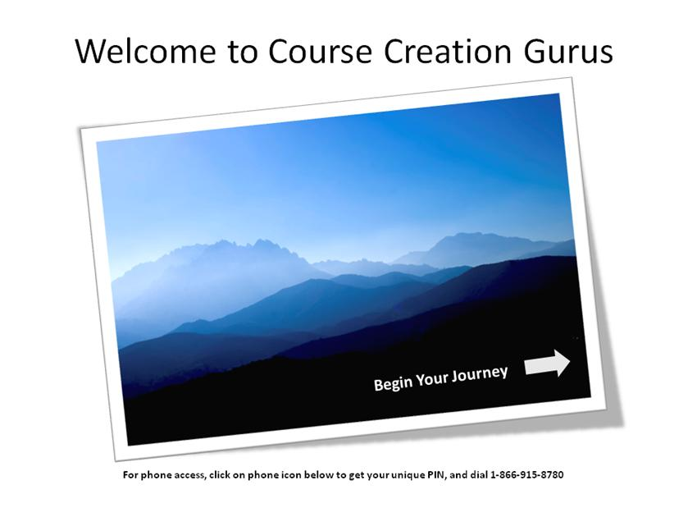
Course Creation Gurus – a collaborative learning program focused on creating self-paced tutorials
WebJunction staff leads: Kathleen Gesinger & Dale Musselman
February 2010 – July 2010

- What first motivated you to try Articulate software, and when did that happen? What was the problem or challenge you were looking to solve? Why'd you pick Articulate software over other tools?
After looking at a few of the course creation tools out there, WebJunction started using Articulate Presenter in 2007. We really liked the easy user interface and that it allowed our users to start with a tool most if not all were familiar with. When Articulate Presenter 09 came out we were extremely excited to recommend this version to our state library partners. One of the main reasons we were looking at course creation software was the need for more library specific course content. There is a lot of course content focused on software or softskills, but when it comes to library specific competencies like supporting public library computers or patron computer policies we need to turn to each other in the library field. We also saw staff creating course content relevant to other libraries but not in a format that could be shared out widely. We wanted to highlight a tool that we saw as approachable, user friendly and SCORM compliant.

- How & why did you set about forming the Course Creation Gurus group? Tell a little about the demographics of the group, and how they use Articulate software. How many people were involved?
We had the software, we had the content ideas and in some cases existing course content but we realized our state partners really didn't have the time to learn a new tool on their own. Many states are facing staff layoffs and resource reductions themselves, so finding the time to learn new tools and create courses just kept slipping off the top of the to-do list. We created the Course Creation Gurus group to create a solid time on the calendar and a safe place to learn new approaches to Articulate Presenter and self-paced instructional design. Based off of a live online cohort model of learning we'd tried the year before (focused on trying advanced features of a web-conferencing tool) we took the same principles and our lessons learned and applied it to this course creation group.

Inspired by the Rapid E-learning blog, we skimmed through nearly every blog post and identified some top themes we could narrow down into manageable and approachable topics. Tom Kuhlmann (writer of the blog) does such a great job of keeping learning fun and approachable we figured, why recreate the wheel and let his expertise lead the way. So from there we decided on the follow areas and order:

Stay focused - Building clear course objectives
Navigate Articulate - Navigate and create a simple template
Three C's of Scenario Building - Challenge, Choice, Consequence
Let the Learner Drive - Learner driven topic exploration
Narration & Annotation - Adding a little more life to your course
Create Quizzes - Building meaningful quiz questions

Once we had our topics defined and our program outlined we extended the invitation to any WebJunction partner administrator (representing 16 states) leading their state library continuing education programs. We knew we had a wide variety of experience and adult education experts in this group. While not everyone had self-paced course design experience, everyone had a training background of some kind and a need for library specific course content. In the end we had 19 total admins join the group and an average of 8-10 participants in any given session.

- What did you do to communicate with the group and keep them engaged and learning?
We designed the sessions to be two 1 hour sessions a month, keeping the live online session time to a minimum but to keep people engaged with learning the tool. The first Monday of the month was our Course Creation Guru session with a key speaker showcasing elements of that month's topic. The goal was to bring in a "rotating guru" each month who would lead the session and offer an activity or facilitate the exploration of that month's focus. We sent out a pre-session email sharing blog posts or other areas for inspiration to get people thinking about the upcoming session topic. In that email we'd connect to our discussion boards for participants to share ideas related to the pre-session content. When questions would come up about favorite microphones or sources for graphics we'd add that content to the pre-session email and encourage participants to share their ideas.

Once our first Monday Guru Session was complete, we encouraged everyone to work with the concepts they'd learned that day. We'd send out a follow up email covering some of the highlights or resources that came out of that session. Two weeks later we met again for our Learner Showcase session that gave us all time to walk through questions that came up and what we'd be working on since the guru session. This meeting was pretty informal and often led to rich discussions.

- How about the platform you used to keep people connected with each other & with resources. Can you tell us a little about the page you set up as the "hub" of information for the group?
We created the Course Creation Gurus group page within our internal platform WebJunction Learning & Support Center as a place to become a group member, view session information, documents and discussions threads. The goal was to keep this page (and a few sub-pages) dynamic and to grow with each session. We made new resources available each month, highlighting relevant Screenr demos, blog posts, books, etc. On the group landing page, we embedded a featured Screenr video to keep the page fresh and to showcase the topic of that month. We also posted all of the session content, login information, dates/times and archives. Anyone who missed a session could view the archive and stay in the loop.

- What were some of your learnings from the six months that you conducted the Course Creation Gurus sessions?
1) From the trainer perspective - it was really a breath of fresh air! Motivated learners can really drive the topics and conversation. We had really meaningful discussions about prior experiences or questions. I really felt like we were all inspired by each other < learner / guru > at one point or another. There was a sense that we all wanted to stay accountable to each other. Because this format was relatively fluid, the trick was feeling ready - but not too ready. Because we were trying to meet our participants where they were and with what motivated them, training development was on-going not ALL up front. We created materials as needed and in our lucky instance, recruited Articulate rock stars Tom Kuhlman and Jeanette Brooks to present three of the six guru sessions.
2) Another learning from the facilitator perspective was that it was ok if not everyone did the "homework." If they kept showing up to the sessions it was still meaningful and relevant to them. No one has extra time on their hands so the fact that our participants showed up two times a month for six months really was what was important. That took a couple of months to get used to and accept. This wasn't a certification program or credit based series but a learning cohort focused on getting up to speed on a tool.
3) During the Narration & Annotation session, we included an exercise that participants did from their desk during the session. Rather than rely on folks trying it after the guru session, we introduced the Narration and Annotation controls within Articulate and walked through the basic steps to begin recording. Then, we pushed out a basic slide deck to everyone with a poem for everyone to practice narrating. They had 5 minutes to practice recording narration from their desk. Once everyone returned we had one of the best discussions of the whole series as we talked about some of the nuts and bolts of adding narration. This lead to a more design oriented conversation about when to use narration and why one would choose not to. The feedback we got from participants was that this approach was very useful! If we do this program again that method will definitely be more fully integrated into the guru sessions.

4) Because this was going to be a pretty significant time together, we tried to keep it fun too! Because we were all venturing into new learning territory we framed the full series as a journey and each month we "traveled" to a new theme or destination. While where we went wasn't the point of the session it helped build a sense of adventure and made planning each session fun too. Once we got rolling, it made complete sense to frame the session Letting the Learner Drive as a Vespas tour through Italy. We didn't focus on that but just let it set the stage for our learning.

- In any shared practice group, there will be varying levels of involvement & commitment. How did you champion the folks who seemed especially committed?
Where training design and development was a central part of a participant's job, we saw a lot of involvement and solid examples of things they'd been trying out. We were able to champion the great work of those individuals (or in one instance a team of two) during the Learning Showcase and use their examples for that session. Where motivation to get a full course posted was high and a top work priority, we found real success in terms of output. However, what we realized as well was just because participants weren't sharing their examples didn't mean they weren't soaking in the concepts or the excitement. We have two great examples of this: Kansas State Library Everyday Ethics and TechAtlas SMART goals.

- What were some of the positive byproducts of the group? Did you see additional sharing/dialoguing or other cool outcomes after the group concluded?
A favorite byproduct so far (we just concluded in late July) is that there is one fully completed course that is now in our WebJunction course catalog and available for library staff across the country. The course is a new course from LibraryU entitled, There will always be storytellers, and was developed by Dawne Tortorella and Lisa Barnhart. This course represents many of the lessons we talked about over the course of our six months together: visual impact, open navigation, including audio and narration where it will make the most impact. It really feels like a success for our cohort! We are really proud of their work!
Another great outcome is that we all have someone to turn to and ask to review a course or an idea. We are really excited about the possibility of an upcoming LibraryU course Basics to Interlibrary Loan (ILL) that is in the initial design phase - this is hot stuff in the library world! A lot of work goes into making sure a library patron can ask for a book that lives at another library and have it delivered to their local library. That's part of the magic of libraries!

- How did you leverage the resources in the Articulate community to augment what you were doing with Course Creation Gurus?
Instead of trying to be the expert of everything as facilitators, we were able to ask participants to post the question on the Articulate forum boards and share back what they learned. These forums really represent the ideal response rate, substantive and helpful replies plus a huge repository of questions and answers that have already asked and answered.

- What's been the feedback from participants? Any quotes, testimonies, or statistics you can share, regarding how the software or the Course Creation Gurus sessions helped them?
75% of responding participants reported that two sessions a month worked for them. We were pleasantly surprised with this response! When asked, “What, if anything, did you like about the two sessions a month set up,” this response is a good representative: It gave us a focus for attempting to create some concrete results from the learning.

Some good feedback from our survey:
“I have a much clearer understanding of the capabilities of Articulate which is always one of my challenges with new software. I also feel empowered by the resources and ideas that were shown.”

“I know who to call. I know where to find information. I know that creating self-paced courses requires more than a good powerpoint. I know it takes time. I currently have a lot on my plate and don't envision creating a self-paced course in the next six months.”

A great suggestion for next time:
“Use an actual case throughout all the sessions of a short course, building on each session. If a course was developed during the process, it would show that something could be created within the time constraints and it could model good instructional design.”

- How has the group helped to flatten the learning curve for new developers? How has it resulted in better/quicker output?
Ultimately, we were able to help create a safe learning environment and a place where participants were able to try new concepts regarding instructional design, planning your course, considering quizzes or evaluations, adding fun and open navigation to a course. Allowing the time and the space to use new software and encourage people to explore the tool in an open yet guided experience made for good learning. During our post-assessment survey a few key responses really helped to confirm this:
A key goal for us was helping folks feel more prepared to create a course:
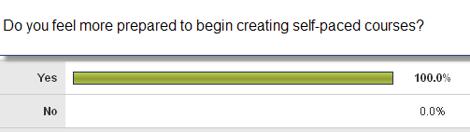
Comfort level with the tool and getting started can be as important as being the subject matter expert:
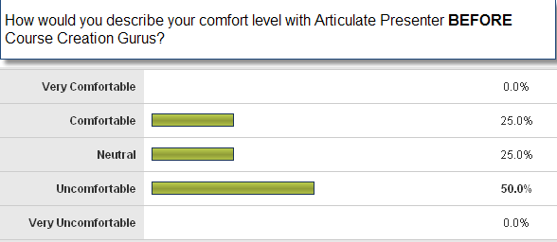

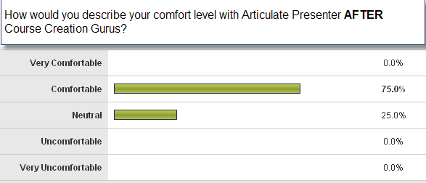

- Any best practices you can share, either about the Articulate software or about building a shared community of practice? Things you'd do differently if you could go back in time?
You need a central coordinator / facilitator who is responsible for keeping the momentum moving. As engaged as participants were, it was very helpful to have someone leading things throughout the full planning and execution of the program. While responsible for setting the tone and topics, the facilitator also needs to be flexible and responsive to the needs of the groups, cheerleading successes and encouraging the group when things seem overwhelming. After going through the full series, next time we'd like to have a course topic and full content in mind to build along the way so that participants see the growing course via the guru sessions and during the learning showcase. Starting from course outline to the template, navigation, building in scenarios and adding narration and annotations.

- How do you see Articulate being used in your organization in the future?
We will continue to use Articulate to support our own software training efforts and in supporting the library focused efforts of our state partners. We like that we can integrate videos created through Camtasia to bundle a seamless looking tutorial.

- How did your experience with leading the Course Creation Gurus affect your plans for other shared-practice efforts in the future? Do you plan to do additional Articulate-focused sessions?
This effort really validated the approach of bringing a group of people together to explore software and to build new competencies related to that tool and the practice. The level of confidence that shined through at the end from our participants was really exciting and certainly proved the effort worthwhile. We will be sharing our methodology to our partners during our September partner meeting to showcase the approach and encourage others to try something similar. Having spent 6+ months focused on Articulate, we are thinking about a smaller version of this kind of collaborative series focused on our internal web-conferencing tool.

