  - Aztec Public Library Community Assessment

Community ASSESSMENT
AZTEC PUBLIC LIBRARY
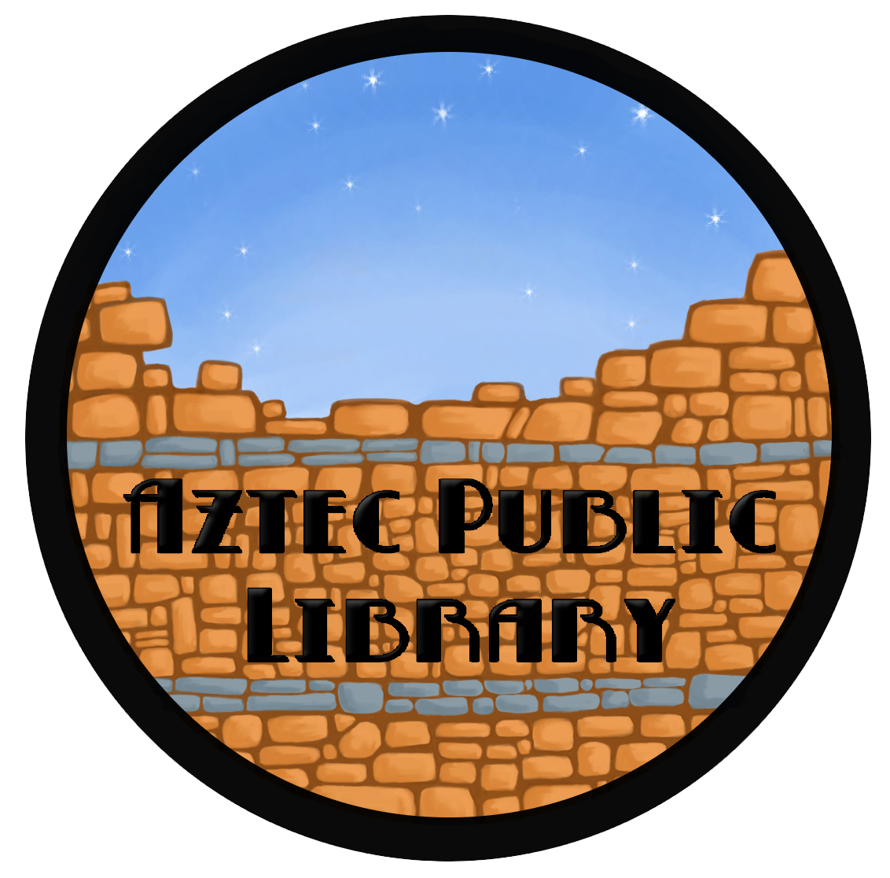

A

Aztec, NM

201 W. Chaco | Aztec, NM87410 | Voice 505334-7658 Fax 505334-7658
azteclibrary@aztecnm.com
www.azteclibrary.org
Submitted to the NM State Library - June 2004

TABLE OF CONTENTS

COMMUNITY PROFILE

Local Government
Type of Government
Legal Service Area
Library Financing
Geographic and Demographic Information
Geography and climate
Transportation, climate, and topography
Population
Socioeconomic Climate
Business and industry
Social services
Unemployment/underemployment
Income levels
Education levels
Educational
Public School Systems
Private School Systems
Home Schooling
Higher Education
Information Systems
Libraries
Commercial Outlets-Internet, Videos
Other local information sources
Recreation and Cultural Activities
Community service groups

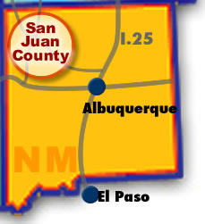

LIBRARY ANALYSIS

Mission and community roles
Legal Basis for Library Operation
Staffing
Library’s organizational structure
Type of staff
Staffing levels
Training
Salaries
Funding
Facility
Exterior
Interior
Furniture and Equipment
Furniture
Computer Equipment
ADA
Media Equipment
Collection
Volumes
Media

Services
Open hours
Circulation services
Youth services
Adult services
Outreach

APPENDIX

FIVE YEAR PLAN
Public Services
Programming
Adult
Youth
Community Outreach
Friends of the Library
Literacy Task Force
NMML Library Task Force
Development
Collection
Personnel
Policies/Procedures
New Facility
Northeast Family Center
Business Center
Technology
Automation
AzTech Consortium

COMMUNITY ASSESSMENT

LOCAL GOVERNMENT

TYPE OF GOVERNMENT
Commission/Manager
- Five member commission, elected by public four year term.
- The Commission is policy making board and is not involved in day-to-day operations.
- Commission does not have the power to hire and fire.
Mayor
- Appointed among commissioner body for two year term.
Municipal Judge
- Elected position for four year term.
City Manager
- Appointed by the commission.
- Responsible for day-to-day operations of the city and oversees the city budget.
City Clerk
- Appointed by the commission. Records and maintains all city records.

DEPARTMENT HEADS
- Police Chief - appointed by commission.
- Finance Director
- Electric Utility Director
- Public Works
- Water/Wastewater
- Parks & Recreation /Maintenance
- City Planner
- Librarian
- Senior Center Director

LEGAL SERVICE AREA
San Juan County, including but not limited to the cities of Aztec, Farmington, Bloomfield, Kirtland, Blanco, and surrounding areas, including parts of Southern Colorado.

DEOMOGRAPHIC INFORMATION

POPULATION
- Aztec 6,380
- San Juan County 120,367 2002
- % Change 1990-2000 = 24%

GEOGRAPHY, CLIMATE, AND TOPOGRAPHY

GEOGRAPHY
Aztec
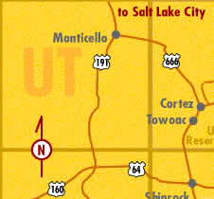
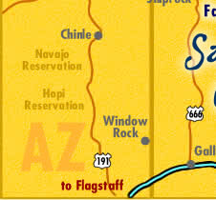
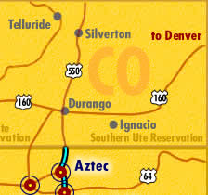
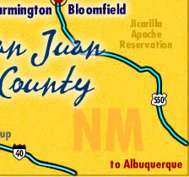
Aztec is located 15 miles south of the Colorado border and 60 miles east of the Arizona state line. It is close to many lakes, rivers, mountains, and deserts. Aztec was originally settled by Pueblan Indians in the 13th century. The ruined city they left behind on the banks of the Animas River is an outlier of the Chacoan civilization that once extended from northern Mexico into southern Utah. Today Aztec is a town of 6,380 with an historic town center. It is the seat of San Juan County government and home to the Aztec Ruins National Monument. Aztec is located between the larger cities of Farmington, New Mexico, and Durango, Colorado, with comfortable residential neighborhoods and a picturesque central business district that houses several thriving local businesses.

San Juan County
San Juan County lies in the northwest corner of New Mexico, where it adjoins Colorado, Utah and Arizona and is partially contained in the Navajo Nation. Rich in cultural treasures and environmental splendor, the county is centrally located in the vast outdoor playground of deserts, canyons, mountains and waterways that make up the Four Corners. For the past two years, San Juan has been the fastest growing county in New Mexico. Its population increased by more than 24% between 1990 and 2000, to a total of 113,801. The county's economy, based in natural resources, power production and regional trade, is diversified and expanding. Yet the cost of living is modest and the ready access to nearby summer and winter outdoor recreational opportunities is outstanding. San Juan County is a great place to live and work. San Juan County is located in the northwest corner of New Mexico, bordering Arizona, Colorado, and Utah. San Juan County is comprised of 5,500 square miles located in the beautiful "Four Corners" area in the U.S.
The vast Navajo Nation Reservation lies adjacent to the county, as does the Jicarilla Indian Reservation. The locale is recognized worldwide for premier big game hunting and for abundant fishing, particularly in the quality waters of the three rivers, which flow through the area. Numerous outdoor activities, including camping, boating, swimming, water skiing, wind surfing, golf, live horse racing, and hiking may be enjoyed year round. Spectacular skiing is available at Purgatory and Wolf Creek ski resorts in the scenic mountains of Colorado, each within a couple of hours drive. If golf is your game, Pinion Hills golf course is right in the heart of the county, located in Farmington, NM.
Various Indian ruins, including Chaco Canyon National Park, the Aztec Ruins, Salmon Ruins, and Mesa Verde National Park are among the area?s point of interest. Farmington, the largest city in the county, provides a shopping hub for the area which covers a 150 mile radius and includes the smaller towns of Aztec, Bloomfield, and Shiprock, New Mexico, as well as several towns in Colorado including Durango and Cortez.
Albuquerque and Santa Fe are each within a 4-hour drive. Las Vegas-style gaming is available at several area casinos on the reservation, and at the county fairgrounds just outside of Farmington. The quality of life, clean air, parent-involved school systems, and the "small-town" atmosphere make this an ideal locale to live and raise children.
CLIMATE

Temperature
 | Winter | High 43 degrees
 |  | Low 17 degrees
 | Summer | High 92 degrees
 |  | Low 57 degrees
Annual rainfall |  | 10 inches
Annual snowfall |  | 19 inches
Humidity |  | 45%
Elevation |  | 5,686 ft.

TRANSPORTATION

HIGHWAYS
State and federal highways provide important transportation links between the isolated Four Corners and other major cities in the southwest. State Route 44 to Albuquerque has been widened and reconstructed; US Highway 64 is a divided four-lane road east to Bloomfield and west to Shiprock. The widening and reconstruction of Highway 544 between Bloomfield and Aztec was completed in 1995. Improvements have been completed on State Route 170 extending north 20 miles to the Colorado state line. Aztec is the gateway to Southern Colorado as Highway 550 bisects the town as it heads north. Aztec, Bloomfield and Farmington are connected by four-lane US Highway 550 to I.25 just north of Albuquerque.

AIRPORTS
Four Corners Regional Airport
Owned and operated by the City of Farmington as a division of the Community Development Department. The airport is certified by the FAA and is located northwest of the city about 1½ miles from downtown. The Four Corners Regional Airport can accommodate commercial jetliners as well as air freight transportation. The Farmington area is presently served by four commercial airlines: United Express, Mesa Airlines, America West Express, and American Eagle.
Aztec Municipal Airport
The Aztec Municipal Airport is located 15 miles east of Farmington and 42 miles south of Durango, CO. The airport property includes approximately 10 acres of city owned land, buildings and T-hangars.

SOCIOECONOMIC CLIMATE

BUSINESS AND INDUSTRY
- Historic Downtown Mainstreet
- Government Administration
- Oilfield Services
- Some retail shops and restaurants
- Tourism

SOCIAL SERVICES
- San Juan Regional Medical Center
San Juan Regional Medical Center is a primary inpatient, trauma and health-testing center offering the most comprehensive range of inpatient and outpatient health care services within the Four Corners region. With a licensed capacity of 160 acute inpatient beds, SJRMC also operates a Level III Trauma Center, and Immediate Care Center, an air and ground ambulance service, state-of-the-art diagnostic and imaging services, ambulatory surgery center and a comprehensive Cancer Center. The 90+ licensed physicians on staff represent 26 areas of general and special practice.

- New Day Center - battered woman’s shelter
- Echo Preschool
- Presbyterian Medical Services Headstart Preschool
- USDA Commodities Distribution
- Northwest New Mexico Seniors Center
- Boys and Girls Club of Aztec

UNEMPLOYMENT/UNDEREMPLOYMENT
San Juan County - 11%

INCOME LEVELS
Aztec
- 54% is low to moderate income.
- 40% senior citizen’s on fixed income.

EDUCATION

AZTEC SCHOOL DISTRICT
Every day 3,266 students cross the threshold of their school in Aztec and begin their school day. They come to us with different skills, with different backgrounds and with different fears but full of energy and dreams. They are our most important stakeholders and we take our mission to ensure all students develop a strong educational foundation seriously.
Aztec is located in the northwest corner of New Mexico in the beautiful San Juan River Basin, a rural community just south of the Colorado border. The Aztec Municipal School District (AMSD) serves 3,266 students in preschool through grade twelve. The district is located in the "four corners area" where New Mexico, Colorado, Utah, and Arizona meet. We have a diverse student population of approximately 45% Anglo students, 30% Hispanic students, and 25% Native American students. The City of Aztec is the county seat of San Juan County and our economic base is tourism, coal, oil, natural gas production and agriculture. The district employs 211 teachers and a support staff of 207 to provide transportation and educational services to our students. We own our own busses, provide our own custodial and maintenance services and we outsource food service to Aramark Corporation. Our students do well on standardized tests and they are extremely well behaved.

SAN JUAN COUNTY PUBLIC SCHOOL SYSTEM
SCHOOL | TEACHERS | STUDENTS
MCCOY | 60 | 510
LYDIA RIPPEY | 50 | 477
PARK AVE | 40 | 513
 | Teacher /Student Ratio | 21-24 ea
KOOGLER | 65 | 760
AZTEC HIGH | 60 | 1050
ALTERNATIVE HIGH | 15 | 60
BOYS & GIRLS CLUB | Instructors | 9
 | Enrollment | 500
 | Daily Average | 130
Independent public school districts serve Aztec, Bloomfield and Farmington, and the Central Consolidated School District serves the unincorporated areas. Our schools are well-equipped, well-staffed, and they perform above the regional average.

Type of School | Public | Private
Preschools | 3 | 13
Elementary Schools
Middle/Junior High Schools
High Schools
Alternative Schools
Private/Parochial |  | 6
Vocational/technical
Tribal |  | 5
Community Colleges | 1 (two branches)
Colleges/Universities | 0

PRIVATE SCHOOL SYSTEM
New Mexico Department of Education Nonpublic School Students
- Aztec 0
- Bloomfield 326
- Farmington 627

HOME SCHOOLING
New Mexico Statues Annotated 22-1-2(U)
New Mexico Department of Education Home School Students
- Aztec 76
- Bloomfield 102
- Farmington 194

HIGHER EDUCATION
San Juan College
San Juan College is one of the nation’s outstanding community colleges, offering academic courses as well as technical programs in traditional career areas to a student body of more than 6,000. In addition to traditional academic courses such as English, History and Mathematics, the college offers programs not often found in accredited institutions of higher education, such as Pilot Training, Semiconductor Manufacturing Technology, Industrial Water Treatment, Media Technologies and Communication, and Outdoor Leadership.

San Juan College is an independent comprehensive community college offering two year Associate Degree transfer programs, Technical-Occupational degrees and certificate programs, Developmental Education and non-credit community service classes. Enrollment is 4,200 credit students each semester with an additional 5,000 non-credit students annually taking community service classes. Tuition at San Juan College has remained unchanged for the last 15 years and at $15 per credit hour it is currently the lowest in the State of New Mexico.

San Juan College East
A branch of San Juan College located in Aztec.

Ft. Lewis College

INFORMATION SYSTEMS

COMMERCIAL OUTLETS

San Juan County Profile
Information Source | How Many
Local Newspapers
Local Radio Stations
Local Television Stations
Bookstores
Video Stores
Music Stores
Local Community Access Cable
Internet Service Providers (ISPs)
Other (community organizations, etc.)

LIBRARIES
San Juan County Profile
Type of Library | How Many
Public | 4
Aztec Public Libary
Bloomfield Public Library
Farmington Public Library
Shiprock Atsa Library
Elementary School | 1
Junior High/Middle School | 1
High School
Vocational Technical | 0
Community College | 1
San Juan College Library
San Juan College West/Kirtland Library
College or University | 0
Hospital/Medical
Law | 1
San Juan College Library
Special
Salmon Ruins Archaeological Research Center
LDS Genealogical Library
Other

OTHER LOCAL INFORMATION SOURCES
- San Juan County Government
- San Juan Economic Development
- San Juan County Historical Society
- San Juan County Extension Office
- San Juan Sun

RECREATION & OTHER CULTURAL ACTIVIITES

Within easy range of Aztec and vicinity are pueblo style Indian ruins and cliff dwellings, national parks and monuments, scenic geographic formations, spectacular mountain scenery and beautiful lakes. Some are listed below:

- Angel Peak Recreation Area
- Aztec Historical District walking tour.
- Aztec Museum & Pioneer Village - Noon Day Shootout
- Aztec Ruins National Monument
- Bisti Badlands
- Bolack Game Reserve & Wildlife Museum
- Chaco Cultural National Historical Park
- Canyon De Chelly National Monument
- Hesperas Ski Area
- Farmington Museum
- Four Corners National Monument
- Mesa Verde National Park
- Monument Valley Park
- Morgan Lake
- Navajo Dam
- Natural Bridges National Monument
- Purgatory Ski Area
- Salmon Ruins
- San Juan Archaeological Research Center Heritage Park

COMMUNITY SERVICE GROUPS

Organization Type
Friends of the Aztec Library
Kiwanis
VFW
Spirit of 63 (City beautification group)
Lion’s Club
Masonic Lodge
Aztec Chamber of Commerce
Key Club

LIBRARY ANALYSIS

MISSION AND COMMUNITY ROLES

In the long tradition of library use by this community, the Aztec Public Library will provide free service to all individuals and groups in the community and San Juan County. It accepts as its basic objective the provisions and the guidance in the use of both print and non-print materials that will aid all the people of the community in their pursuit of education, reliable information, and in the creative use of leisure time.

Educational service to adults is its primary function, and the Library will pursue an active program of stimulation, leadership, and cooperation with other agencies in encouraging the reading of socially significant materials.

The Library, in recognizing its responsibility to develop adult citizens for whom the use of books and other media of communication is necessary and natural part of living; provides special services to young people. It seeks to direct and stimulate young readers by making available specially selected collections, and individual guidance.

In the provision of special services for children, the Library strives to guide the child toward a love of reading and an awareness of books as a means of satisfying his mental, emotional and creative interests.

The Library will support the Freedom to Read statement endorsed by the American Library Association in 1953 and the Library Bill of Rights adopted by ALA in 1948, amended in 1961, and amended again in 1967. These two documents, which contain basic policies that should govern the services of all libraries, may be used as a point of reference by the librarian when inquiries about pertinent matters are made by the public. As the guardian of the right of every adult to read whatever he chooses to read and to form his own opinions, the Library will contest encroachments on that freedom by volunteer arbiters of moral and political opinion seeking to impose their own standards or tastes on others. Neither additions to nor withdrawals from the collection shall be influenced by groups or individuals.

LEGAL BASIS FOR OPERATION

State
- NMSL Rule 93-1
- State Grants-in-Aid to Public Libraries, Rules and Regulations (See Appendix (NMSL Rule 93-1 Fact Sheet)

City Ordinance
- Aztec City Ordinance No 325
- See Appendix (Ordinance No. 325)

STAFFING

LIBRARY’S ORGANIZATIONAL STRUCTURE
- Librarian
See Appendix (Aztec Public Library Staff)
- Administrative Assistant
See Appendix (Aztec Public Library Staff)
- Temporary Clerk
Assists the Librarian and the Assistant Librarian. Can open and close the library if necessary. Performs duties such as Circulation, Tech Services, assisting with programs, and other tasks as needed.
- Volunteers
The Library has a long tradition of strong volunteers. We presently could not function with out the help of five dedicated women who show up regularly and can be called upon during most emergencies!

TRAINING
- Librarian
  - Librarian’s Certificate Grade I
  - NM State Library Development Services Continuing Education Workshops
  - Planning for Automation
  - Writing A Technology Plan
  - Community Assessment
  - Freedom of Information
- Administrative Assistant
  - Librarian’s Certificate Grade I
  - Youth Services Roundtable Workshop
  - NM State Library Development Services Continuing Education Workshops
- Temporary Clerk
  - Continuous training by Librarian and Assistant as needed to perform various duties.
- Volunteers
  - Continuous training by Librarian and Assistant as needed to perform various duties.

SALARIES
- Librarian $25,000 - $26,000
- Administrative Assistant $19,000 - $20,000
- Library Clerk

FUNDING

- State-Grants-In-Aid NM $2,265.00
- Library Budget $102,309.00
- Friends of the Library $ 900.00
- San Juan County
- Other Grants

FACILITY

EXTERIOR
The Aztec Public Library is located in the City Complex adjacent to Pioneer Park. This provides a nice green grass carpet for summertime programs. The 2,300 sq. ft. red brick structure was constructed in the early 1960’s and has under gone one renovation when a drop ceiling was added in the early 1990’s.

INTERIOR
The interior consists of one large room that houses Adult Fiction, Adult/Young Adult Non-fiction, Reference, Southwest, Large Type, Biographies, New Titles, Books on Tape, magazines (1 yr back), newspapers (1 yr. back), card catalog, and Young Adult Fiction. The library also has an in-house Red Amazon parrot named Jackson. One small room makes up the Children’s Room and includes a card catalog, Easy Fiction, Junior Fiction, Beginning Readers, Boardbooks, Junior Non-fiction, Biographies, also puzzles, games, toys, and pets. Also a men’s bathroom, a women’s bathroom, and a workroom /office with a storage closet and a utility closet.

FURNITURE AND EQUIPMENT
Furniture
- 5 Tables w/chairs for public use
- 6 Computer Workstation w/chairs
- 1 Study Carral w/chair
- Bookshelves
- 2 Office Desks w/chairs for staff use

Computer Equipment
- 1 Pentium 75 MHZ, 32MB,
- 28.8 modem
- 2 Pentium 100 MHZ, 16MB,
- CDRom Dr, 28.8 modem
- 2 Pentium 100 MHZ, 32MB
- Cdrom Dr
- 1 Power Mac 6100
- 1 Pioneer CDRom DRM-624X Changer
- 1 HP Deskjet 850C Color Printer
- 1 HP Deskjet 600 Color Printer
- Logitech Pagescan Color Scanner

ADA
We are not, at present, compliant with current ADA Code. With a plan in place for a new library, we have been able to put off renovating which would require adding on to the building to add room for another restroom and the existing two restrooms would have to be combined. The aisles would also have to be widened in order to accommodate this change and we would lose our already precious book space.

MEDIA EQUIPMENT
- 1 VCR/TV Unit
- (with roll around cart)
- 1 Copier
- 2 Filmstrip Projector
- 3 Typewriter
- 1 public use
- 2 office use
- 1 Word Processor

COLLECTION

VOLUMES
- Book/Serial 30,450
- Subcriptions 43

MEDIA
- Audio 1,200
- Video 250
- Cdrom 130

SERVICES

HOURS OF OPERATION
Summer Hours
- Mon - Thru 9:00am - 6:00pm
- Fri & Sat 9:00am - 5:00pm
- Sun CLOSED
Winter Hours
- Mon - Thru 9:00am - 8:00pm
- Fri & Sat 9:00am - 5:00pm
- Sun CLOSED

CIRCULATION SERVICES
InterLibrary Loan - service provided at no charge. We go through the State Library’s ILL network for requested titles.
Requests take a week to ten days.
Fines determined by lending library.
Reserves - titles requested by patrons to be held when returned.
Titles held for pick up one week.
Regular Books/Books on Tape
14 day check out.
Three renewals.
Fines of .05/day (five days grace).
Maximum fine is $1.00.
Video
7 day check out.
Fines of .05/day (five days grace).
Maximum fine is $1.00.
CD Rom - can be checked out from the desk and used at the computer workstations.
Hope to circulate at one point.

YOUTH SERVICES
- Storytime
In the Fall, Winter, and Spring, the library facilitates two Storytimes a week. One is held on Thursday for the Echo Preschoolers and averages about 30 kids, and the other is a public storytime that averages 15 participants. Karen Lozier, coordinator of these programs is assisted by two members of the community, “Grandma Hugs” - Kay Hughes, a retired special education teacher who provides a “grandma” element, and Leanne Schwabe, a young mother and certified school teacher who has young children who attend.
- Summer Reading Program
The library has a Summer Reading Program that typically starts the first week of June and runs through the second week of August. We have embraced the State Library summer reading program themes and have had between 200-300 kids participate.
- Battle of the Books
A State Library sponsored reading program that the Library participated in this last year (1998-99) with one enthusiastic participant who would like to go again. Would like to see this program grow.
- Jr. Volunteer Program
Youth program designed to help young people get to know the library by working as a volunteer and doing designated tasks such as checking books in and out, shelving, clean-up, pet care, computer monitoring, as well as other jobs. We feel that this has a positive effect on young people and serves to bolster esteem and confidence. The volunteers have logged in over 700 hrs in just under one year. See Appendix (Aztec Jr. Volunteers)

ADULT SERVICES
- Coffee Social
A Coffee Social is held the first Wednesday of the month and is formatted as a social gathering with light refreshments served and members of the community bringing in samples of their breakfast breads. A speaker is usually arranged and topics range from gardening to holistic health. Sometimes a craft demonstration is presented. This program has on the average about fifteen participants.
- After Hours
This is a new program designed for adults and is tentatively scheduled to run on Thursday evenings at 7:00pm. Topics planned for discussion included archaeoastronomy/star gazers, social themes, business topics, current events that are in the public interest.

COMMUNITY OUTREACH
AzTech Consortium
- See Appendix (AzTech Consortium)

Aztec Library Board
- See Appendix (Aztec Library Advisory Board)

Friends of the Library
This group is going through a reorganization stage with newly elected officers and a renewed desire to accomplish fund raising for a proposed library to be located in the Northeast San Juan County Family Center. A brochure is in the works and the group is also planning a Second Annual UFO Crash @ Aztec Symposium to be held March 25, 1999. This group also plans to produce a Newsletter, and is now about 30 members. Newly elected officers are:
- President Suzanne Ramsey
- Secretary Donna Chadwick

Juvenile Justice and Children’s Issues Committee
A committee that meets once a month at the Farmington Police Department to exchange ideas and information pertaining to youth issues and sponsored by Judge Paul Onuska.

New Mexico Municipal League

New Mexico Municipal League Library Task Force
- See Appendix (Public Library Funding in New Mexico)

Northeast San Juan County Family Center Executive Committee
- See Appendix (San Juan County Northeast Family Center Proposal)
- See Appendix (Aztec Public Library Support Of)

San Juan County Literacy Task Force
See Appendix (Aztec Public Library and Literacy)

UFO Crash @ Aztec 50th Anniversary Symposium
- Annual fund raising event that provides an informative
- and fun outlet for the community. Also provides library and Community support.

APPENDIX

- Aztec City Ordinance No. 325
- AzTech Consortium
- Aztec Jr. Volunteers
- Aztec Public Library Advisory Board
- Aztec Public Library and Literacy
- Aztec Public Library Staff
- Libraries for the Future
- NMSL Rule 93-1 Fact Sheet - Public Libraries
- Public Library Funding in New Mexico
- San Juan County Northeast Family Center Proposal
- San Juan County Northeast Family Center

