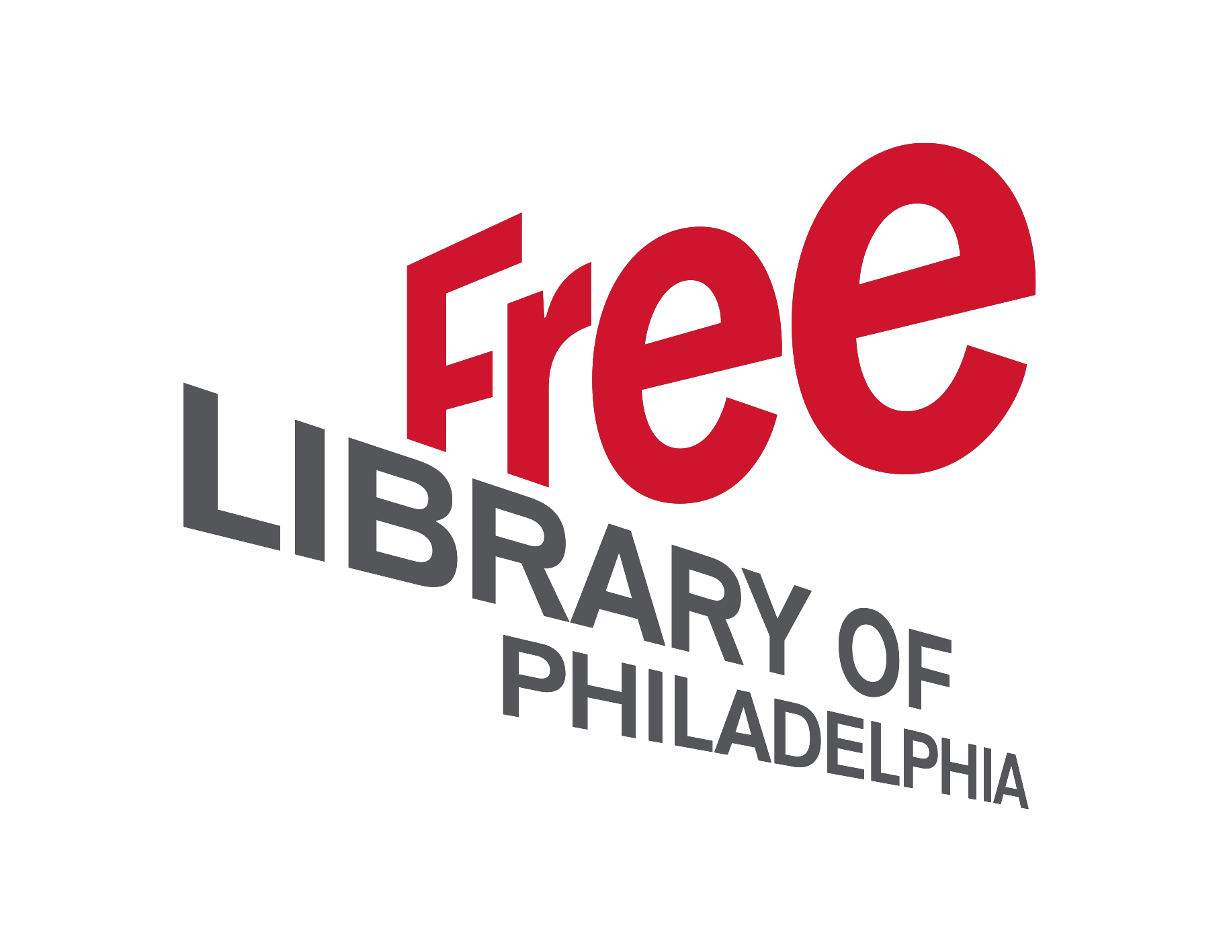

Webinar 3
Skills for Community-Centered Libraries:
SOAR

Take and Turn

This project was made possible in part by the Institute of Museum and Library Services [Grant #RE-95-17-0089-17].

SOAR Discussion Questions

Strengths:  1. What is the library known for?  2. What does the community think the library does well? How can we build on that together?  3. What key resources give the library an advantage to connect with their communities in a world where information resources can be found nearly everywhere?  4. What makes the library unique? | Opportunities:  1. What community needs and wants could the library address?  2. How do the library’s strengths align with community needs? How could the library develop programs or services targeting these needs?  3. What community partnerships would lead to greater programming success?  4. What are key areas of untapped potential for the library?  5. What changes do we expect to see in our communities over the next five years? Where could the library make a difference?
Aspirations:  1. What is our community passionate about?  2. What should our future community look like?  3. What strategies and actions support our vision for this future library and community?  4. Based on the passions and needs of our community, what can we do to advance the library’s strategic plan goals? | Results:  1. Considering the identified strengths, opportunities, and aspirations, how will we know we are on track in achieving our goals? What results do we want to see?  2. How might we track the impact or changes that have happened?  3. Imagine it’s ten years in the future and your neighborhood library is being recognized as one of the most community-centered libraries in the country. What is said in the proclamation? What did you do along with the community to receive this recognition?

Taking SOAR to your Community

As you develop programs with your community members, you’ll need to ask what matters to them and collectively agree on topics. As a community-centered library, you can then connect your community’s desires to library resources or partners who can fulfill these goals.

The following questions will help you plan a successful discussion with your community.

Directions: Review the questions below. Begin to plan a discussion at your library. Add specific planning notes in the bulleted spaces. If you are attending the workshop with someone from your library, you are encouraged to plan the SOAR meeting together.

Planning

  - What are the goals of this dialogue?
  - What community stakeholders should be invited to this discussion?
  - What are strategies to increase attendance?
  - Will this discussion involve a panel or roundtable?
  - Are there experts in your community or assets that can bring additional knowledge to the conversation? (such as a community member that writes grants for a non-profit)

Capture the Dialogue and Sharing Success

  - Identify one or two individuals who can take notes to capture the discussion taking place. If budgets and resources allow, consider an audio or video recording. These strategies will be helpful for developing your event summary for a newsletter, email or library website.
  - With permission of participants, assign a staff member or volunteer to take a few photos to use on social media.

Logistics

- What space in your library will be the best location for this discussion?
- Consider how you will select a time and date for the meeting?
- Could this meeting happen more than once to include more voices in the discussion?
- Can you provide childcare for participants?
- What A/V arrangements do you need to make and will your Digital Resource Specialist be available to assist?
- Will you create a handout or take-away materials?

Feedback

  - How can you create a way for attendees to provide feedback or other thoughts and ideas following the meeting? Would an electronic survey after the meeting or a paper survey at the end of the meeting provide better results?

Notes:

