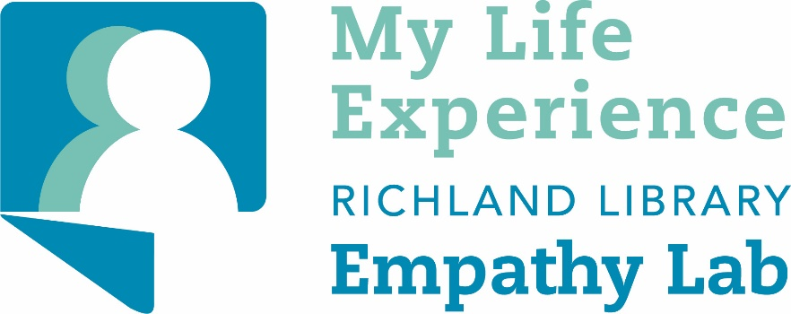

Thanks to our grant funding, we were able to try out several different headsets.

- HTC Vive
- Oculus Rift CV1
- Oculus Quest
- Oculus Go

Empathy Lab software:

We Wait (Rift)
Becoming Homeless (SteamVR - Vive & Rift)
Traveling While Black (Rift, Quest, Go)
Notes on Blindness (Rift, Quest)
Testimony (Rift, Go)
6x9 (Go)
Anne Frank House (Rift)
Clouds Over Sidra (from the Within app)

Other software:

Within (Oculus, SteamVR)
theBlu (Oculus, SteamVR)
Fantastic Contraption (Oculus, SteamVR)
Dreams of Dali (Oculus, SteamVR)
Remembering (Oculus)
Google Tilt Brush (Oculus, SteamVR)
Google Earth VR (Oculus, SteamVR)

Experience Notes

- In general, we found the room-scale experiences available for Rift and Quest to be the most affecting for customers.

- For the empathy lab, we used the Oculus Rift head set the most because it had the widest amount of content available.

