Questions: IFLA Global Vision Discussion Webinar with ARSL
http://www.webjunction.org/events/webjunction/global-vision-an-interactive-discussion.html
Event Description: The Association for Rural and Small Libraries, in collaboration with WebJunction, invites rural and small libraries to join this highly interactive webinar discussion for the IFLA Global Vision initiative. In preparation, please review the questions below. You may also refer to IFLA’s Trend Report as well as other relevant publications about libraries and the trends and developments affecting them.
Together we build literate, informed and participative societies. Together we create the future. Join us!
Libraries in 2022 – Your Vision
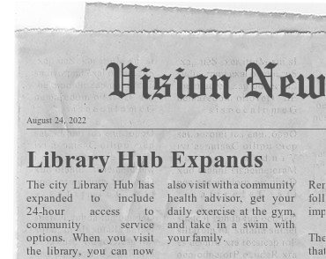
Imagine the year is 2022, what have libraries achieved?
What would a newspaper headline say?

What keywords come to mind in your vision?

A vision on libraries
Q1. What do you see as the core values of libraries?

Q2. What are libraries exceptionally good at?

Q3. What could libraries do more of?

Q4. What could libraries do less of?

Challenges
Q5. What are the main challenges to libraries?

A united library field
Q6. What would be the characteristics of a united library field?

Q7. What could be the focus of a united library field?

Additional Steps
- A summary of the webinar discussion will be shared with IFLA
- Vote! https://globalvision.ifla.org/vote
- IFLA Global Vision report published in early 2018
- Future IFLA workplan to achieve collective vision
- Visit https://globalvision.ifla.org
- Stay tuned for news about the IFLA Global Vision discussion following #iflaGlobalVision

