January Reader Poll Results: Space Planning & Design
In January, we asked readers to select their biggest space planning or design challenge. It was clear from the responses that budget is a top concern, but also that many libraries face multiple challenges, as indicated by the number of “All of the above” selections. Readers shared more details in the comments.

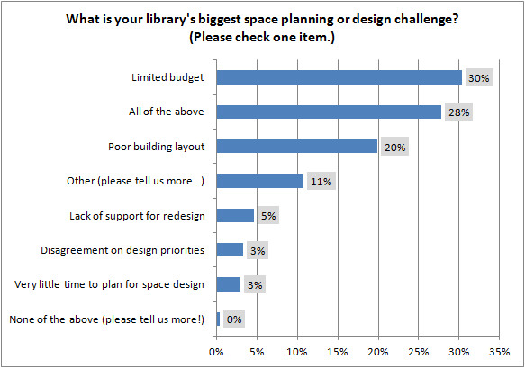

Reader Comments
- Old building (1950s) limits options for outlets, seating and shelving. There are only so many ways we can rearrange everything else. New technologies set off a domino effect as we scramble to include them in the mix.
- "we had money for a new library and have a new site, but city leaders denied the project since ""libraries are a thing of the past and won't exist in 5 years!""
- Still have the site......"
- Out growing our building, limited space
- Too many materials and a reluctance by the collections department to reduce it so that we can open up spaces.
- I would have checked 'All of the above,' but there is no lack of support here for redesign.
- I would like to be trained specifically in space design for libraries. This would make a great college level course.
- Built-in, Fixed Circulation desk and shelving. Not flexible for rapid future changes.
- Structural Integrity of Building
- Designing physical space for a library/information services that is now predominantly digital. How much physical space is still required? Is it required at all? How do you keep the library profile alive and in front of people if there is no "visual" to remind them?
- not enough time to work on the redesign, not able to close parts of the library to renovate or de arrange shelves etc
- Lack of space for books.
- We're in an original Carnegie building, which is gorgeous from the outside, and not at all conducive to a modern library layout on the inside. We share the building with a concert hall on one side, a gym on the other, and a pool in the basement (humidity issues!). There was a redesign effort a few years ago that restored part of the building to its original (read: difficult to use) layout, and decorated the children's and teen areas, without great lighting or electricity in general. Understaffed and underbudgeted, getting money and time to redesign anything so soon afterward is a challenge.
- Makerspace or Reading Area. Patrons tell us their priority is checking out books but aren't those the patrons we already have? Wouldn't a makerspace bring in new patrons? How do we justify the cost - with such limited funds - when that is not what the current patrons are asking for? Frustrating.
- Lack of space.
- Lack of space, limited budget/resources
- Building just not large enough.
- Trustee obstruction
- All of the above-- plus one more. A shortage of space for both public and staff areas.
- Inability to add or move electrical outlets and data lines.
- Two renovations that did not integrate new space in--just tacked it on. Result--too many doors, exits and areas we can use and no walls free of shelving for displays... Another renovation is being planned but now hard to correct design defects because of weight bearing walls, etc. Frustrating.
- Where do I begin? I'll focus on the children's area since that is where I work. Space is at a premium so we can't get rid of the tall bookshelves that block our view of the room from the children's desk. We have a castle/puppet theater by the fire door. This is built up on a platform with two steps with another 3 steps to the door. We are meeting with people to try to make this for ADA compliant. Also can't see the castle area from the desk because of tall bookshelves.
- Redesign to accommodate more technology in labs, study rooms, classroom.
- Raising funds for a new library building.
- No room to grow. We are hemmed in on all sides.
- "Older building that can't have structural changes.
- Up-to-date seems to address six months ago or more."
- getting new library but h&s means I can't take my plants that my kids love!

